Contents
Local Validation 3
Tools and their respective versions: 3
Run unit tests: 3
Auth Service: 5 passed 3
Streaming Service: 3 passed 4
Admin Service: 6 passed 4
Frontend tests: 5
Also, each backend count includes 2 new metrics.test.js tests. 6
Alert rule tests 6
Local env run: 6
Build and run the stack locally 6
6 containers are running: 7
4 health replies, 200 for the frontend: 7
App is working in the browser: 8
AWS Account Access 8
IAM admin user: 8
AWS configure 9
Note the admin IP: 10
Budget Alerts: 10
Terraform: 10
Initialize: 10
Plan: 11
Apply 11
Output: 12
Cluster access from machine: All 4 nodes are in ready state 12

Local Validation

Tools and their respective versions:
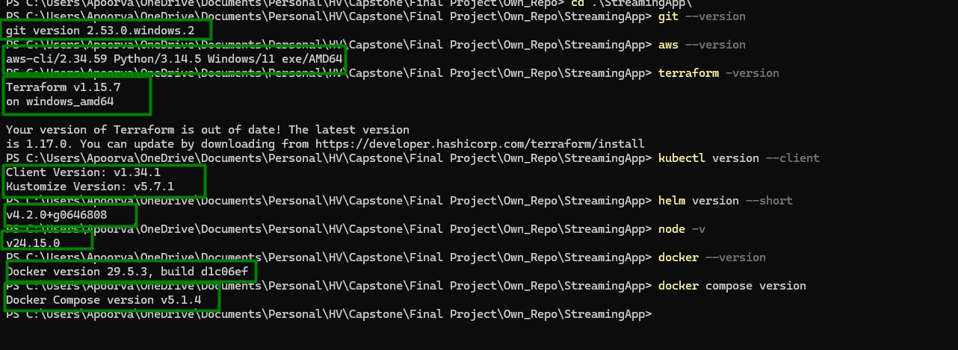

Run unit tests:

Auth Service: 5 passed
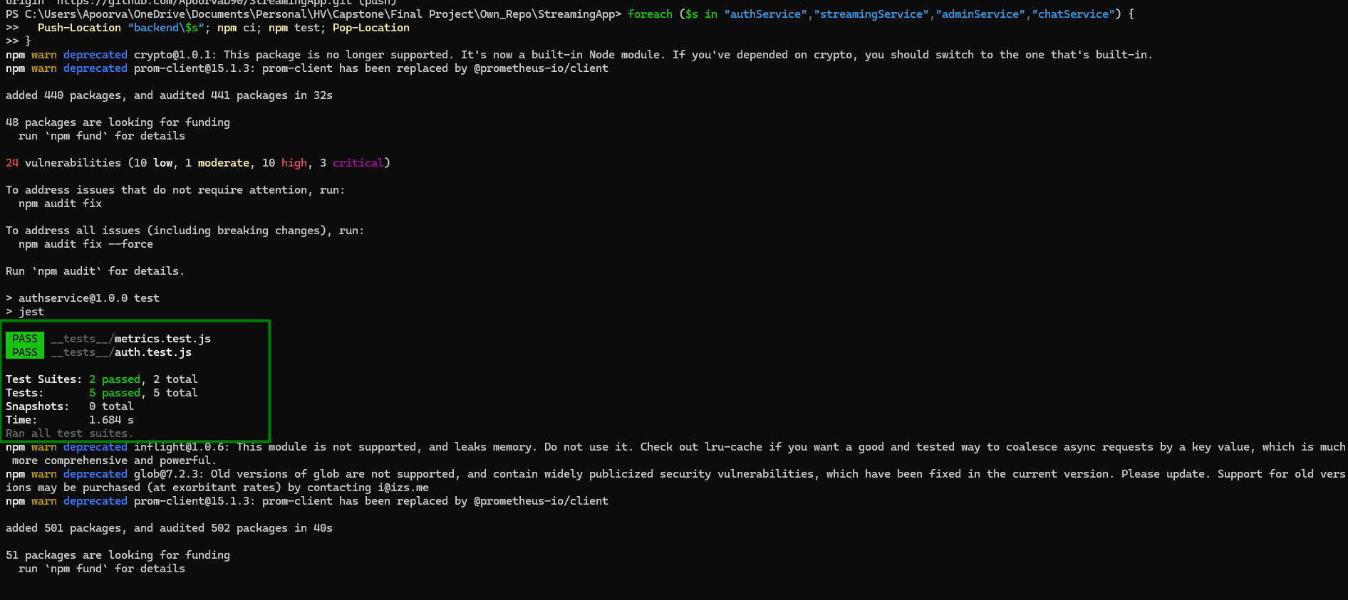

Streaming Service: 3 passed
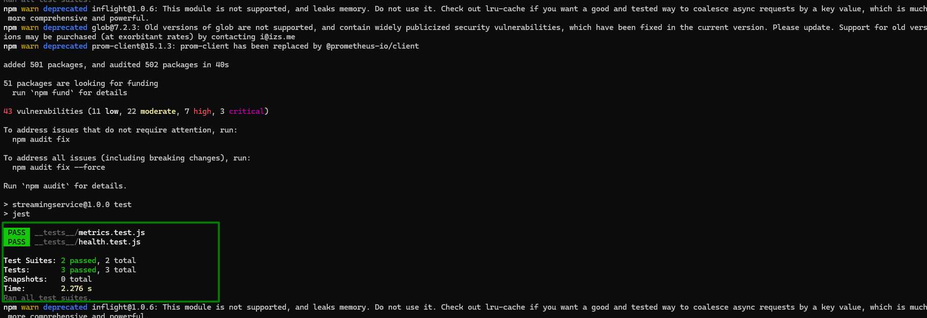

Admin Service: 6 passed
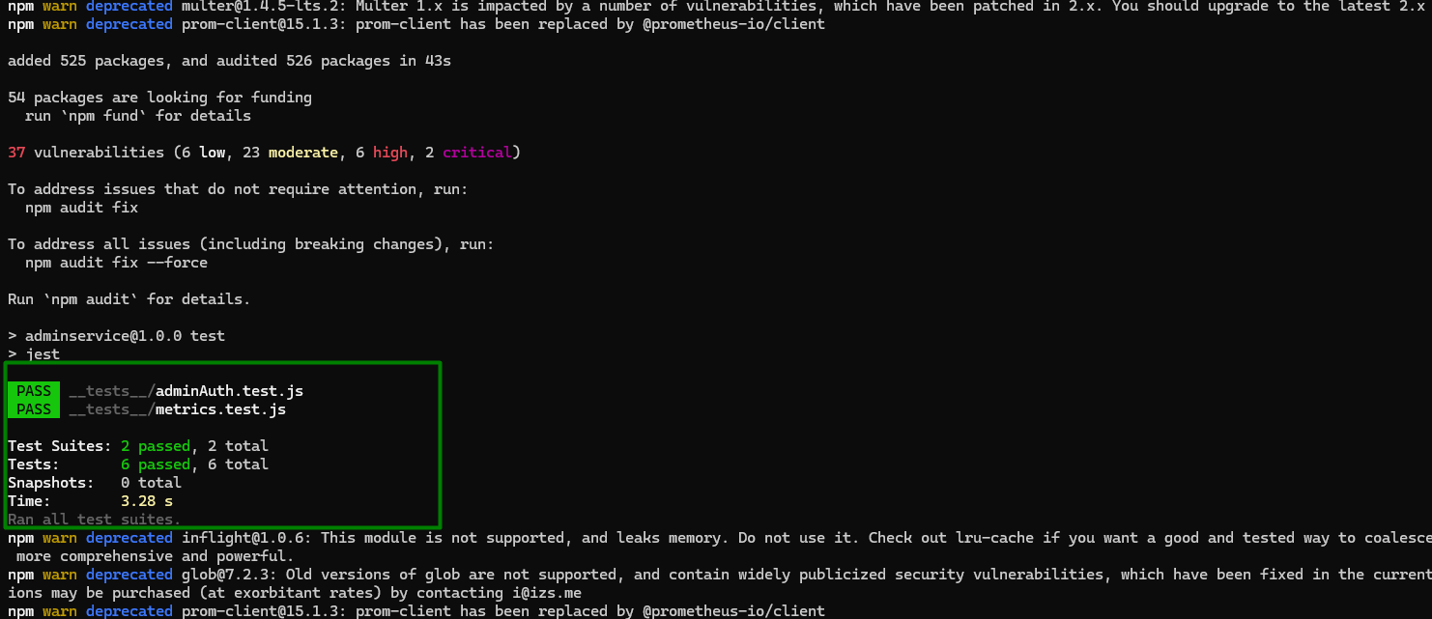

Chat Service: 5 passed
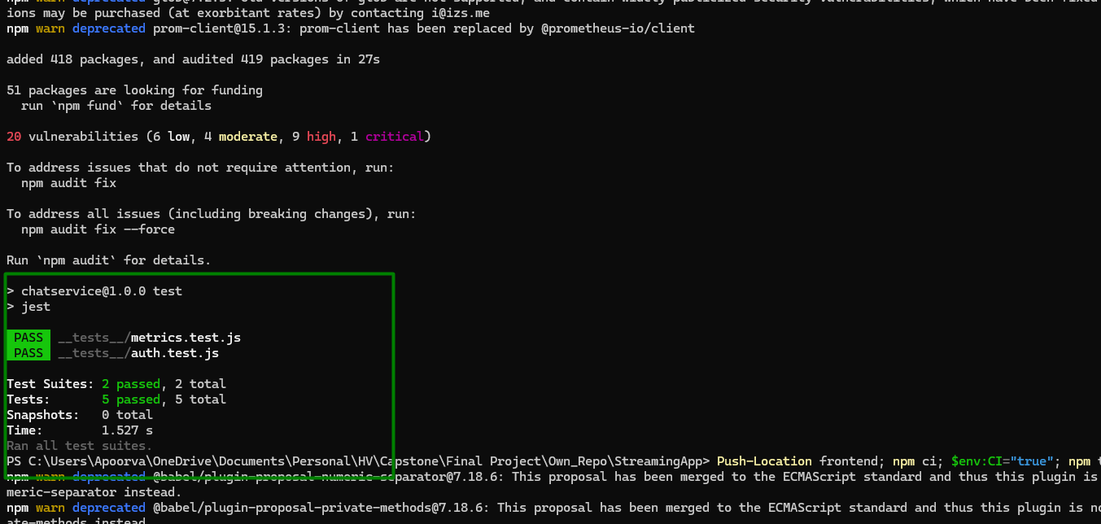

Frontend tests:
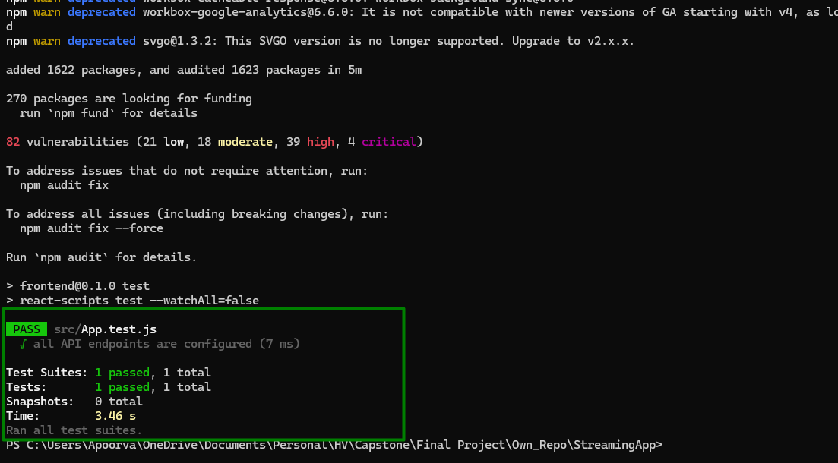

Also, each backend count includes 2 new metrics.test.js tests.

Alert rule tests
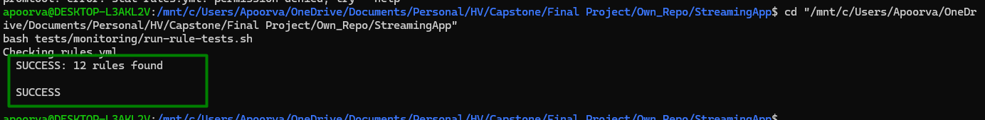

Local env run:

Set JWT_SECRET to any long random string
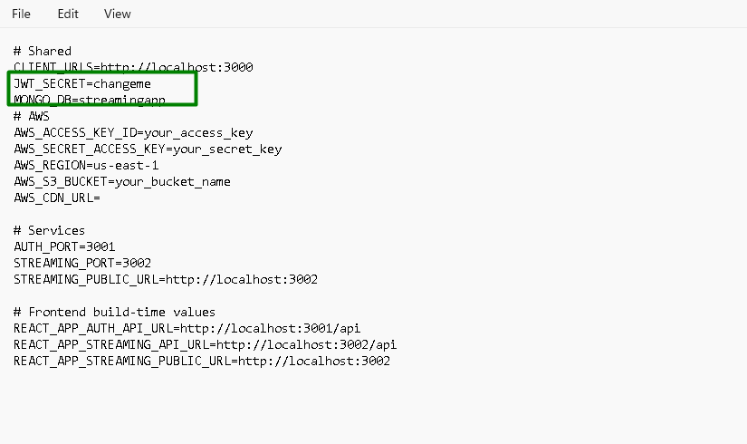

Build and run the stack locally
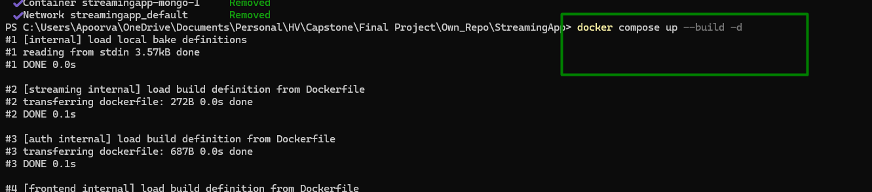
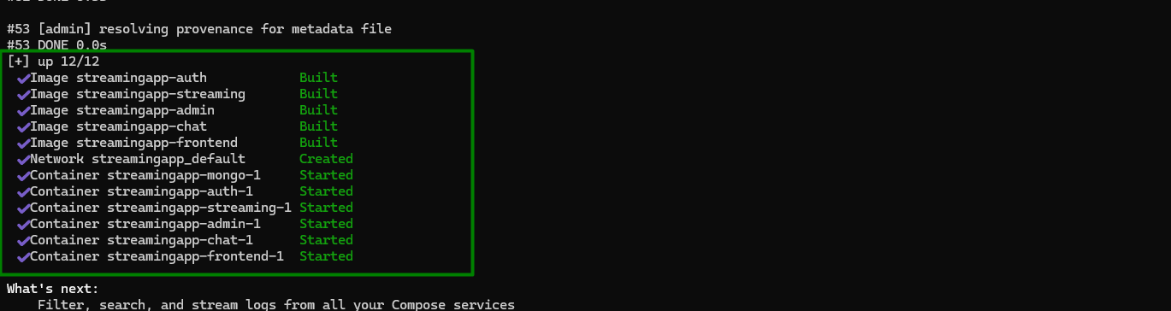

6 containers are running:
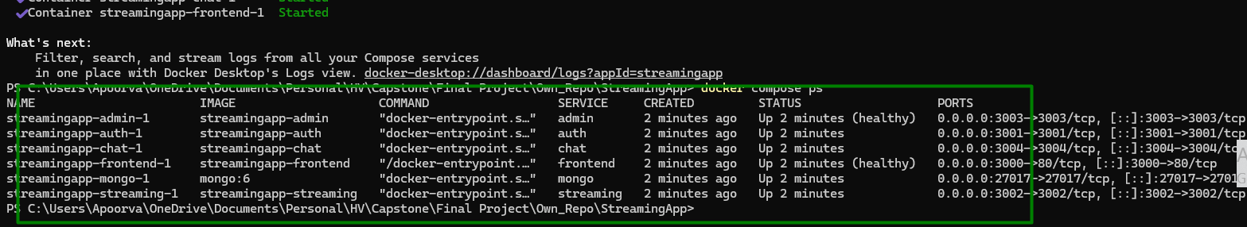

4 health replies, 200 for the frontend:
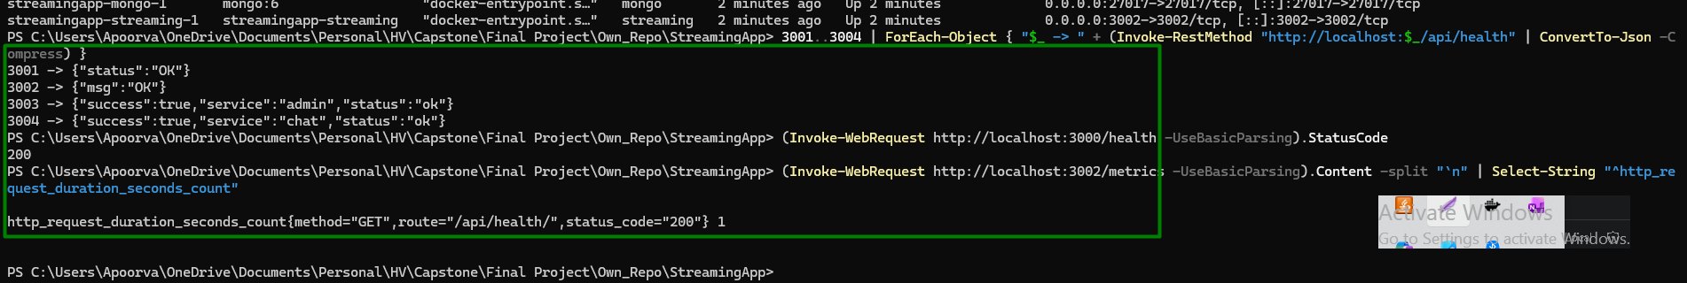

App is working in the browser:


AWS Account Access

IAM admin user:
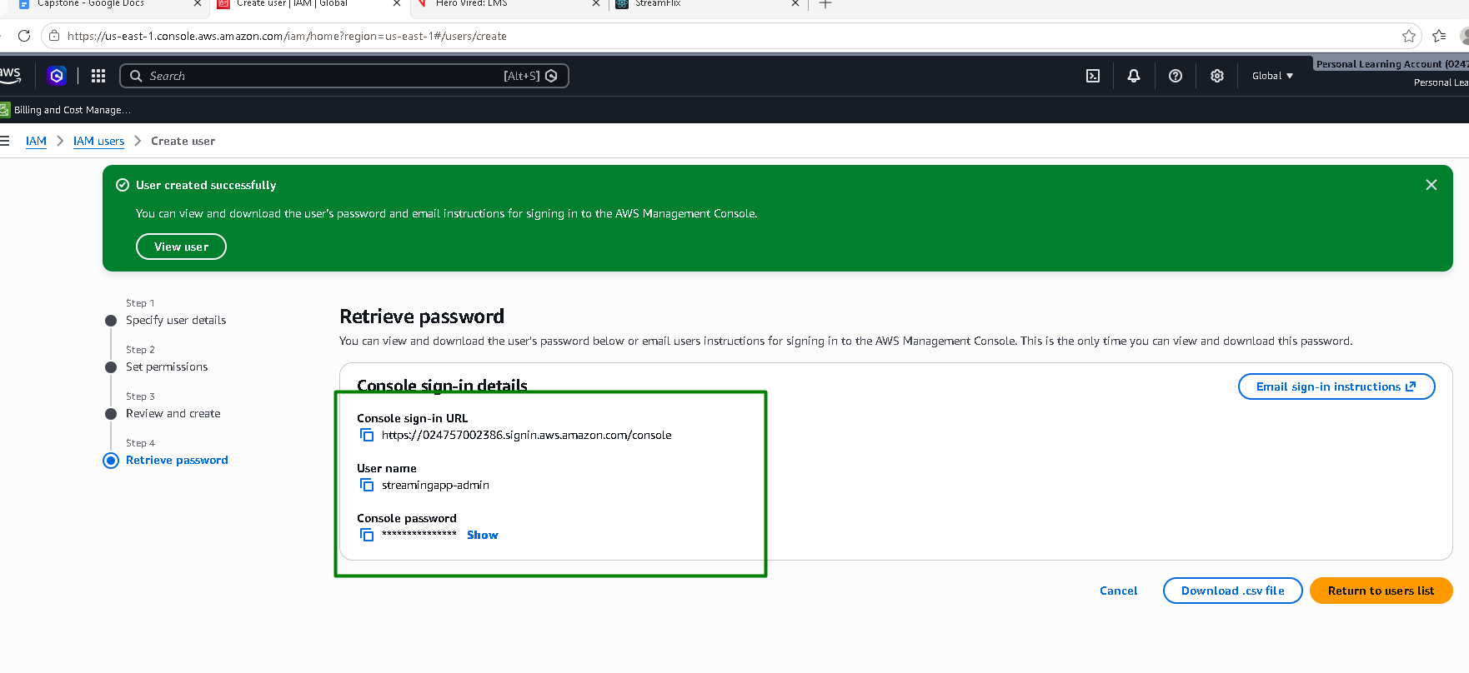

AWS configure
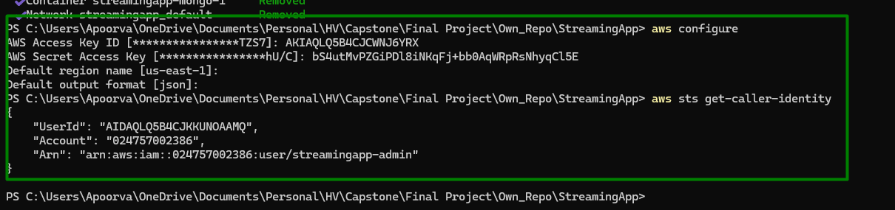

Terraform State Bucket and Lock Table

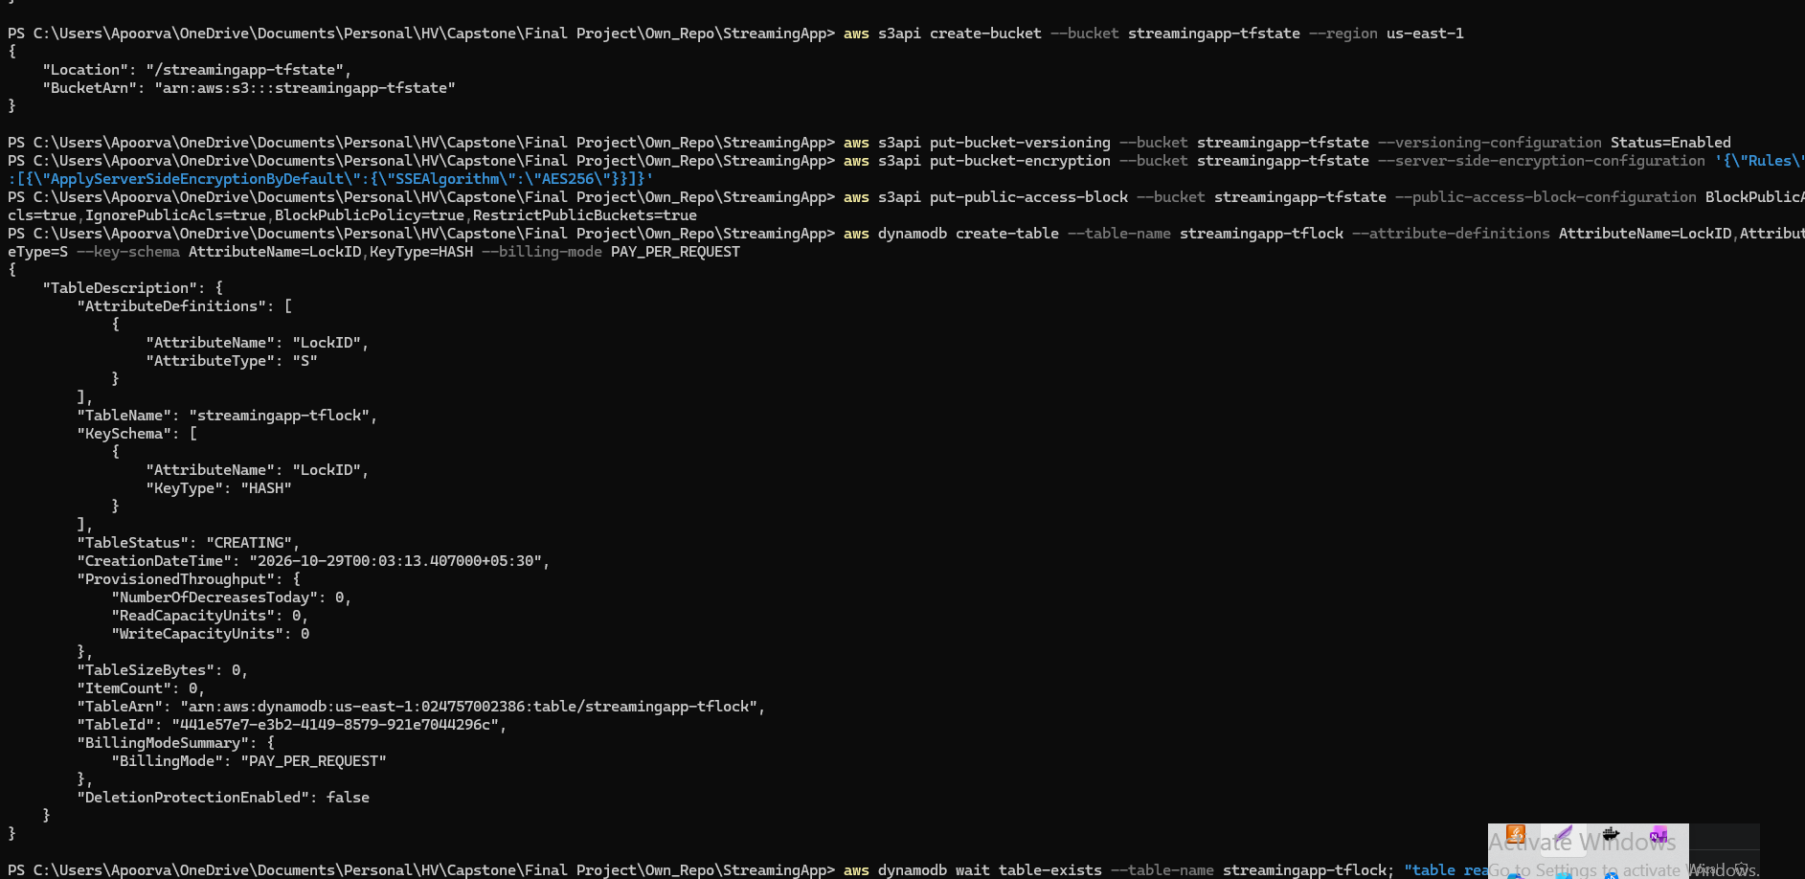
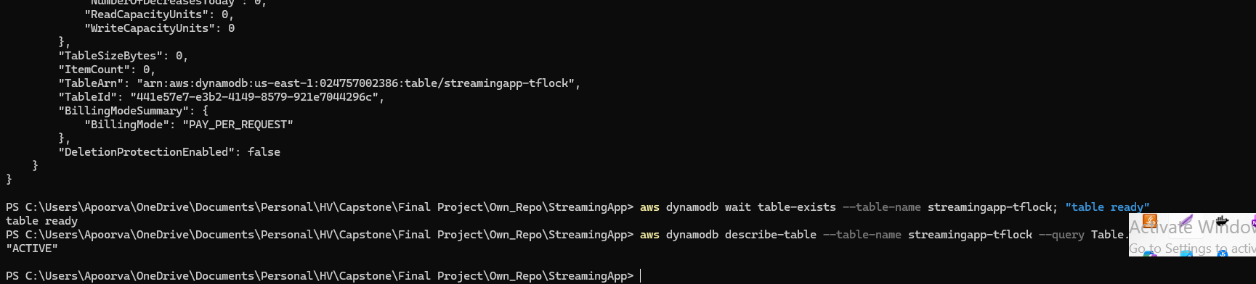

Note the admin IP:

Budget Alerts:
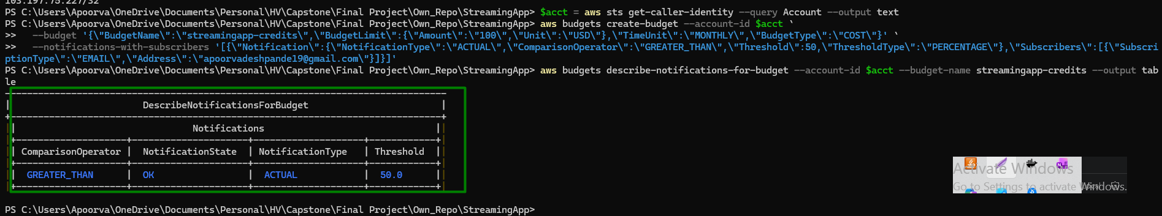

Terraform:

Initialize:
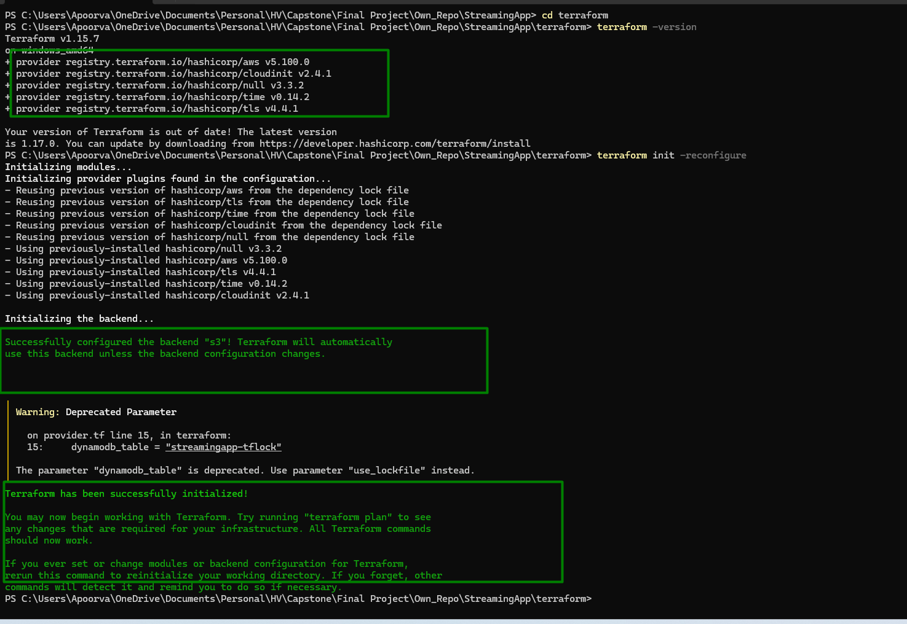

Plan:
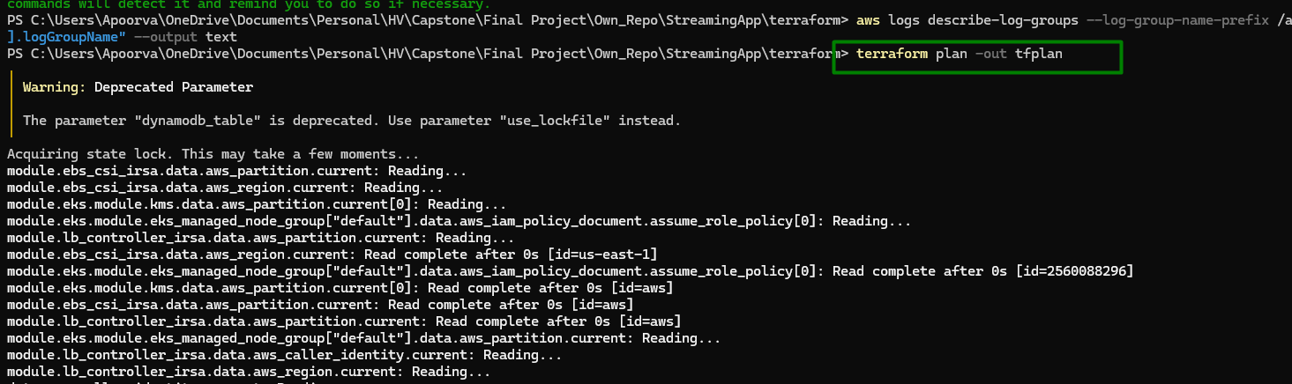
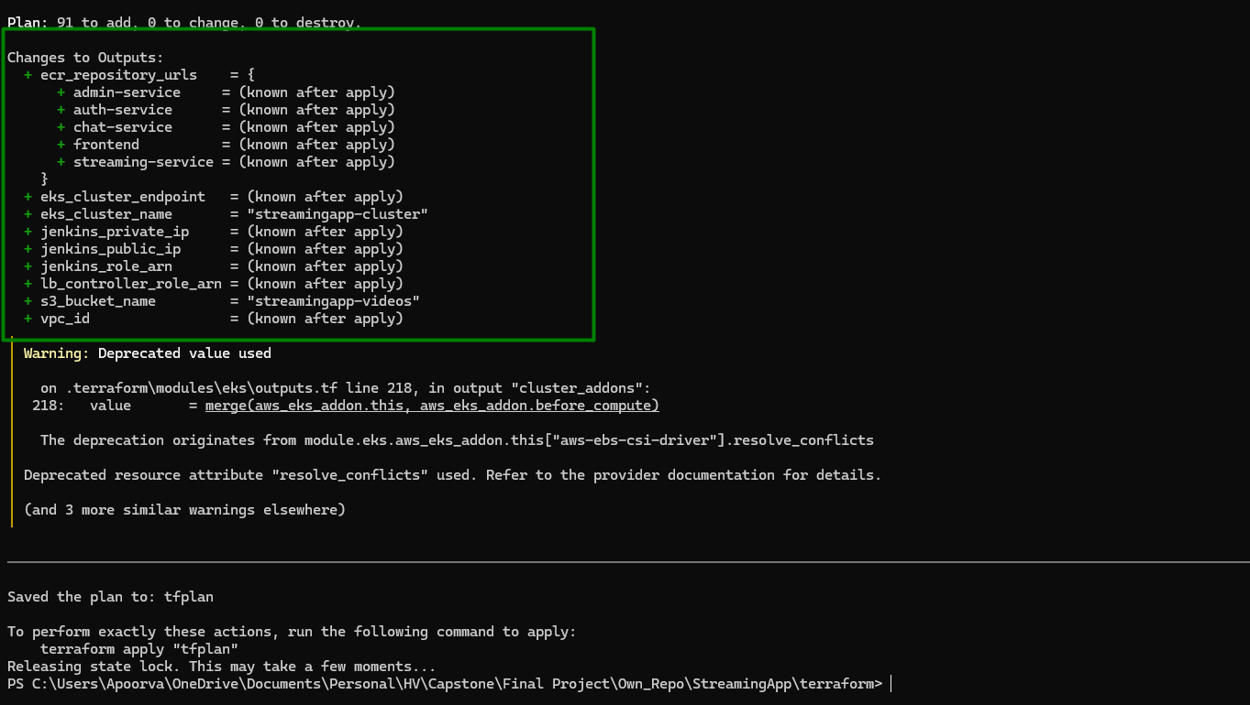

Apply
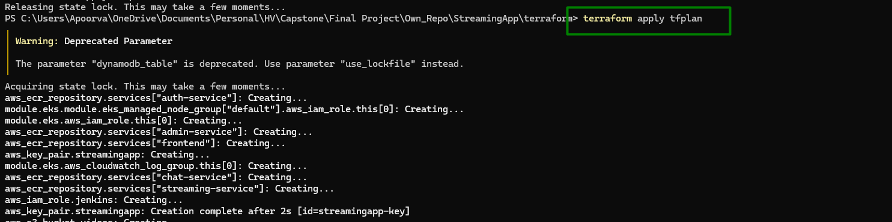
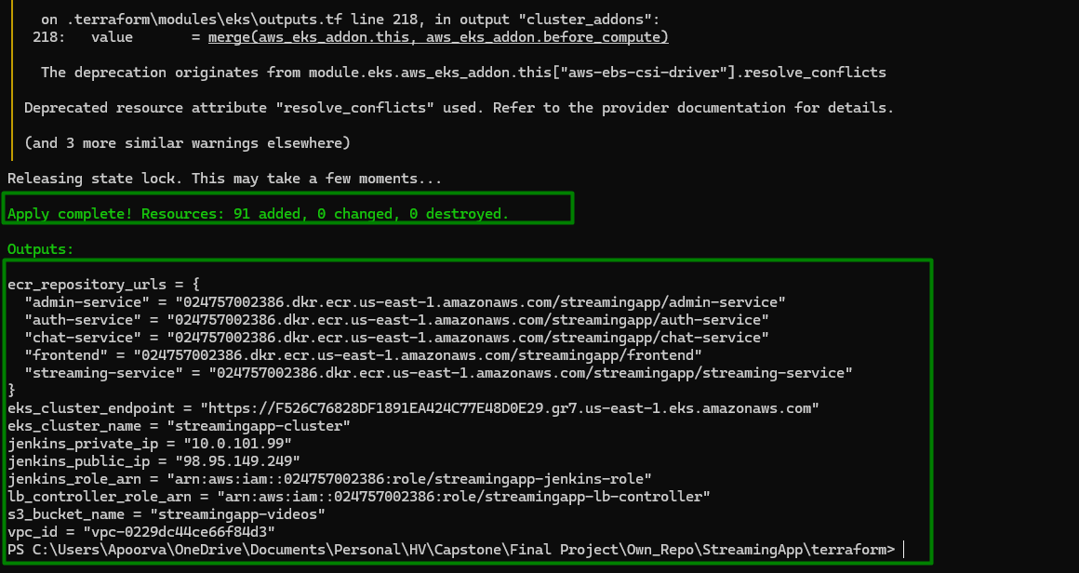

Output:
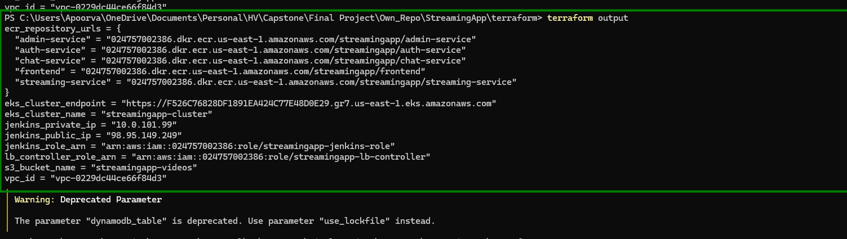
Cluster access from machine: All 4 nodes are in ready state
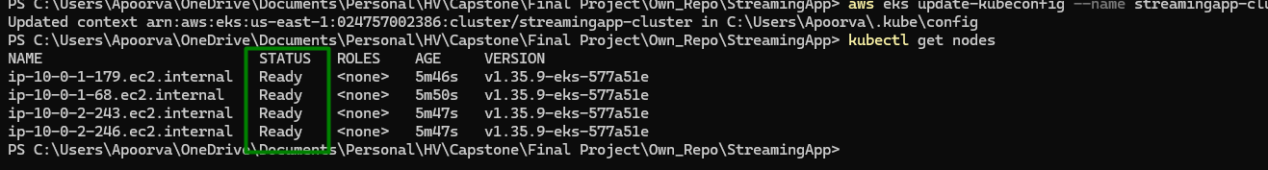

Ansible from wsl:

Run the playbook
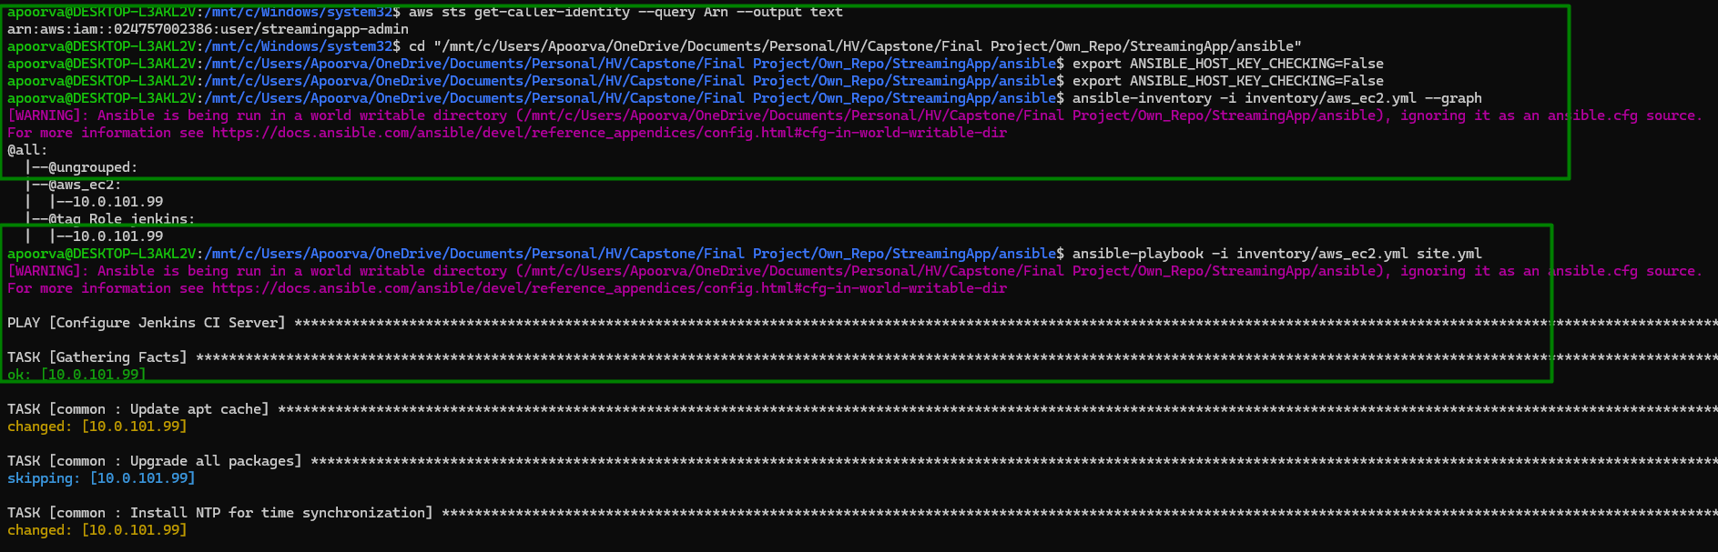

Check Jenkins server from WSL:
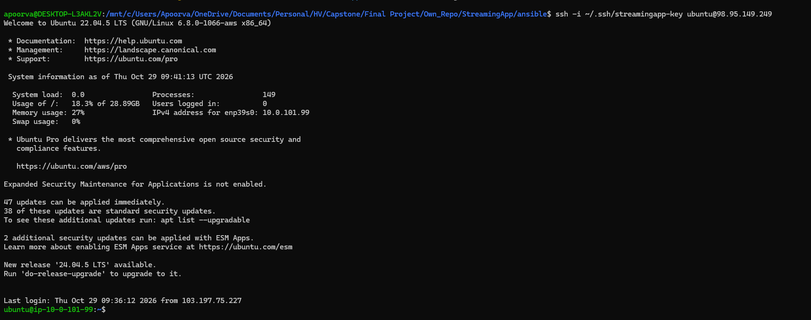
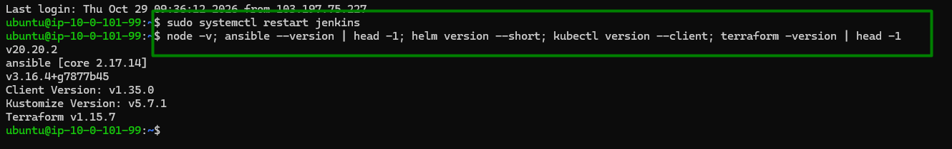
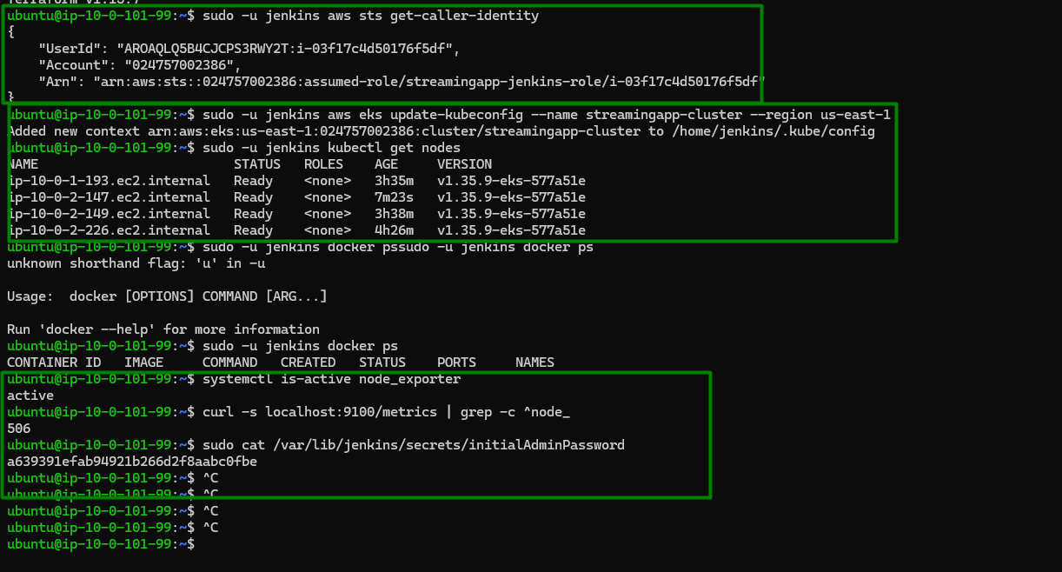

Slack and Jenkins configuration
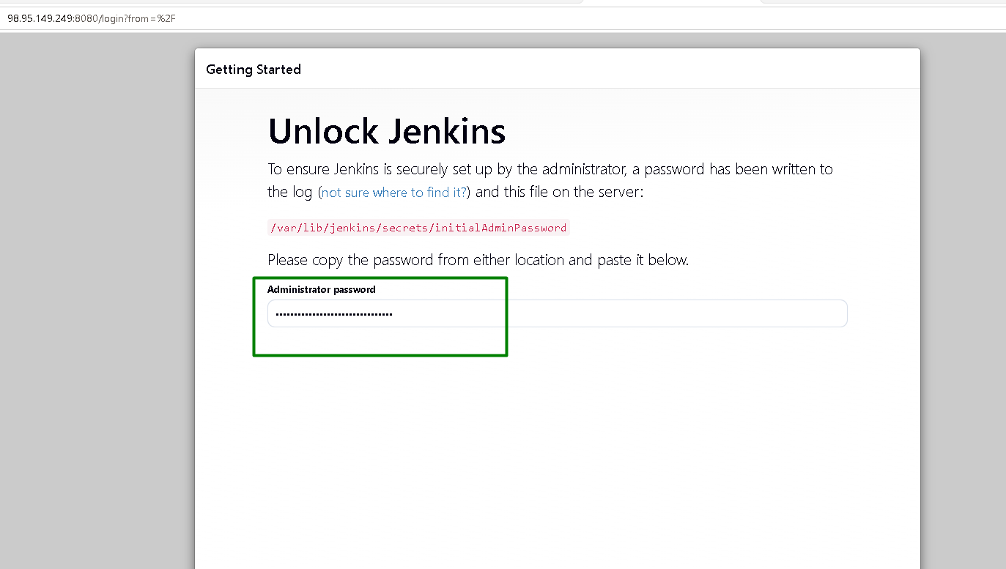
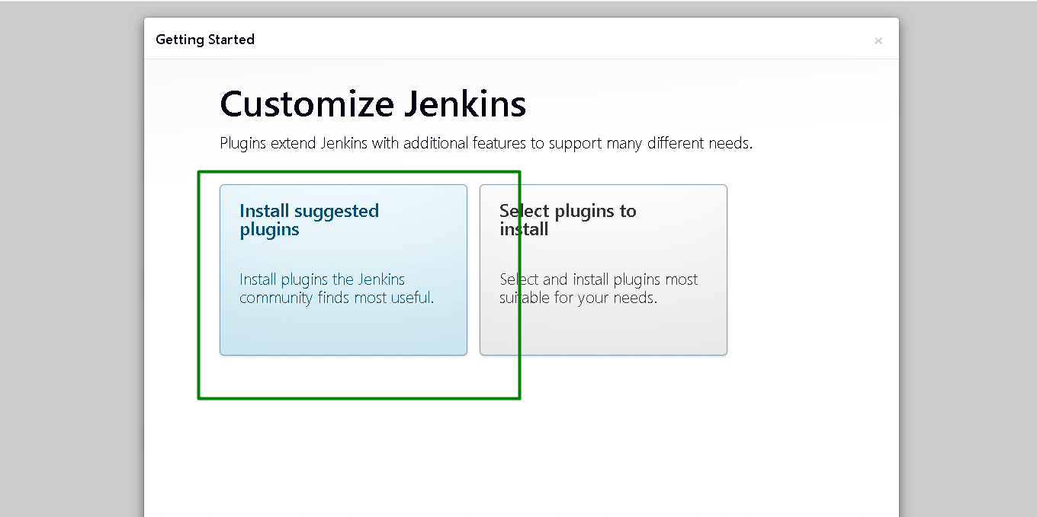
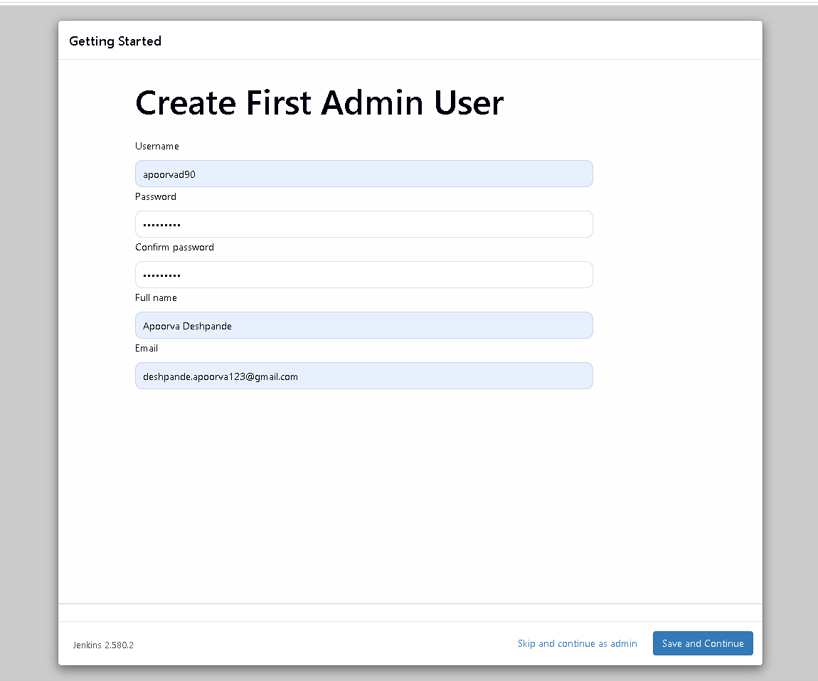
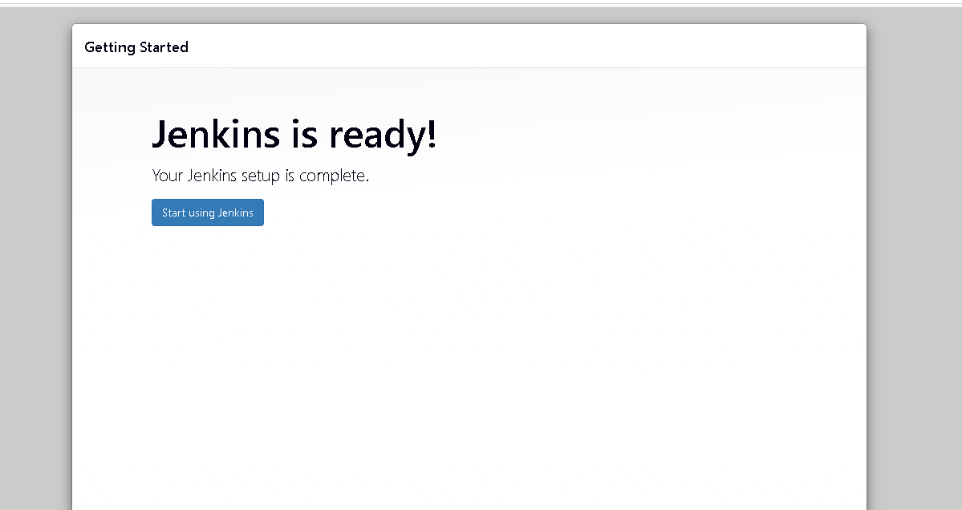
Setup Wizard - Jenkins

Manage plugins
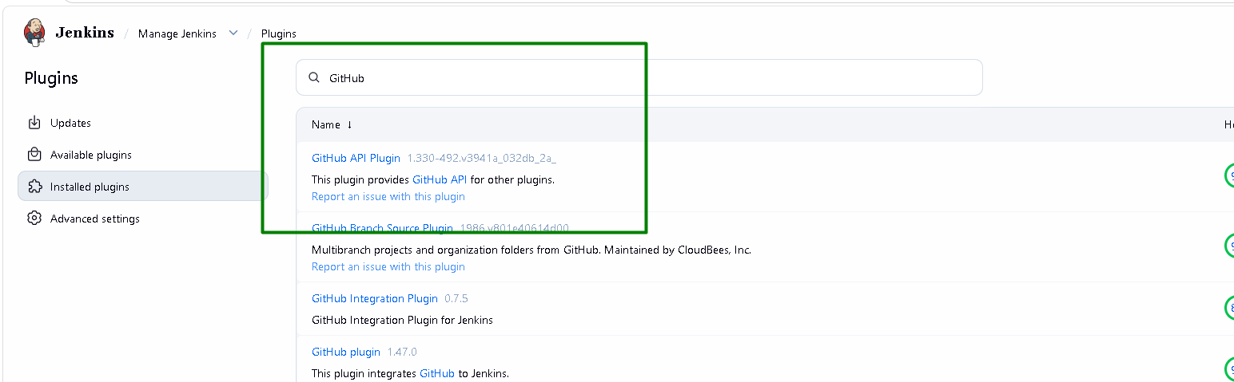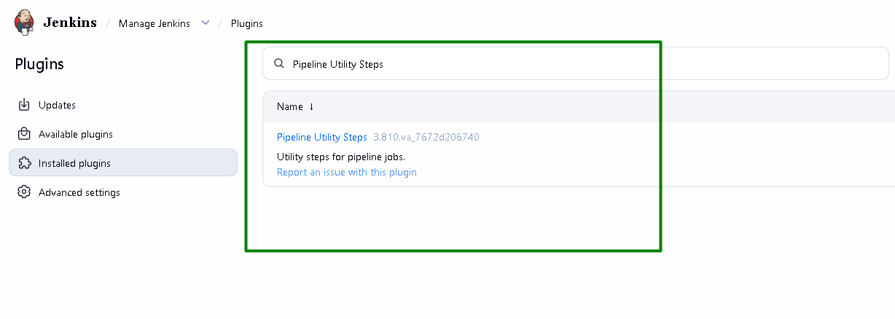
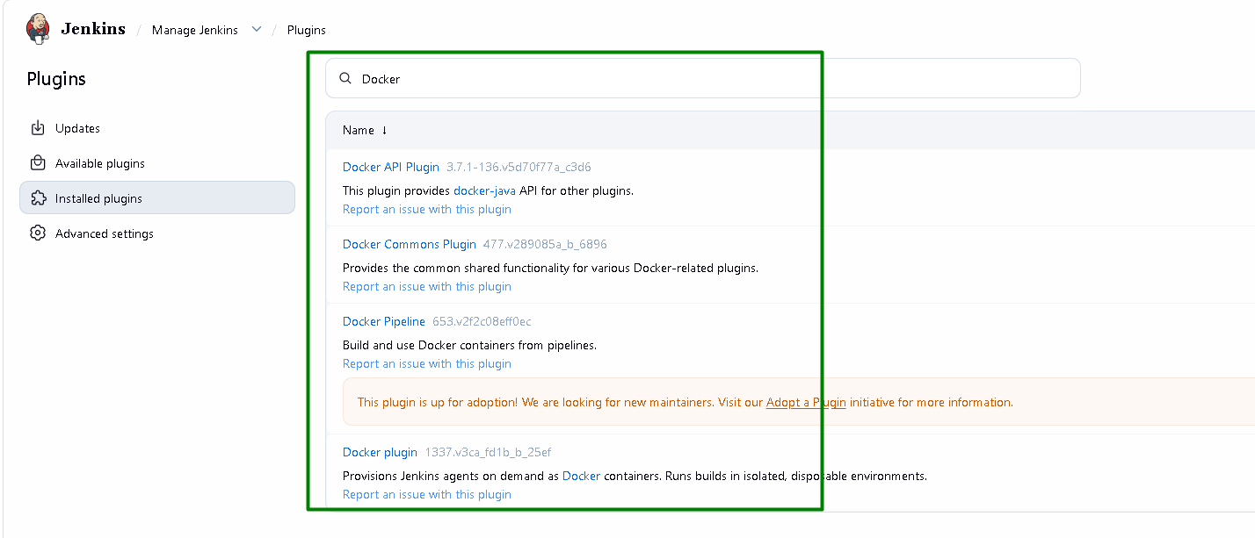
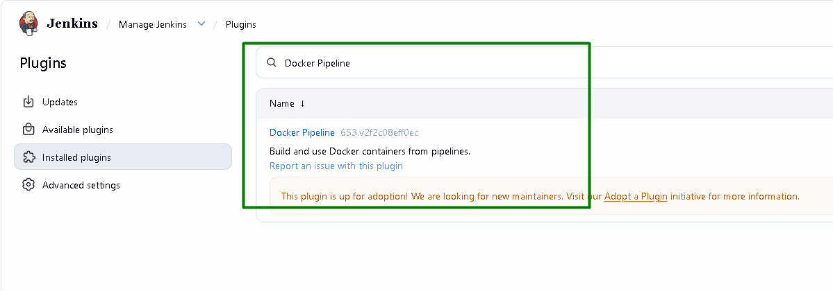
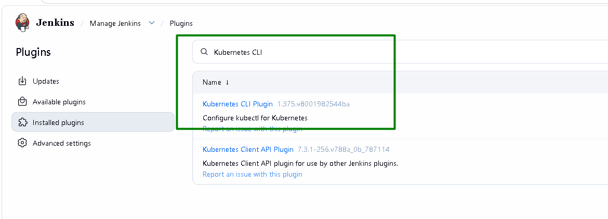
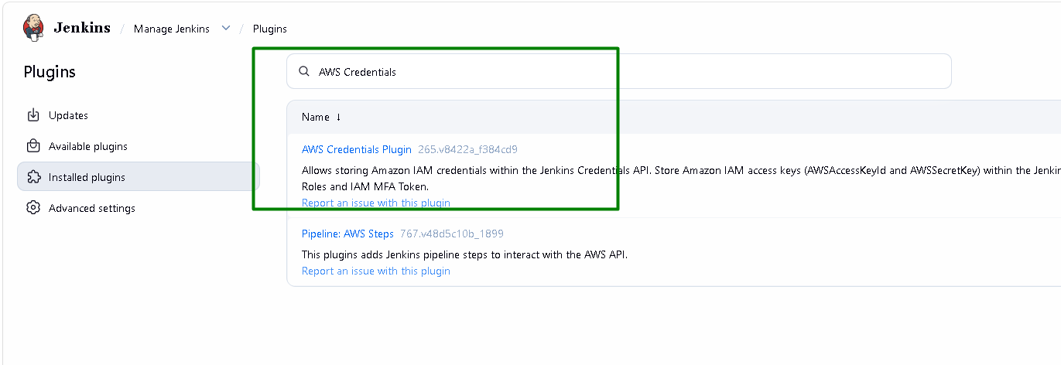
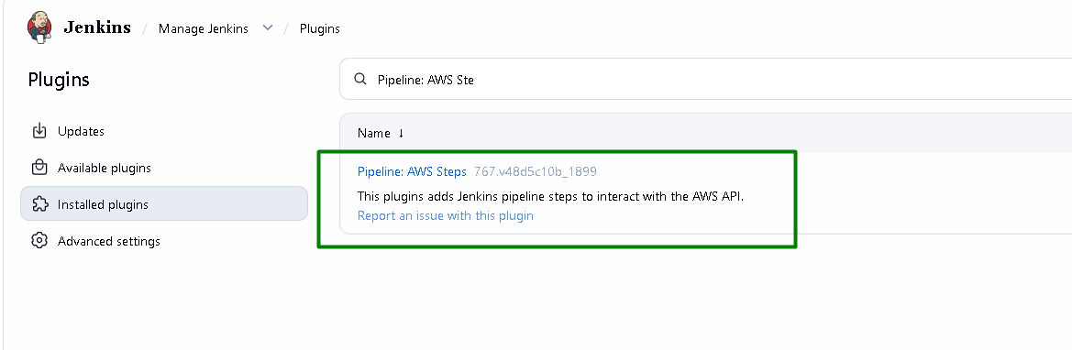
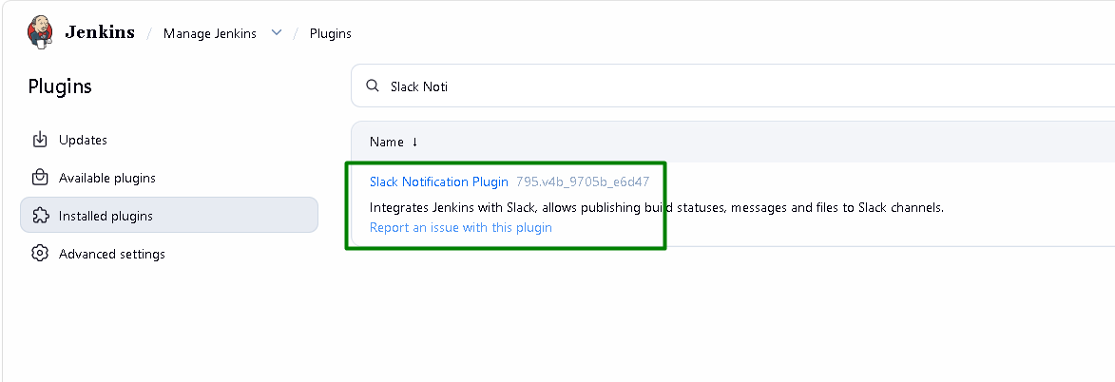
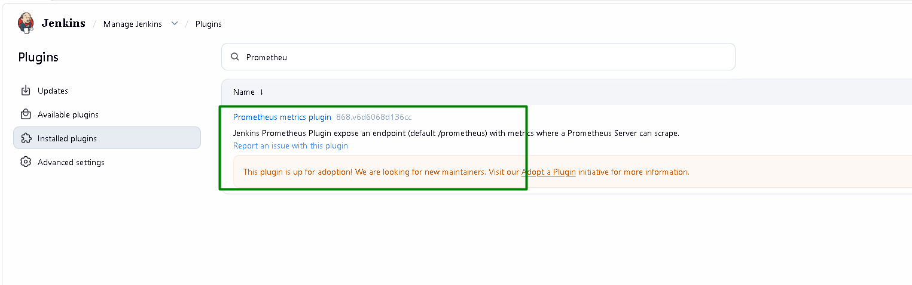

Slack Integration

Create a new workspace:
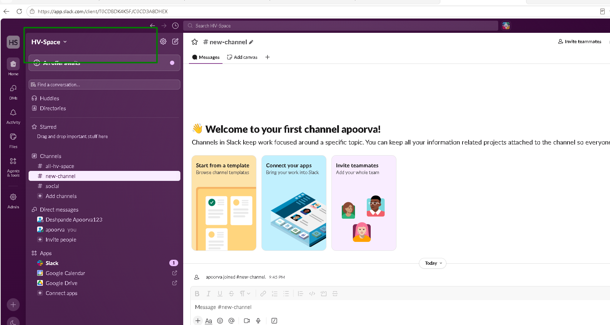

Create a channel named devops-alerts
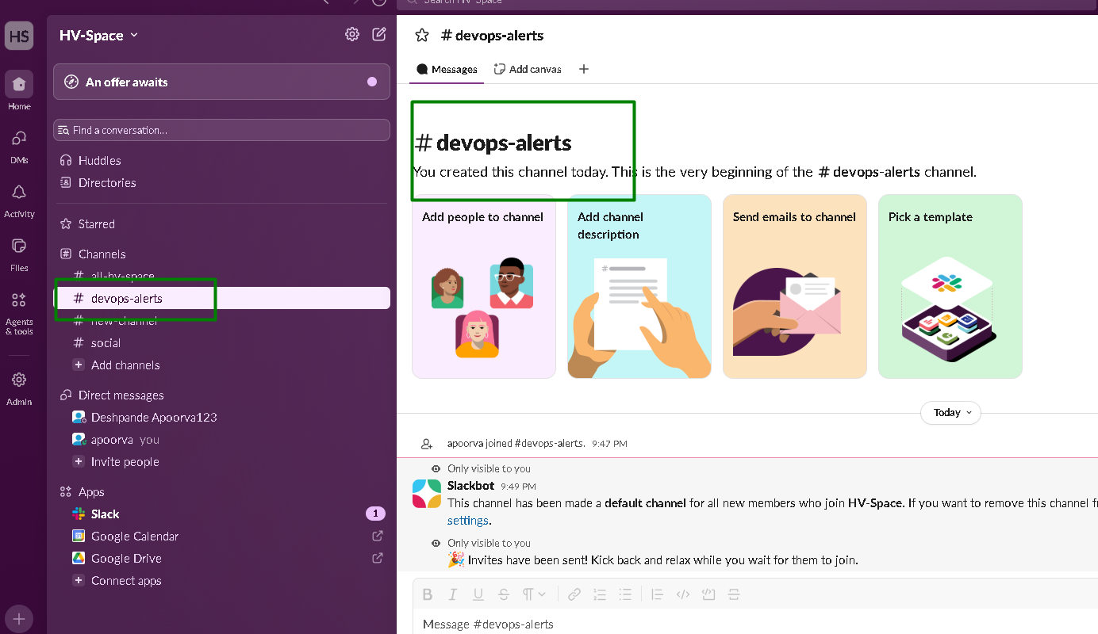

Create a new app
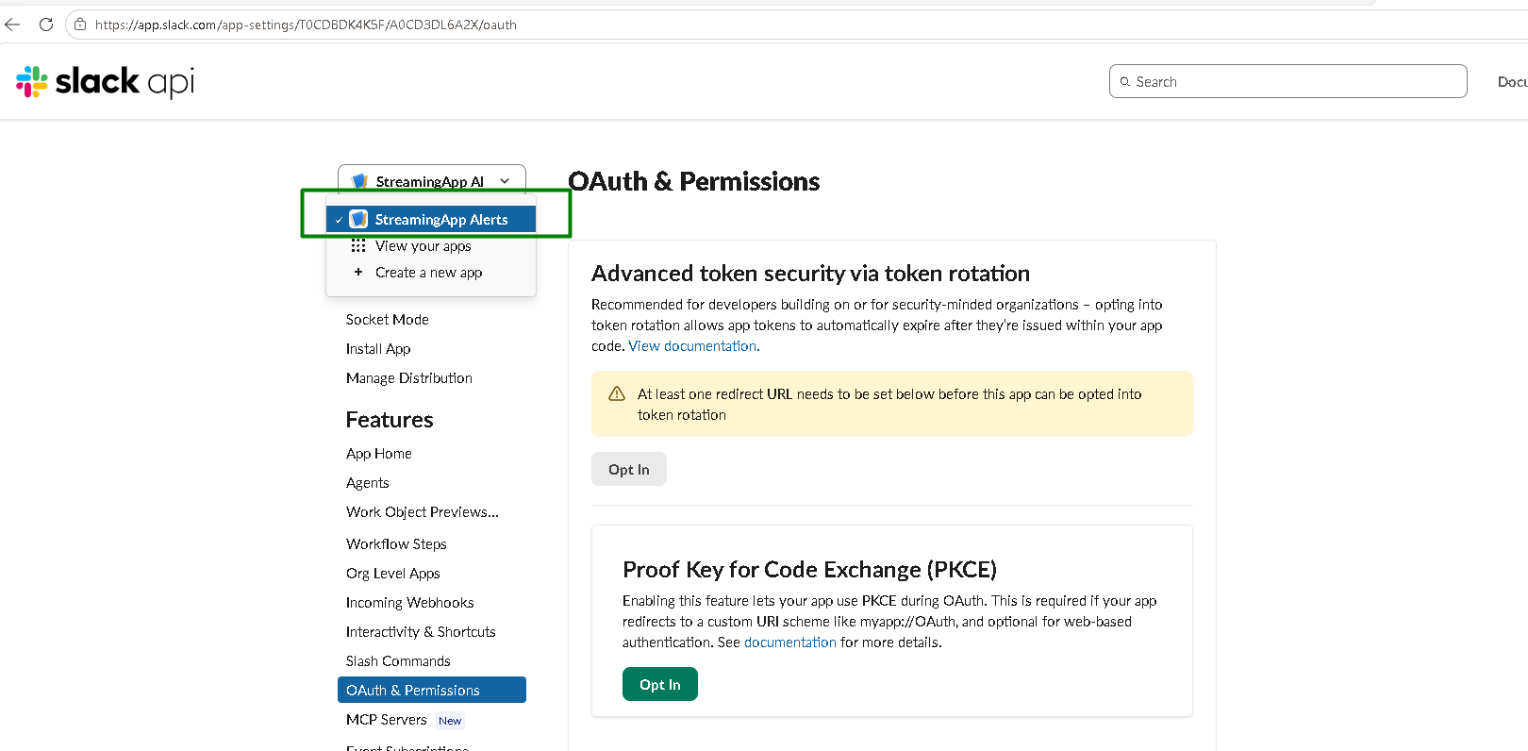

Add chat:write scope:
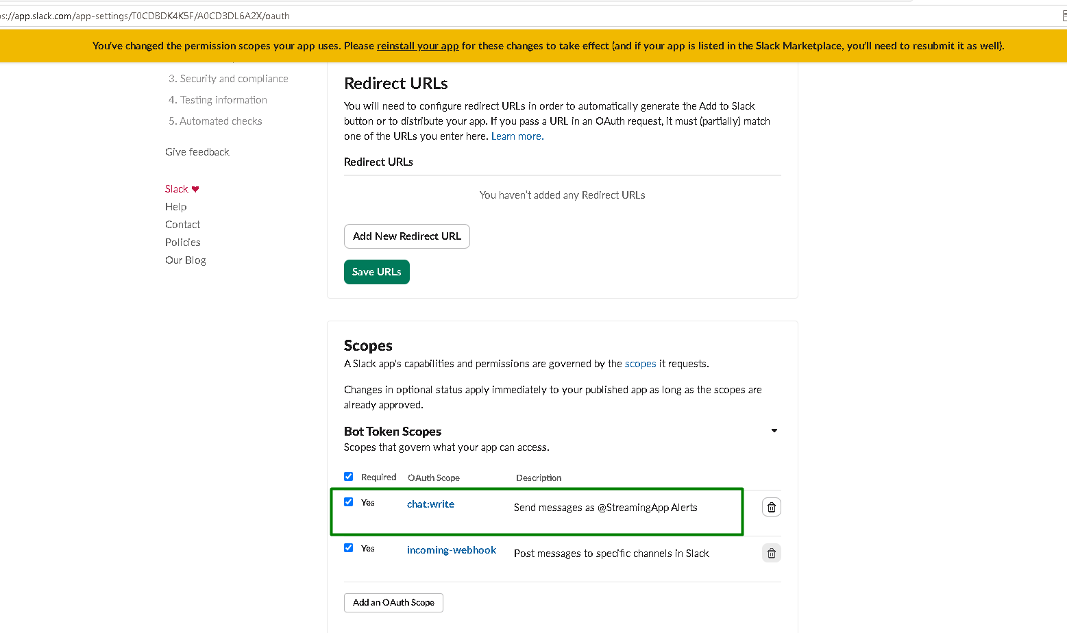

Add StreamingApp Alerts to the Slack channel:
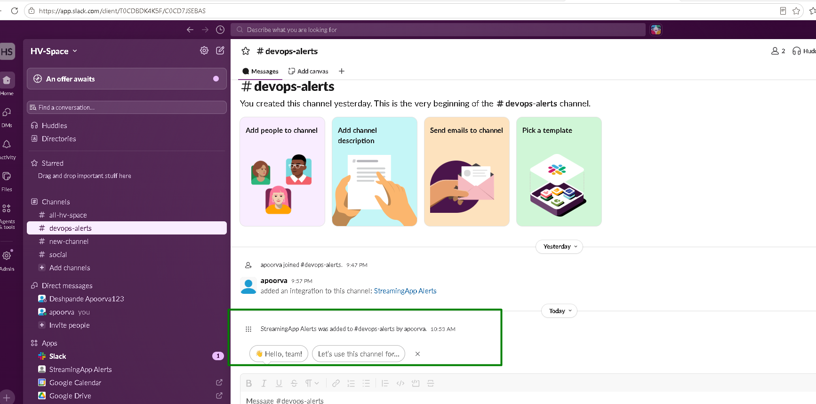

Add required Credentials to Jenkins:
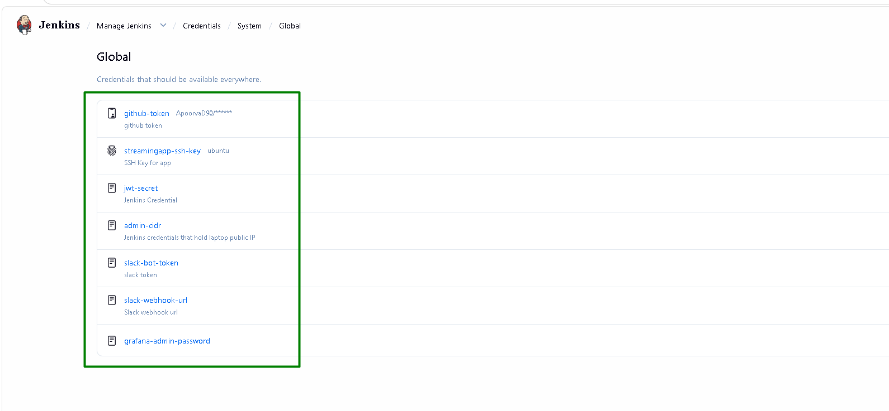

Configure Slack in Jenkins:
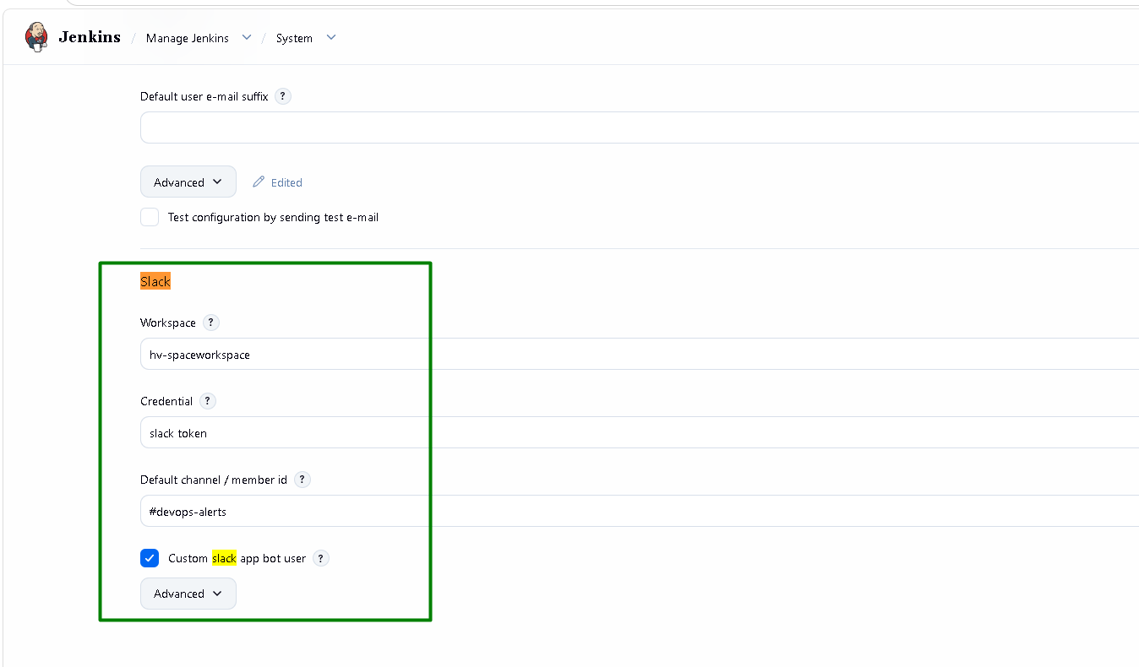
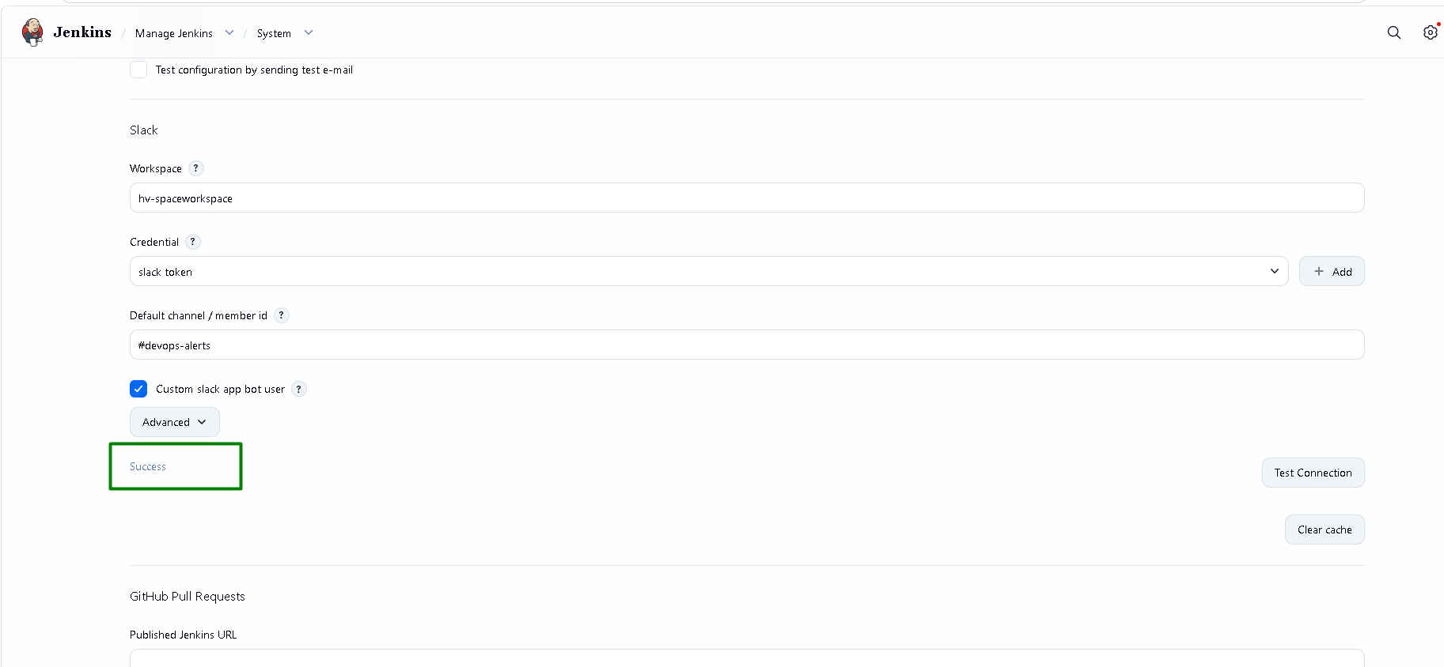

Test message appears in devops-alerts channel:
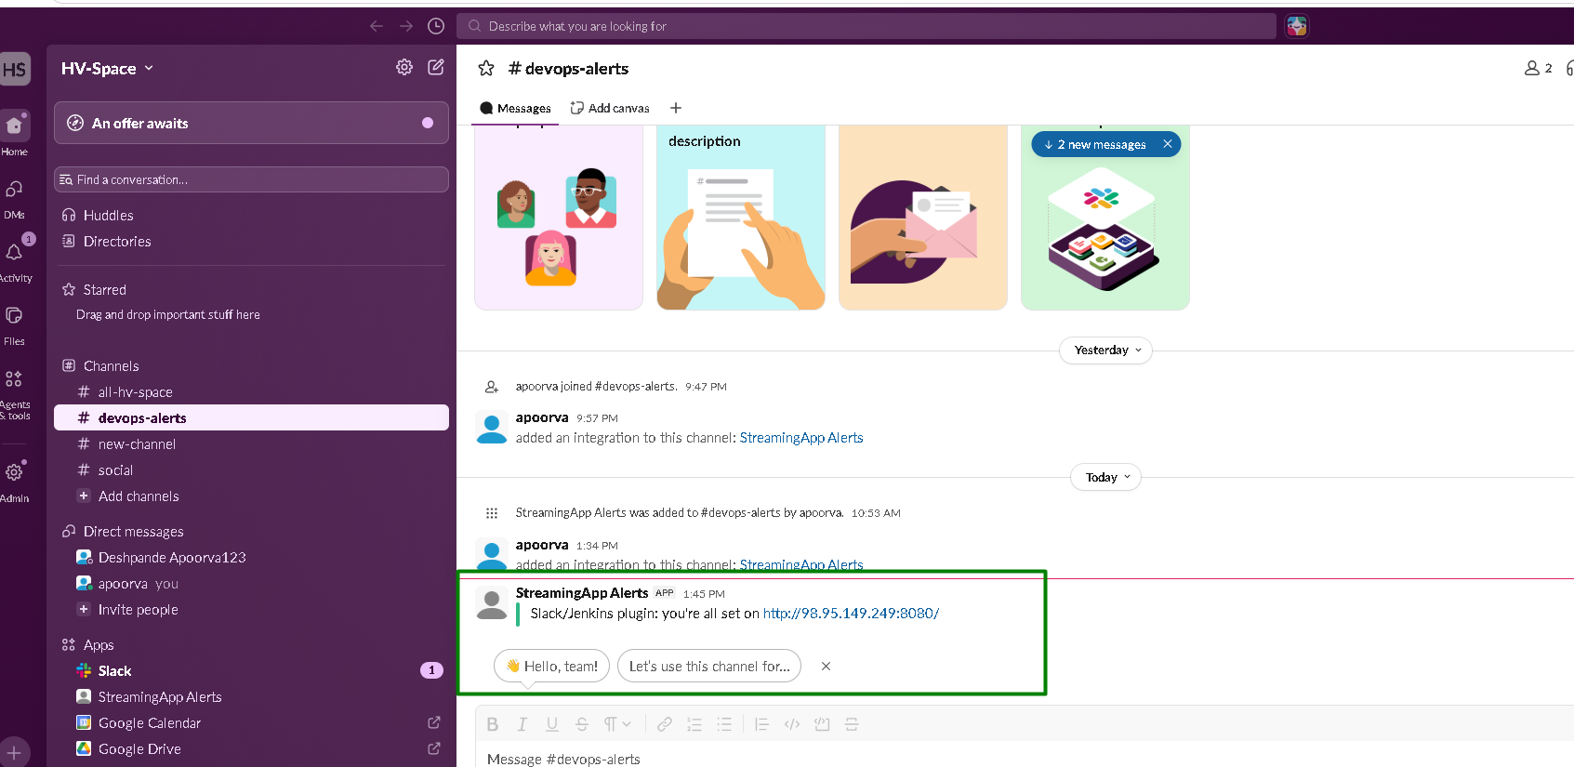

Terraform Job
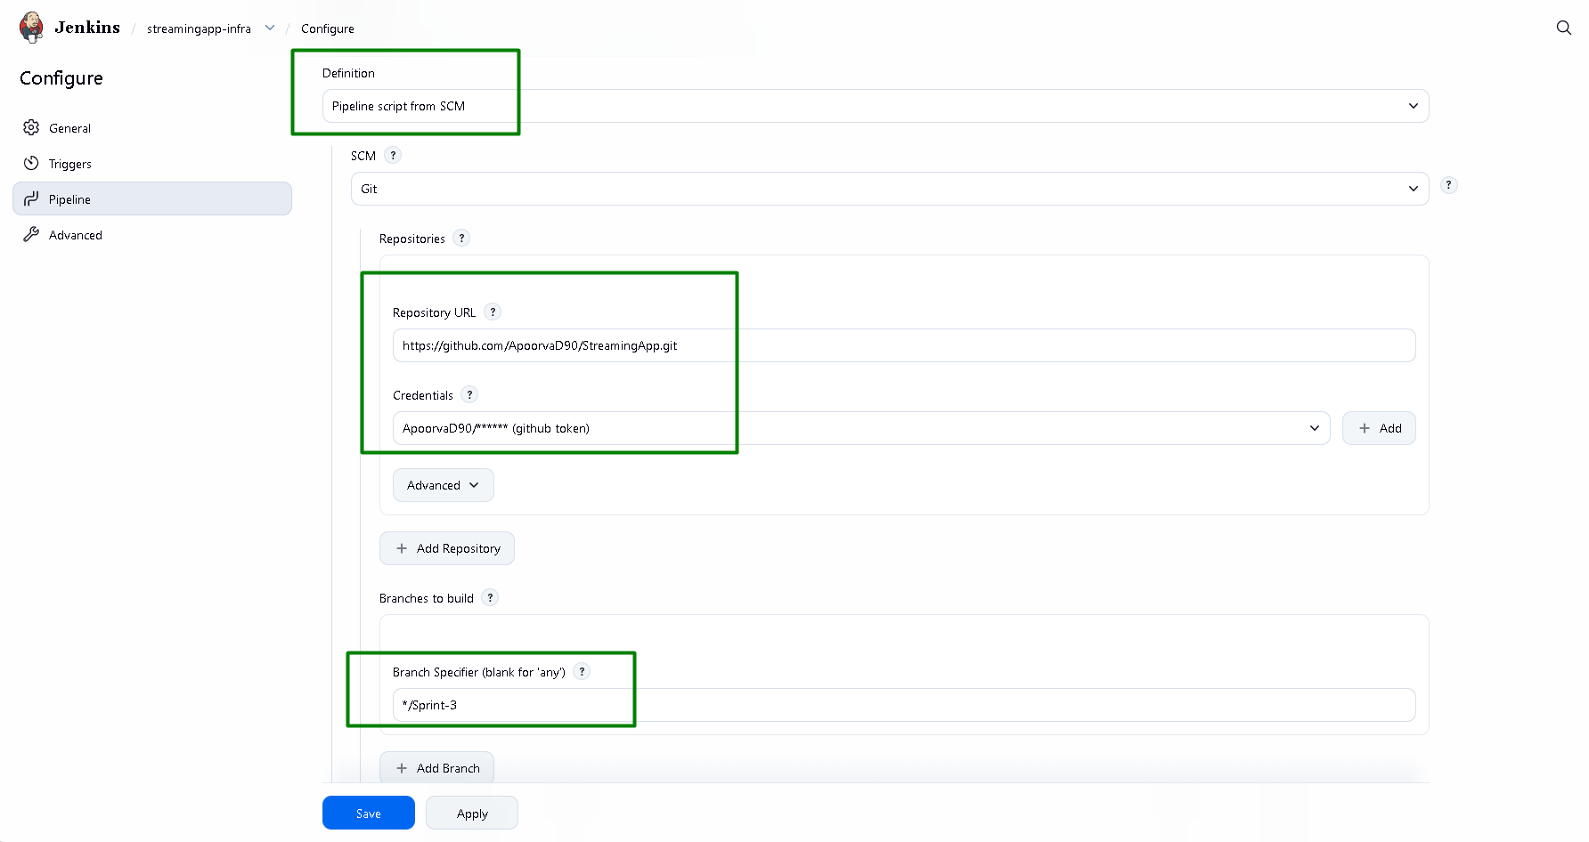

Ansible Job:
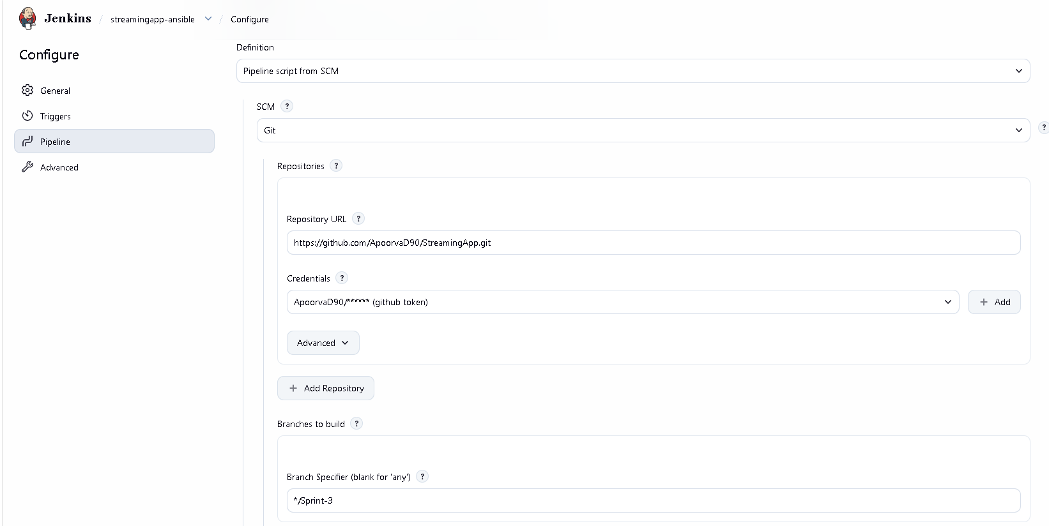
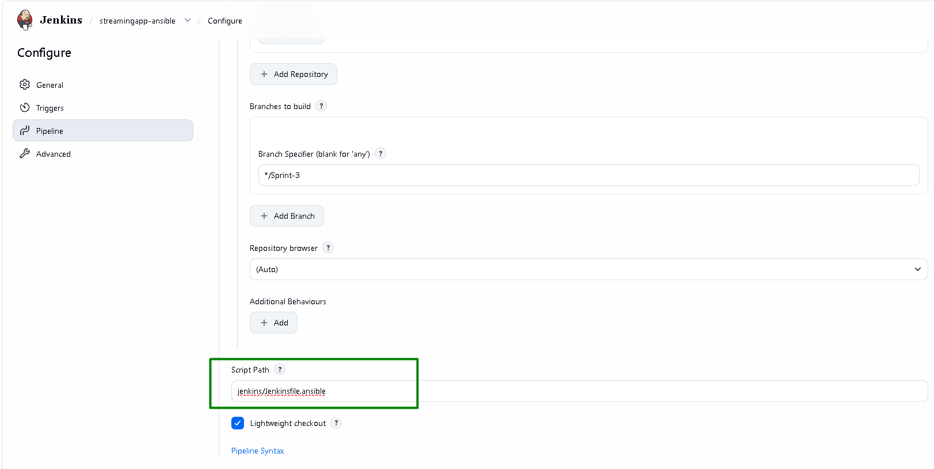

App job:
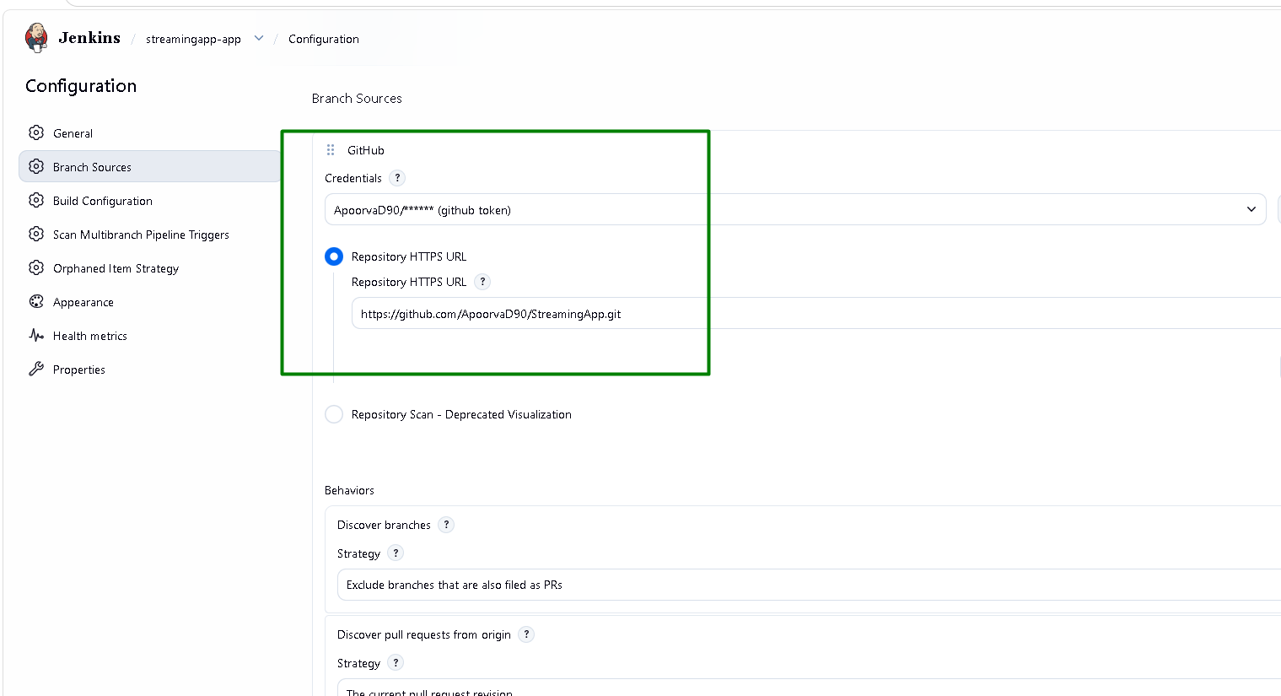
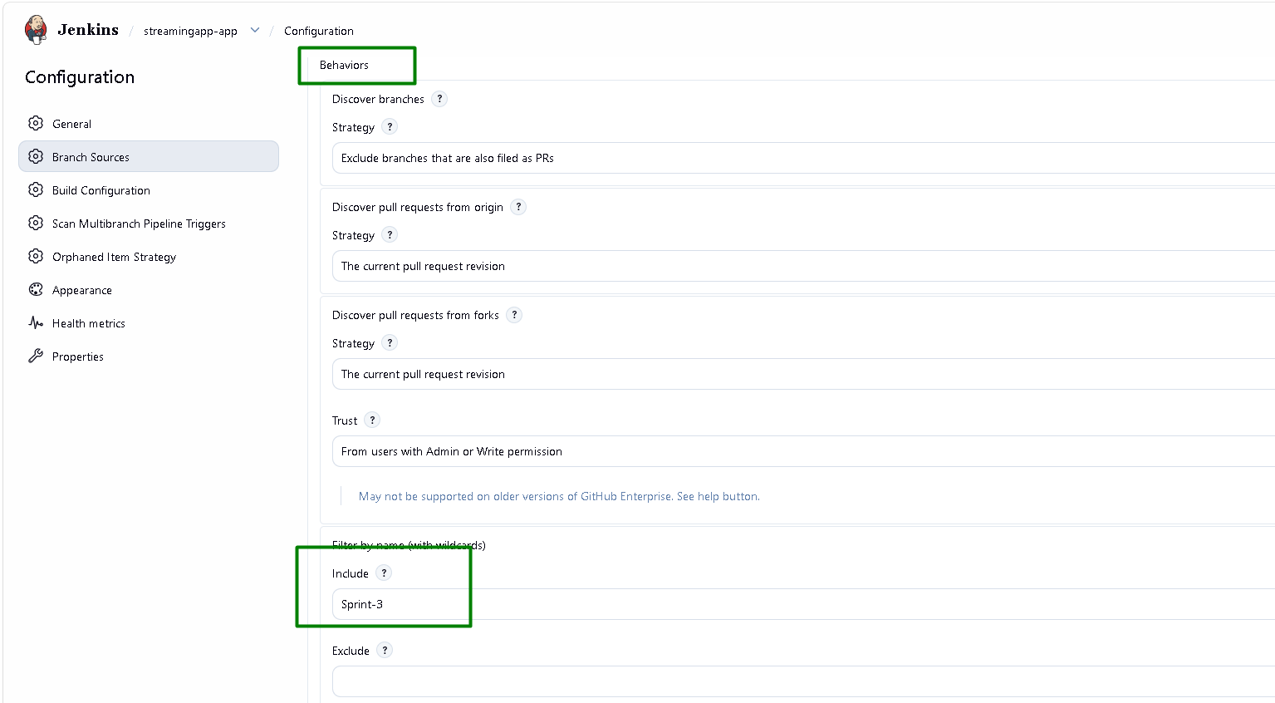
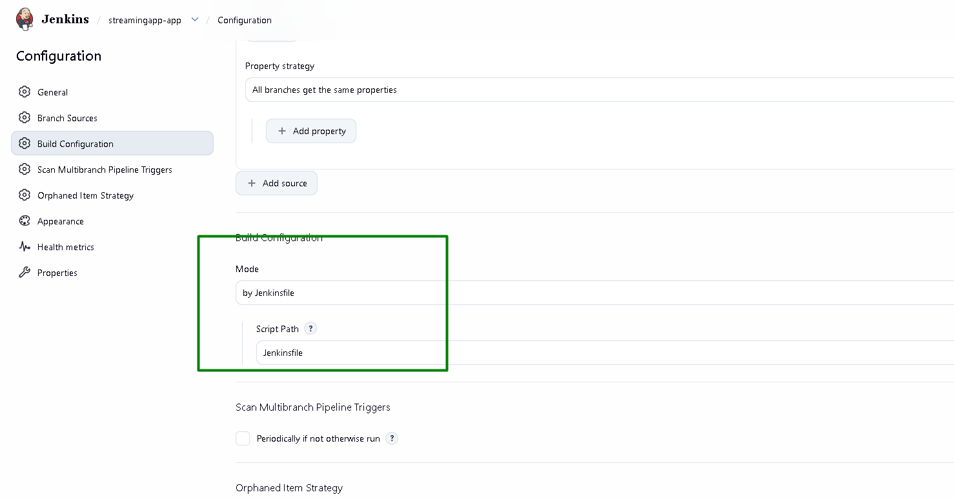

GitHub Webhook:
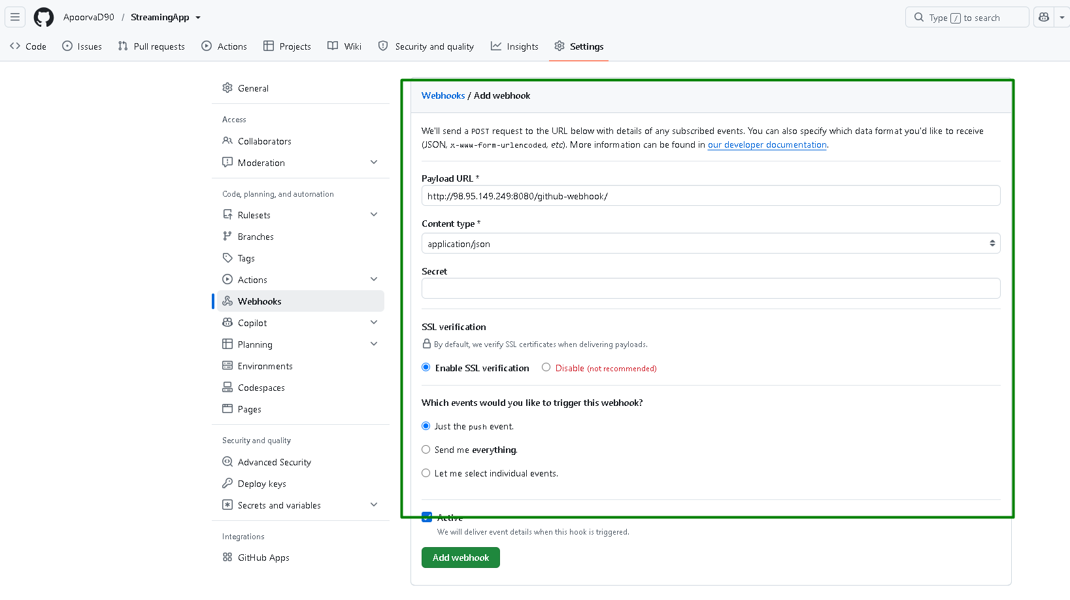
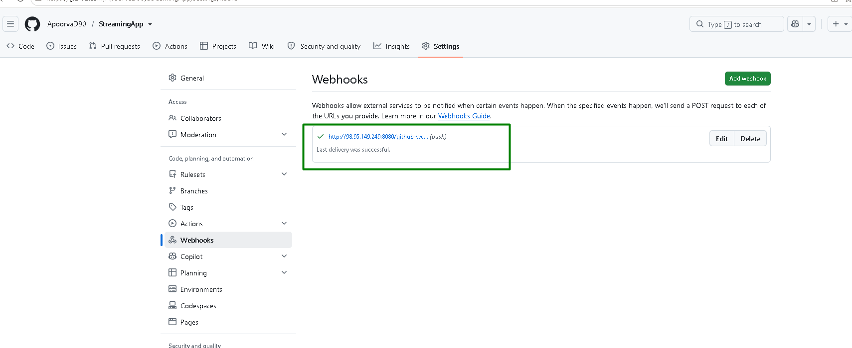

Run the pipeline chain:
Build streamingapp-infra using Build now option in Jenkins. That will run the plan
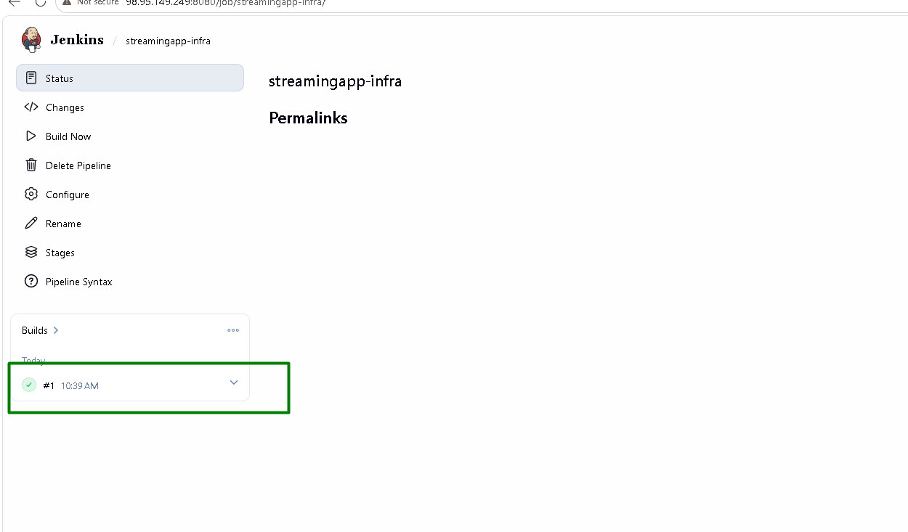
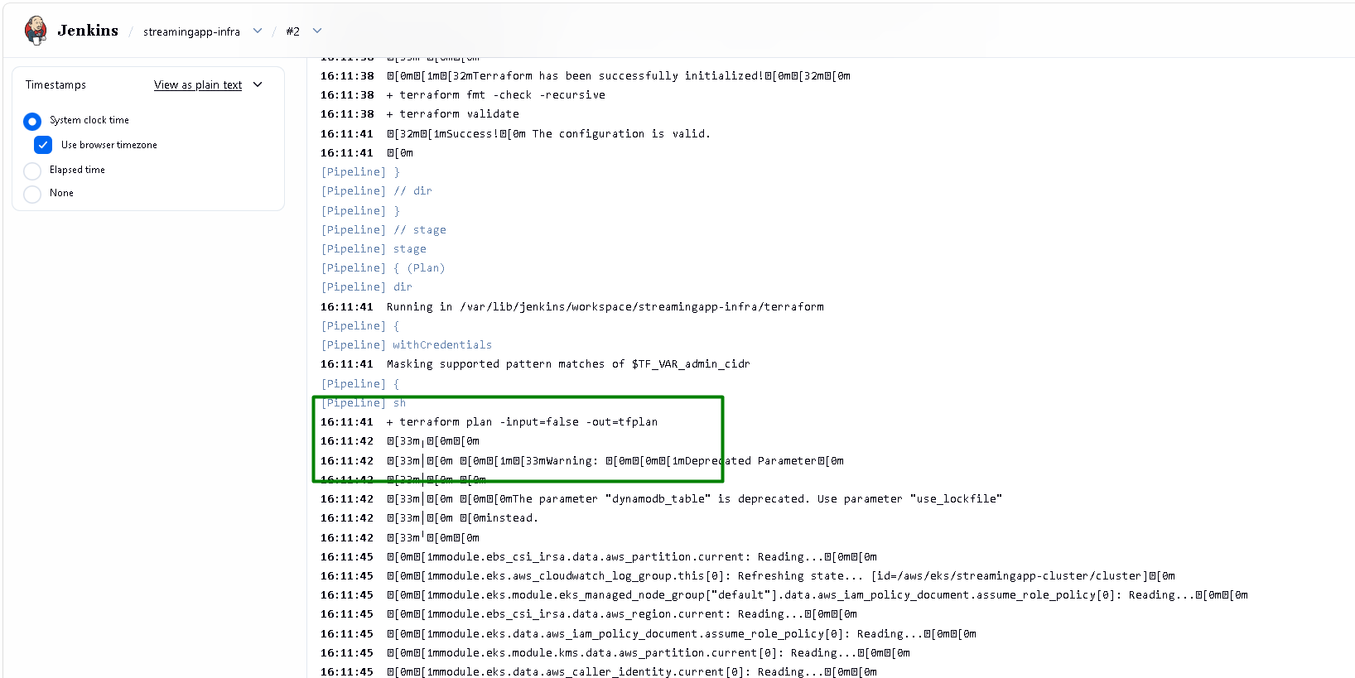

Next run with Action as Plan. It should say “No changes. Your infrastructure matches the configuration”:
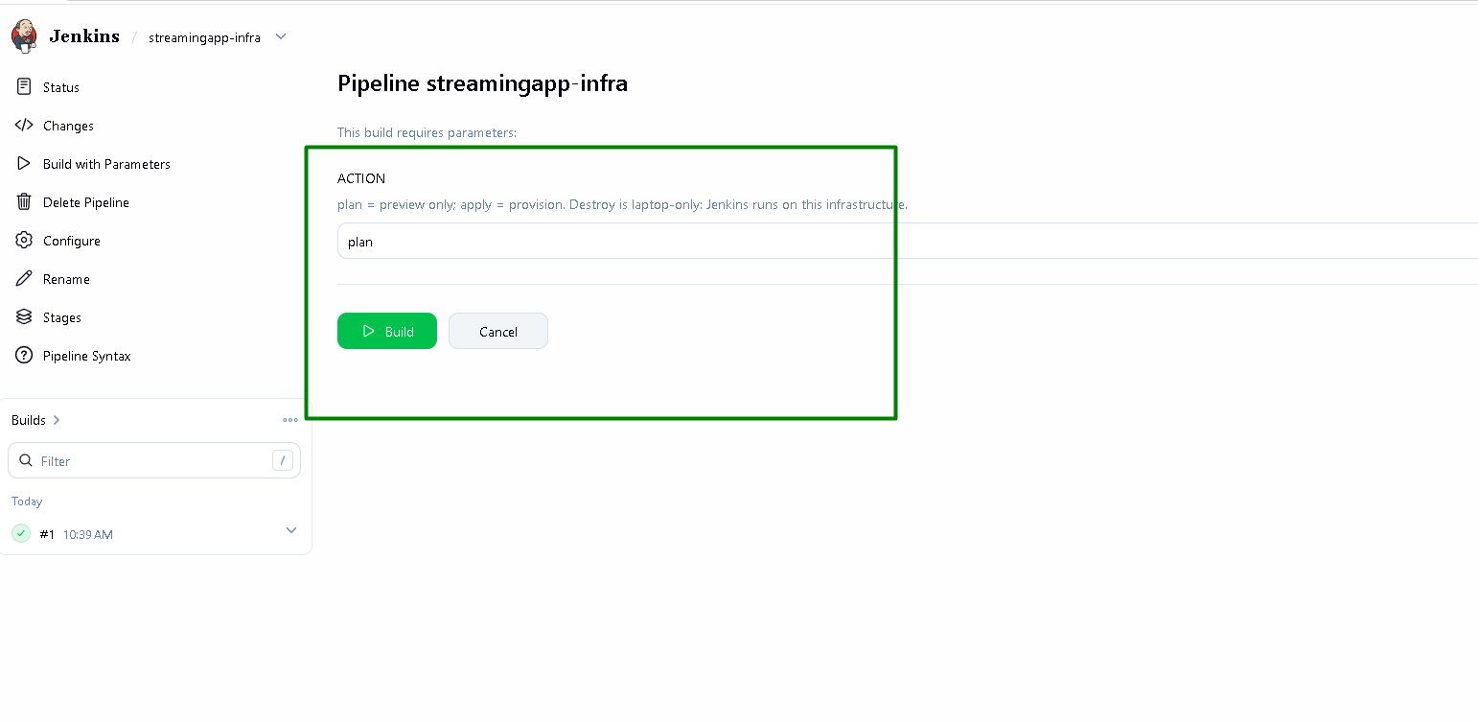
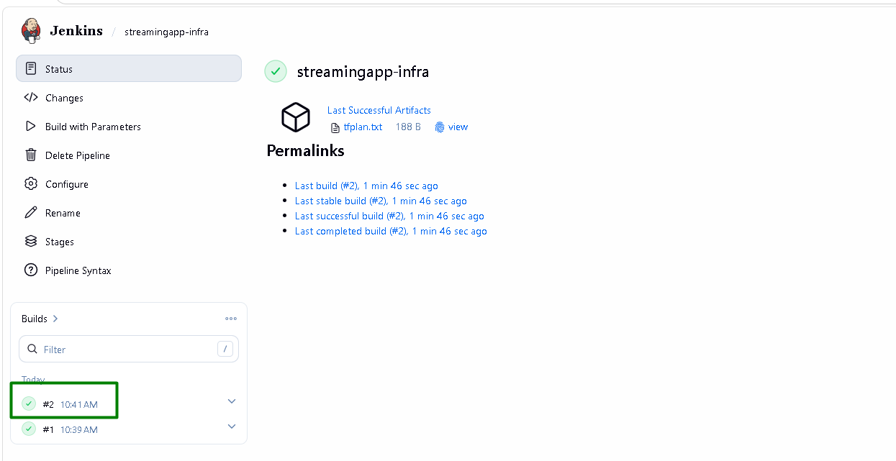
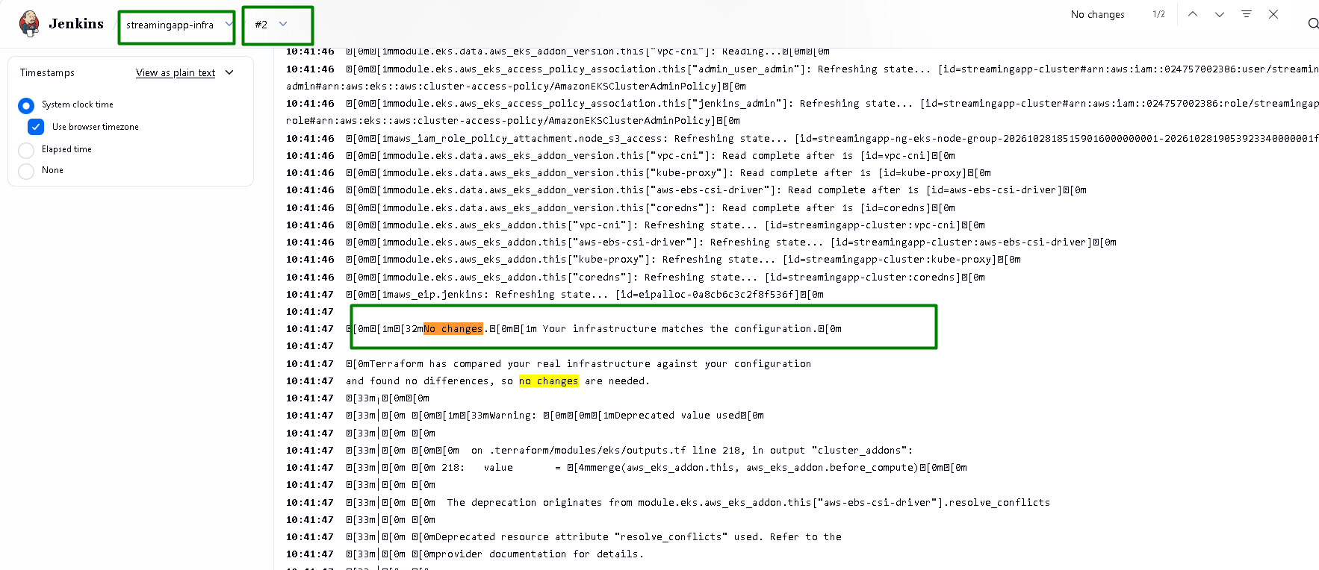
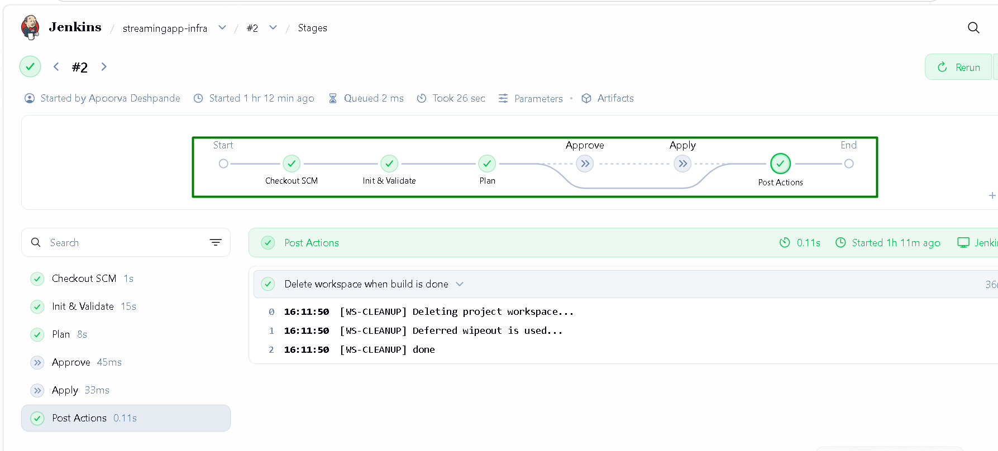

Next run with Action as apply:
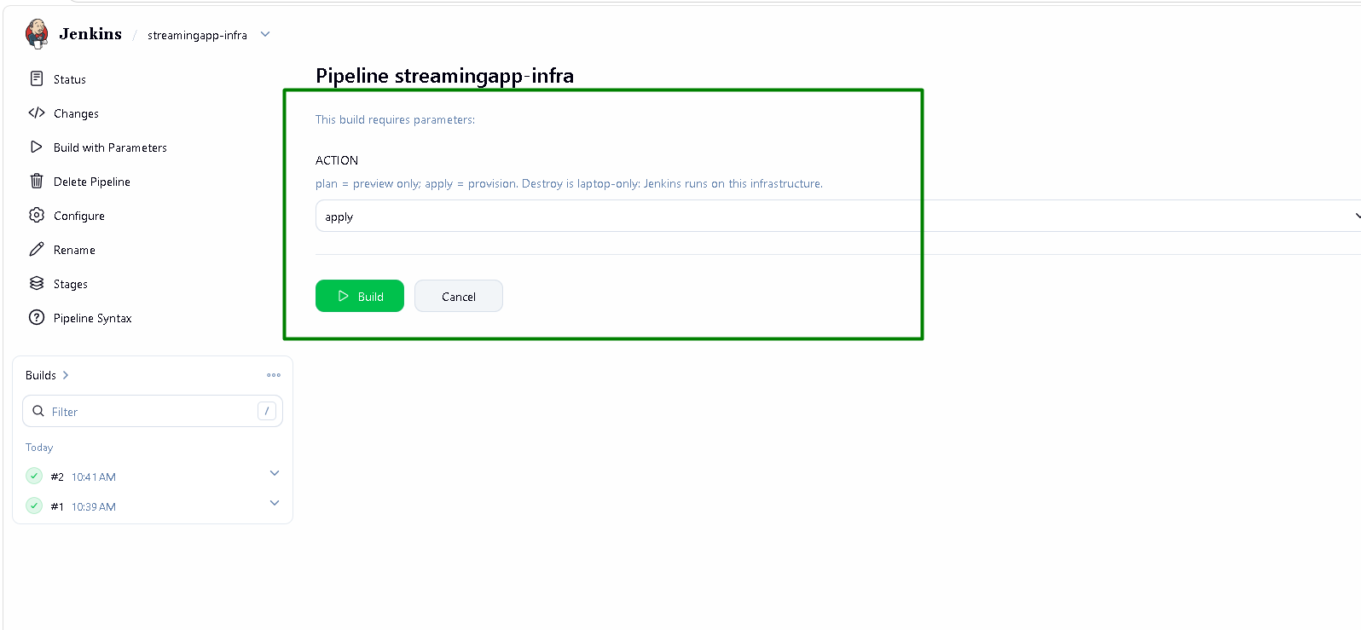
It pauses at approve stage:
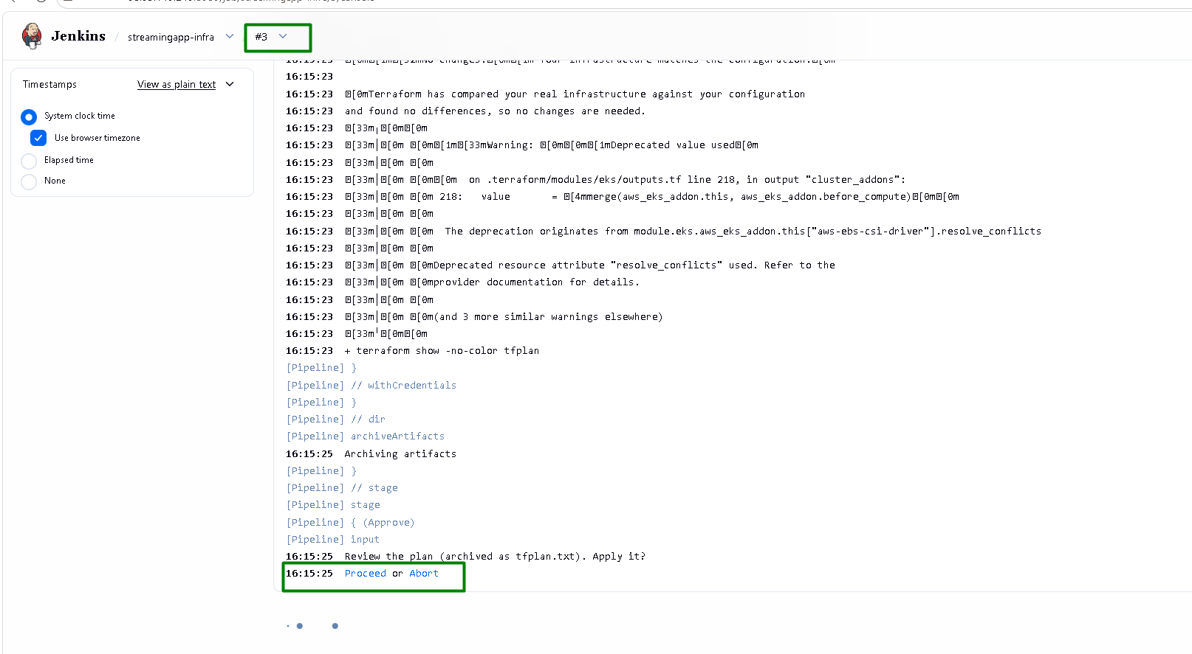
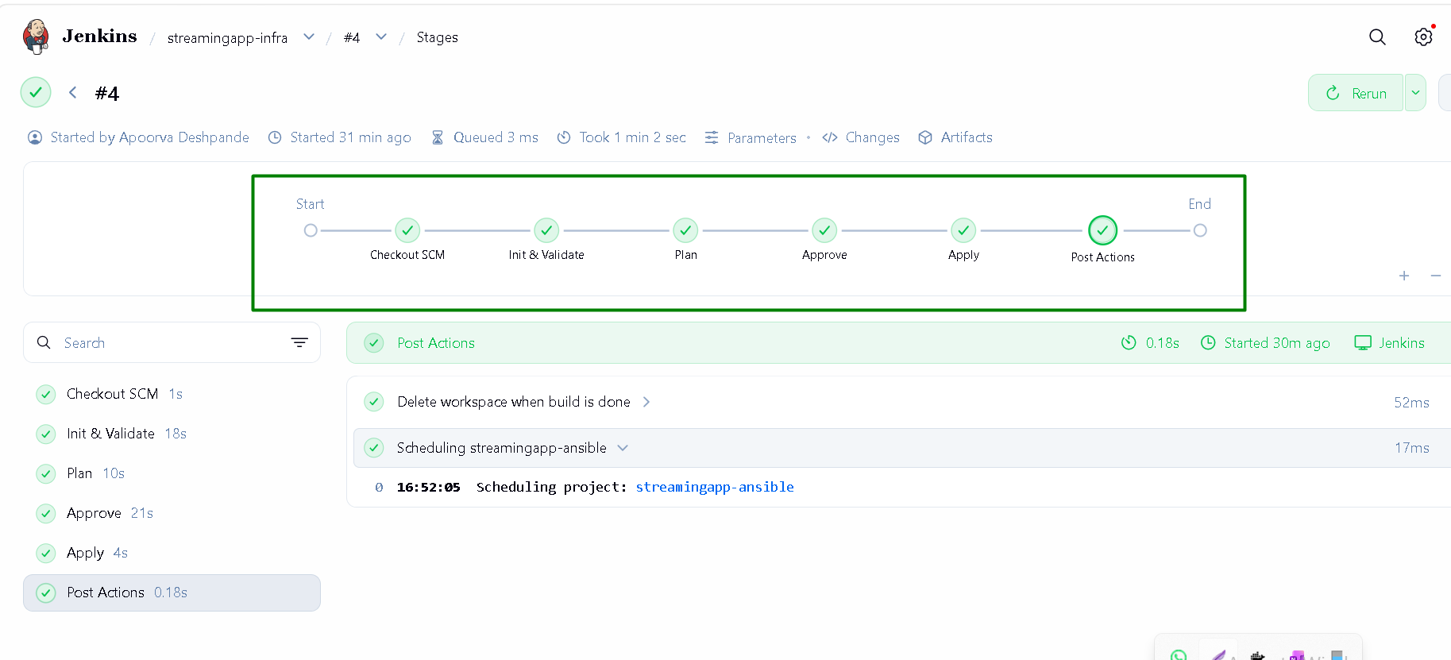

Once approved, it will proceed. Apply will complete successfully and ansible job will start automatically
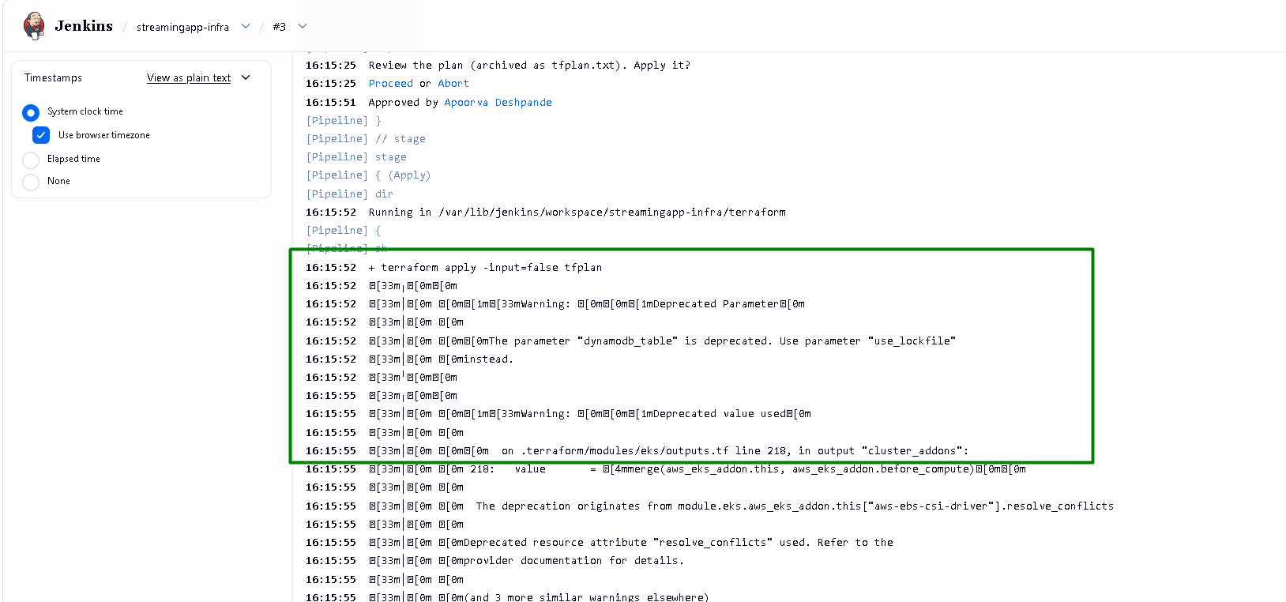
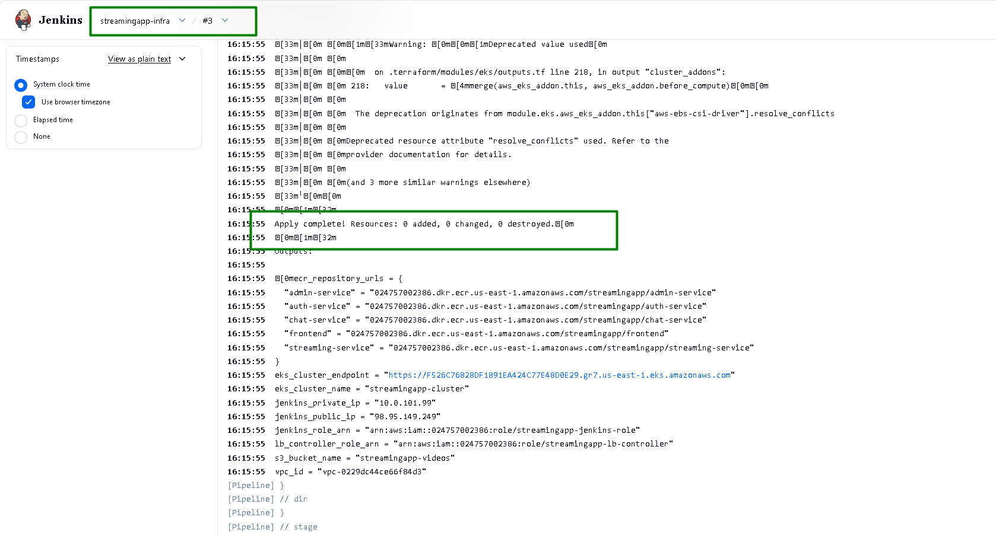
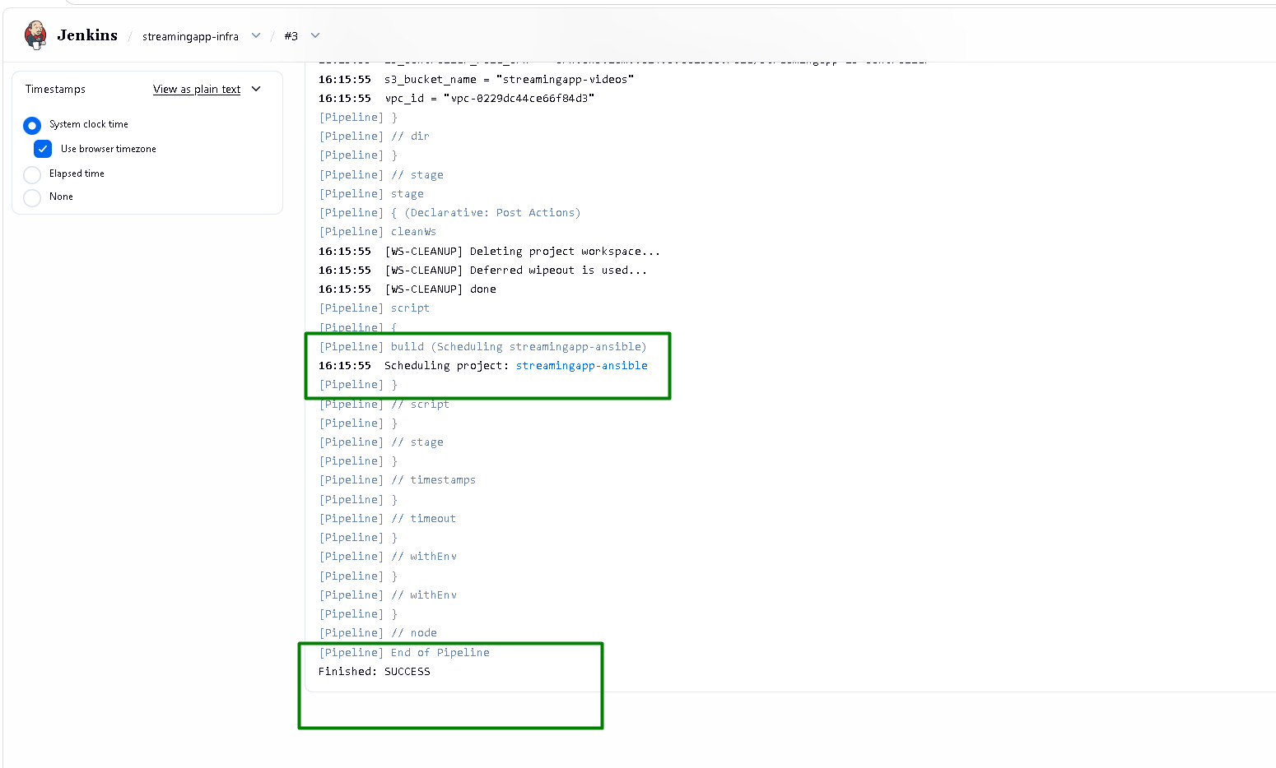
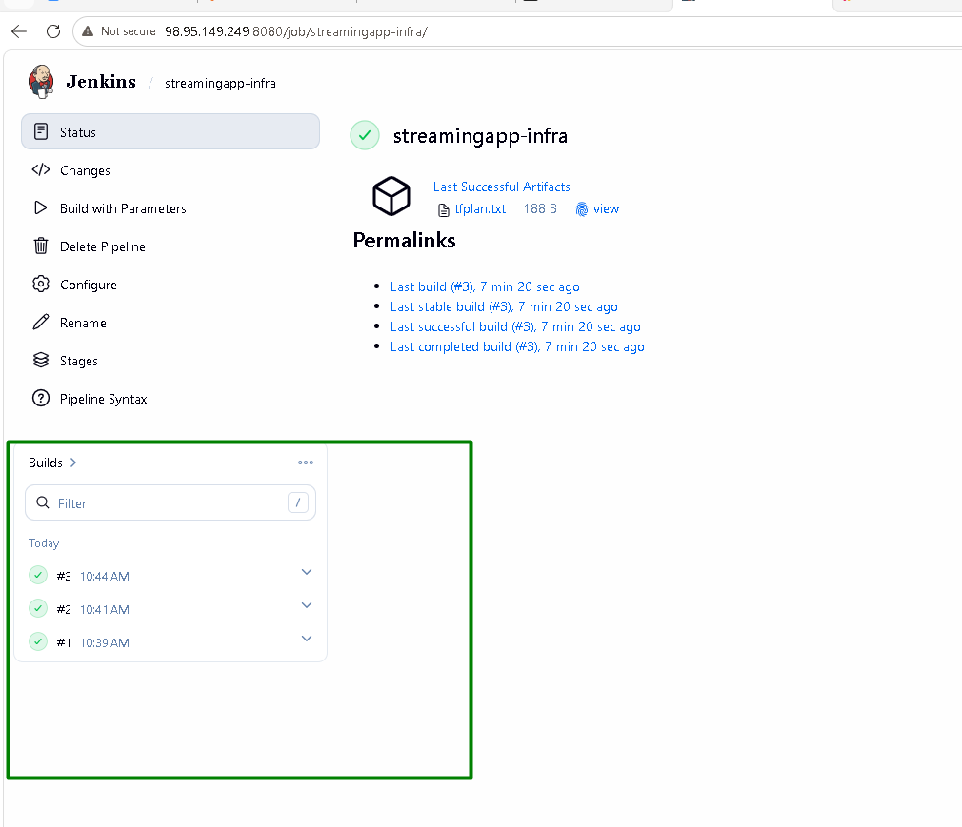
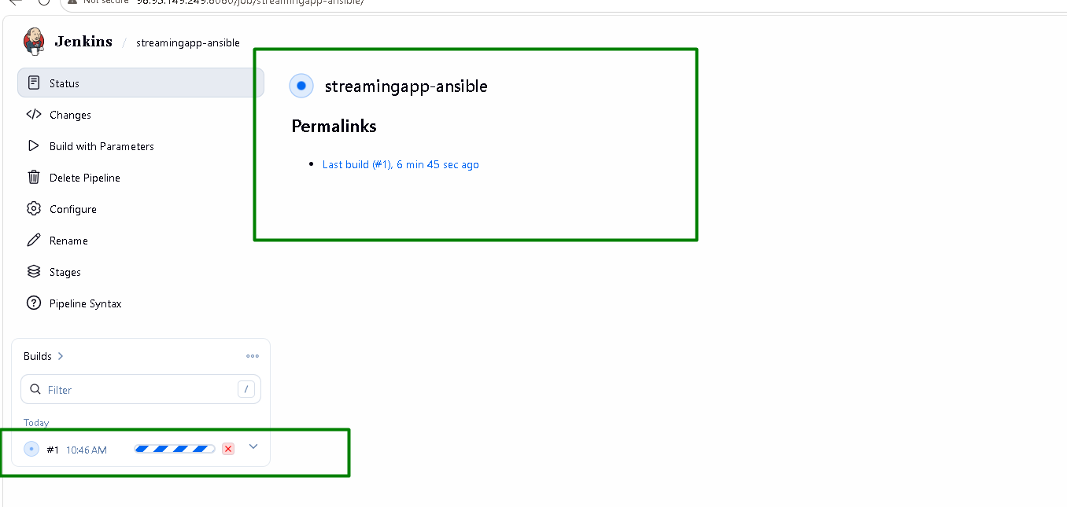
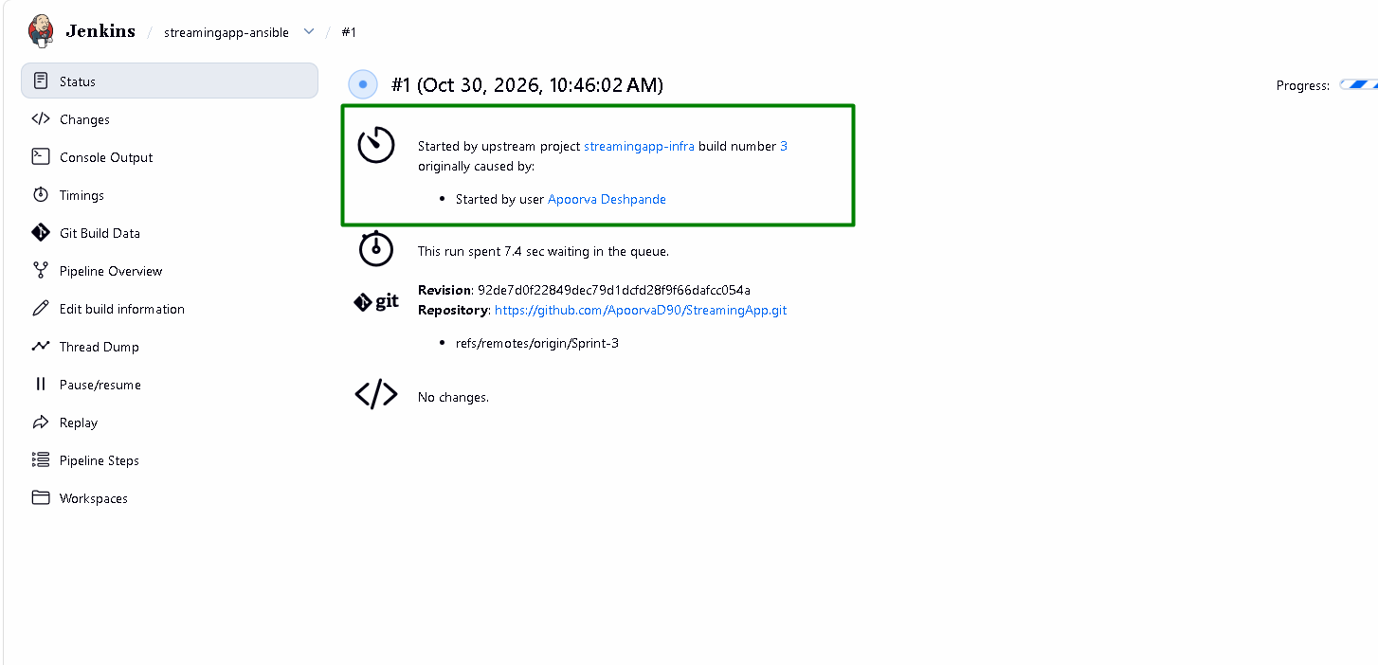

Ansible job starts. At the end of this job it also triggers, streamingapp-app job:
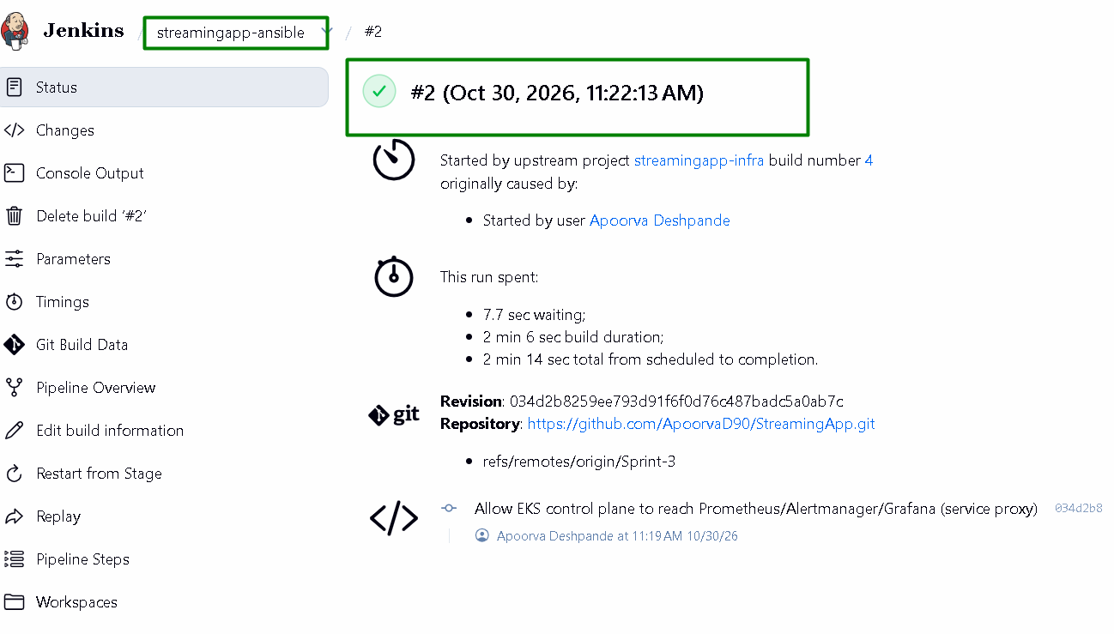
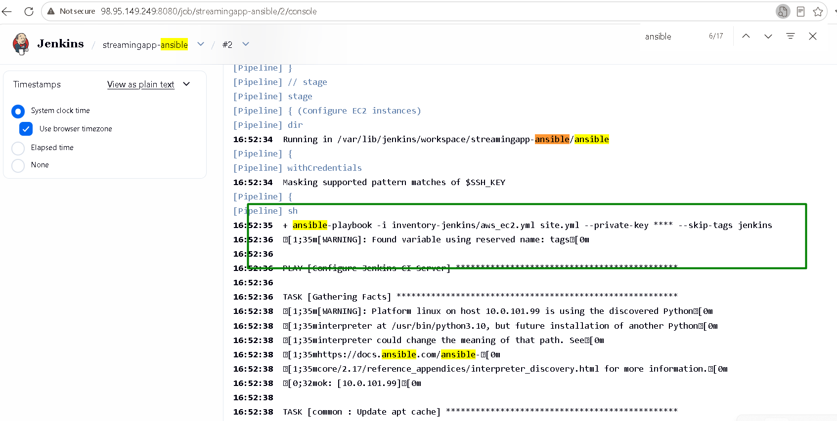
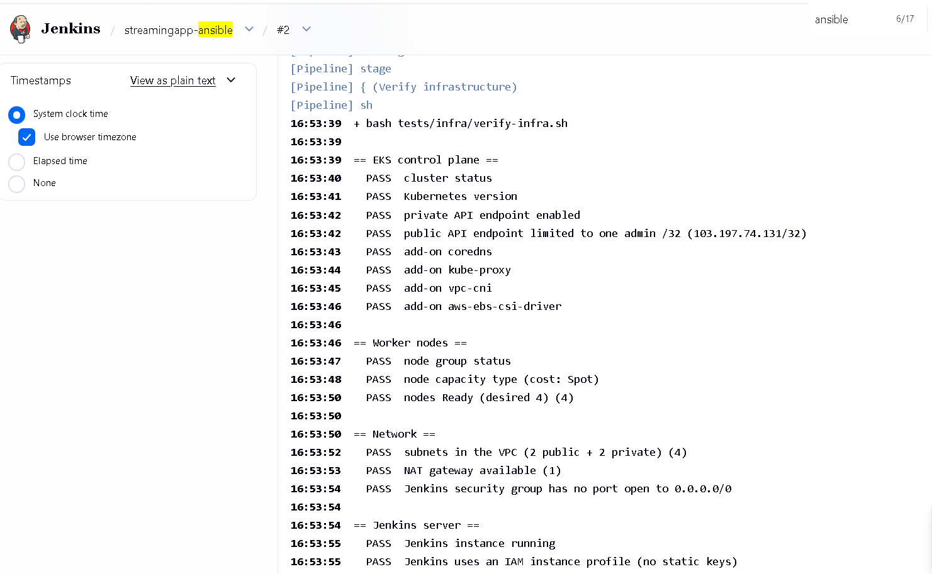
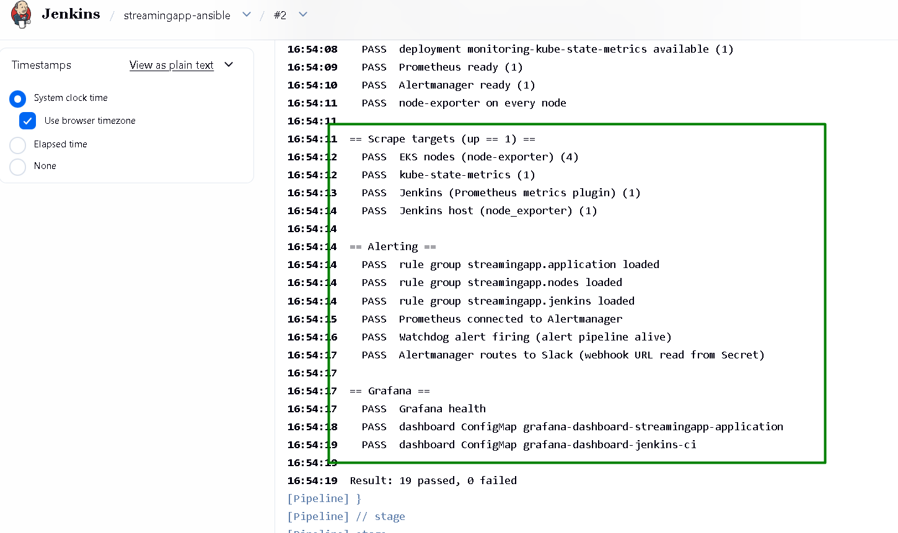
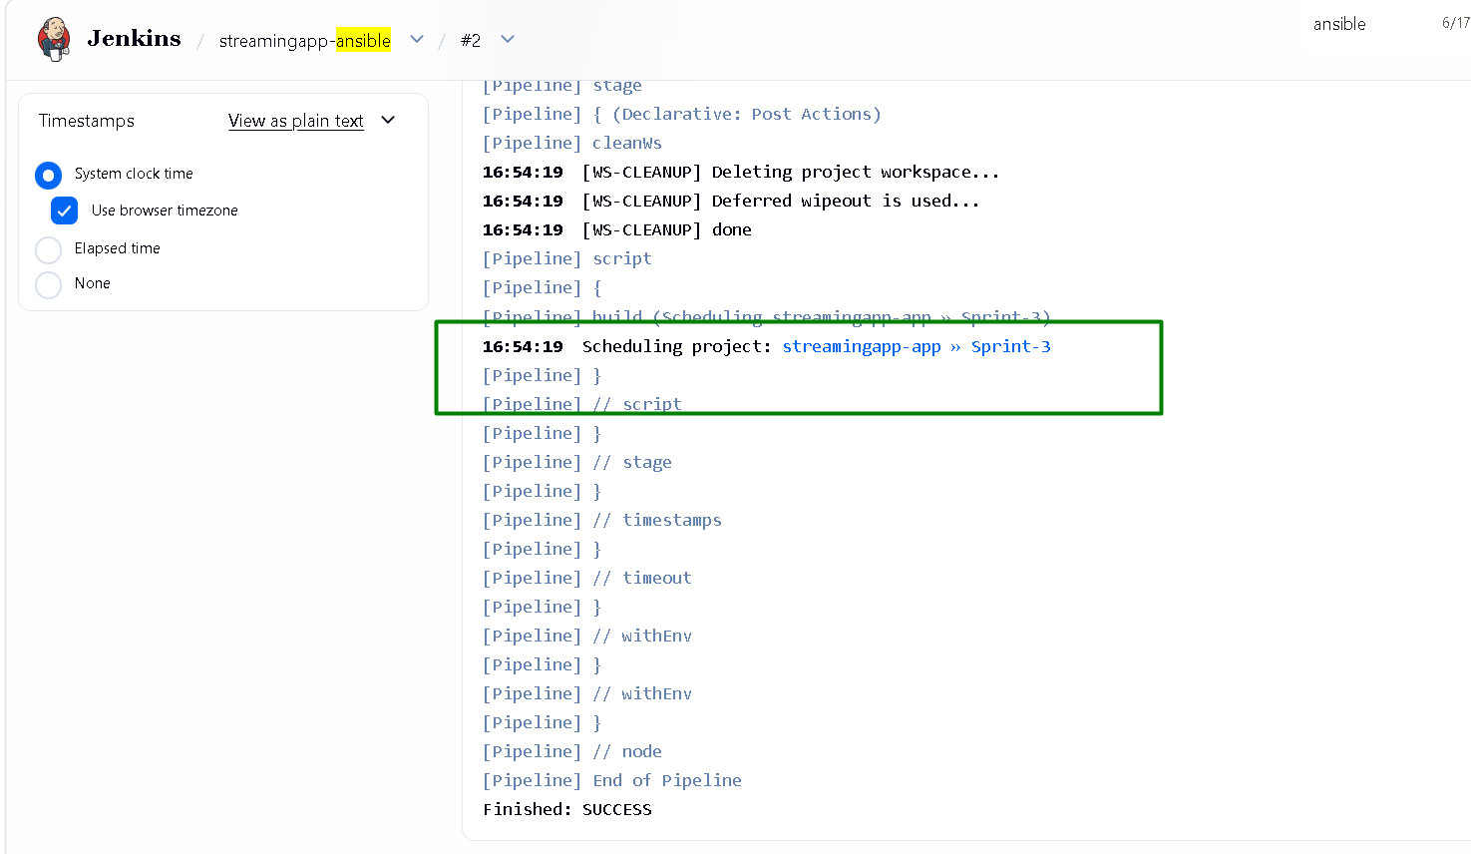
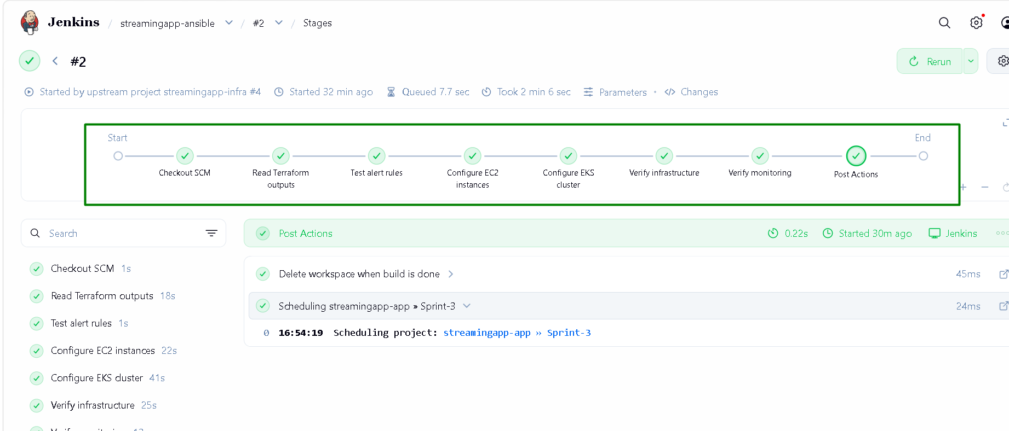

Streamingapp-app job started automatically after ansible job success. It is also triggered by any push made to the Git branch:
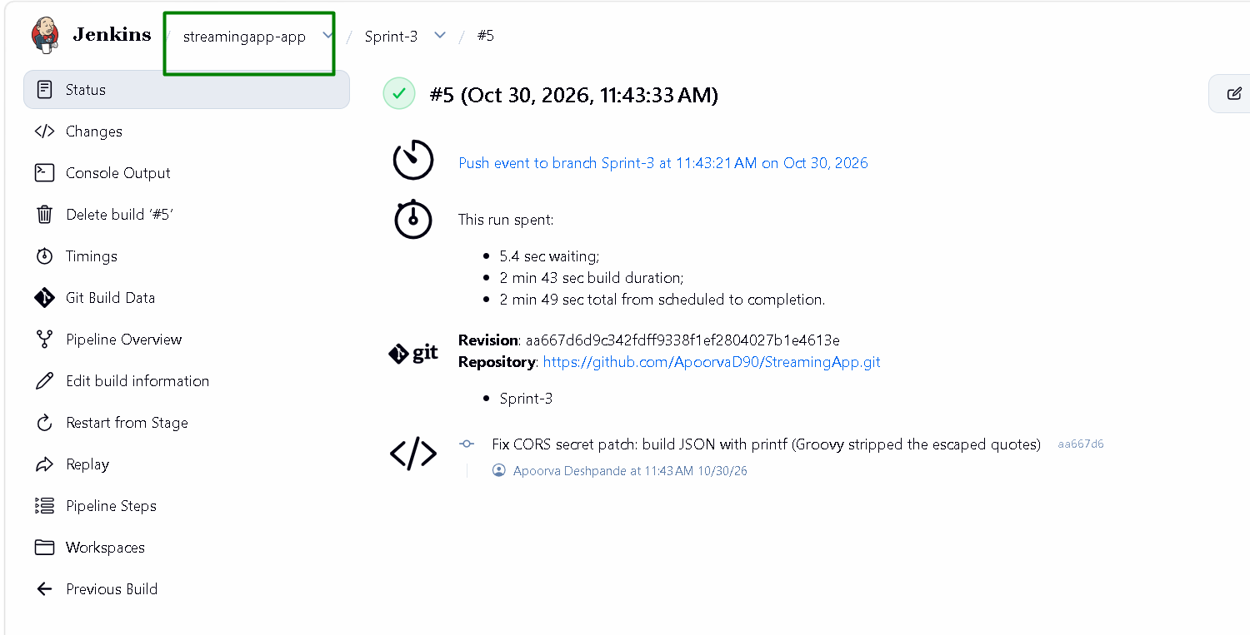
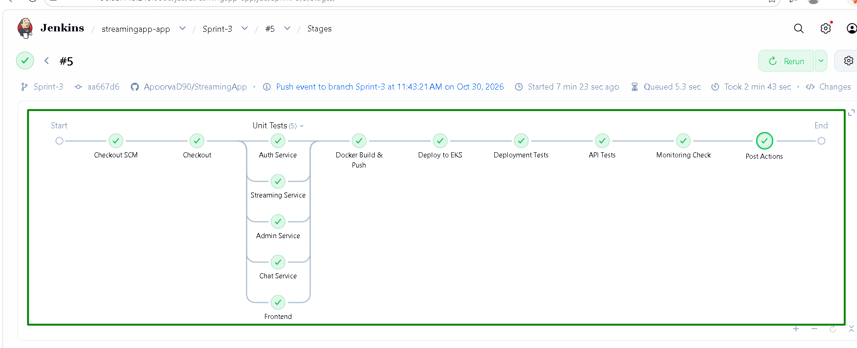
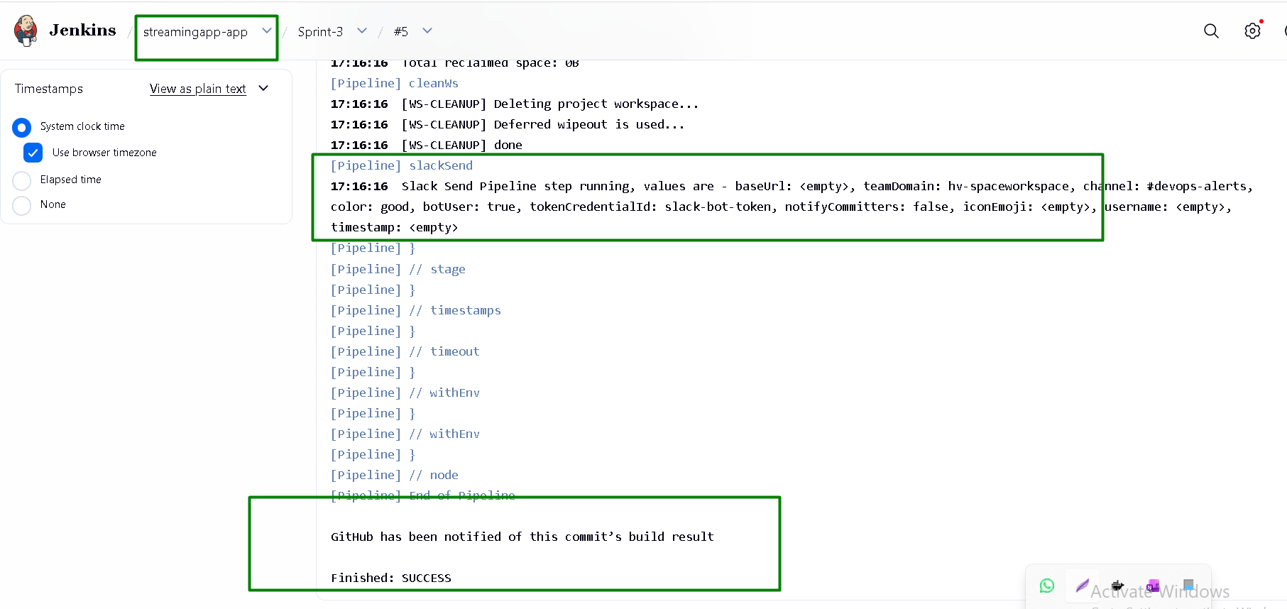

Slack shows the notification for build success:
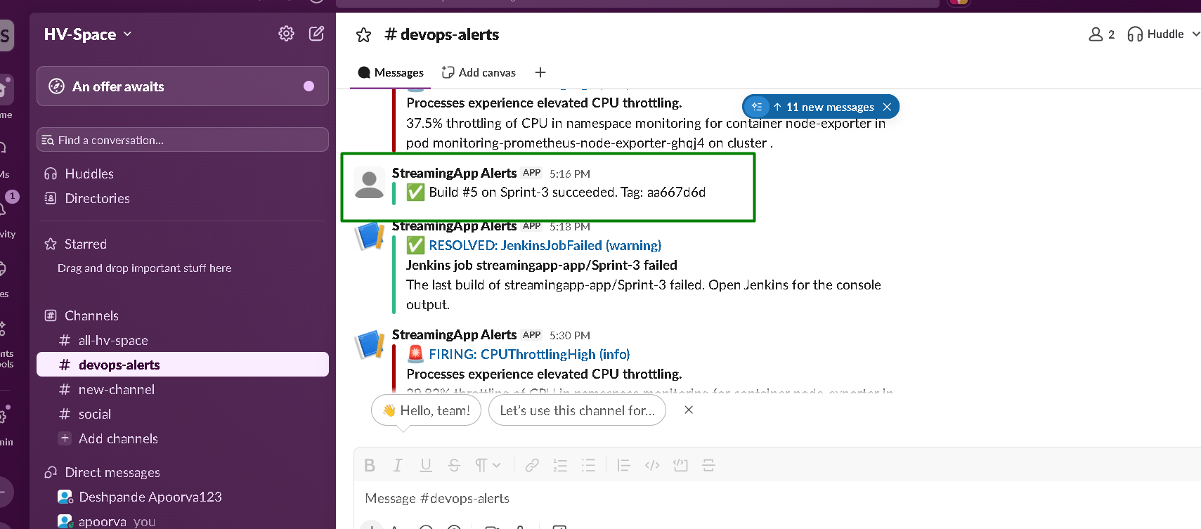

Slack also gets alerts for elevated CPU throttling and Pod restarts:
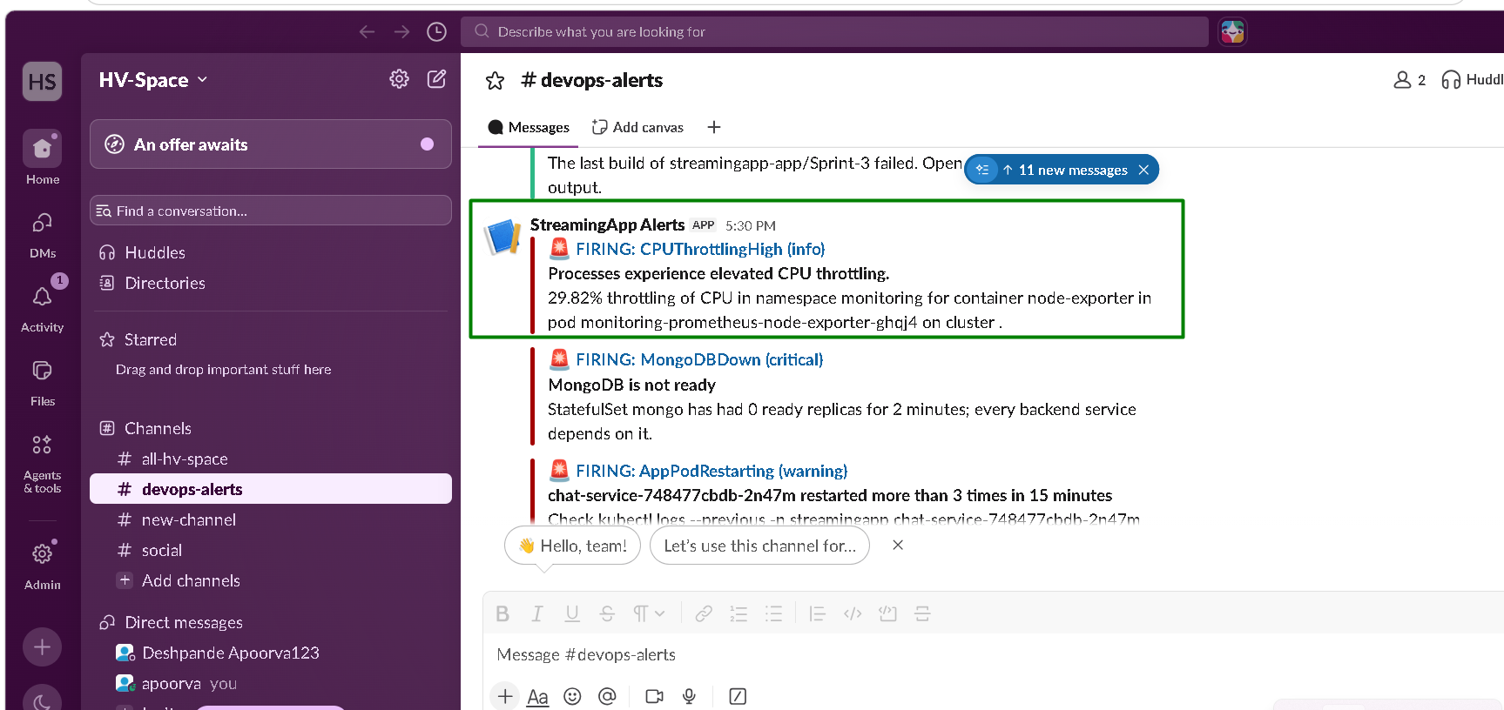
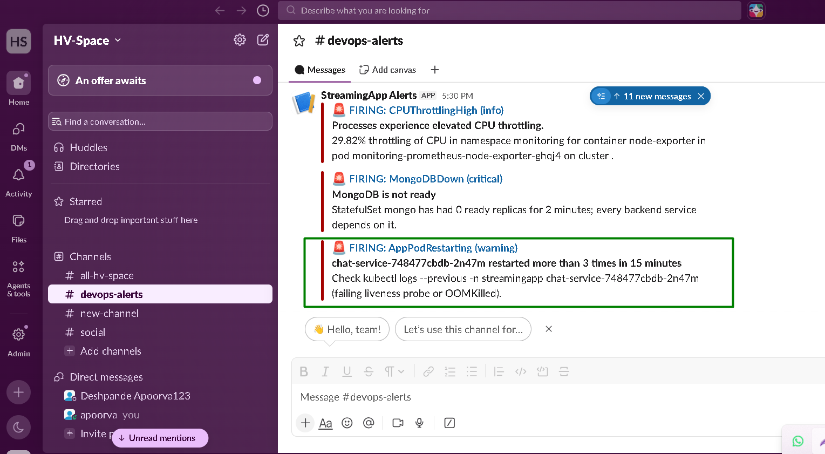

Slack also gets notifications when build fails:
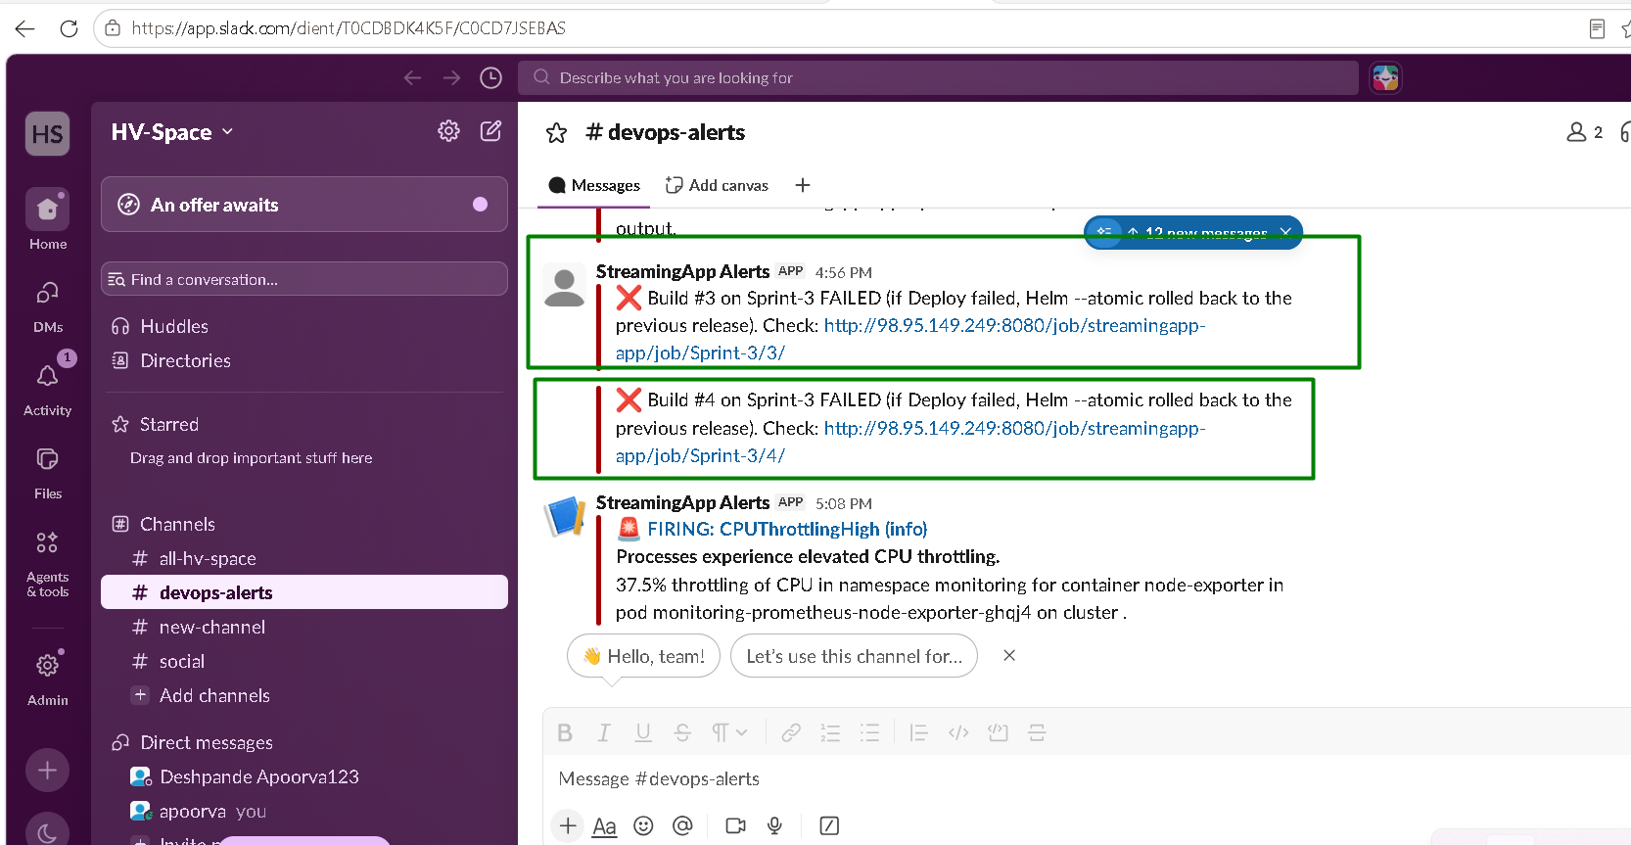

Verification and evidence:
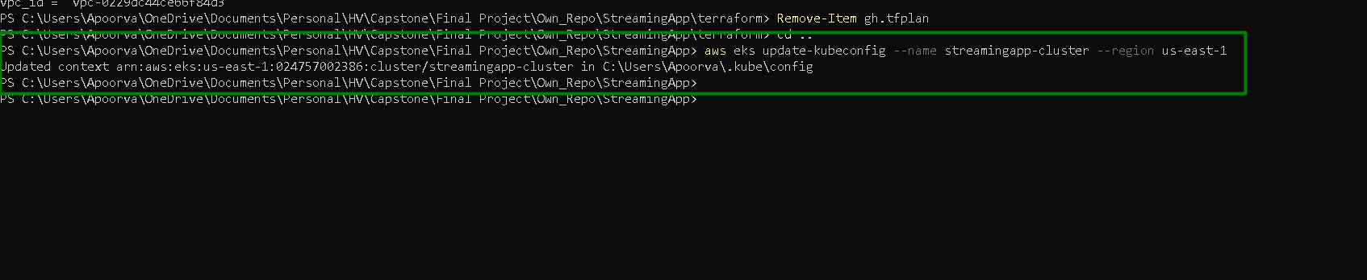

Pinned images:
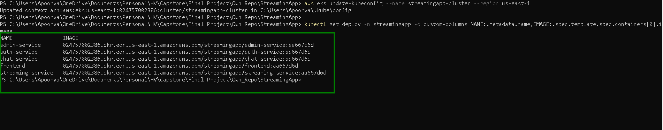
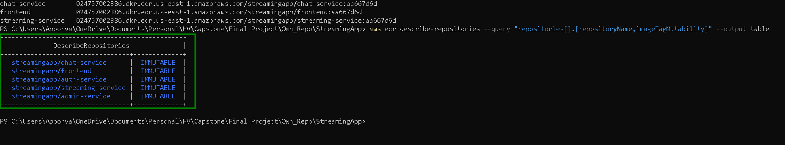

Deployment and health checks:
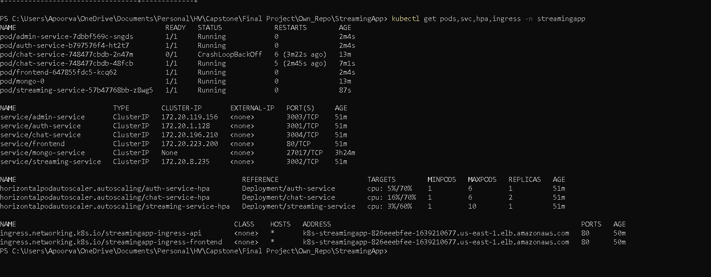
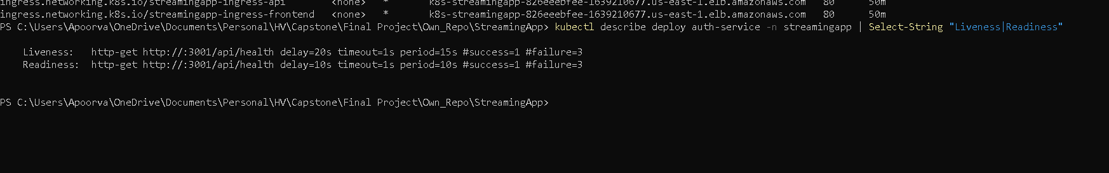

Autoscaling:

Replicas rise within 2 minutes
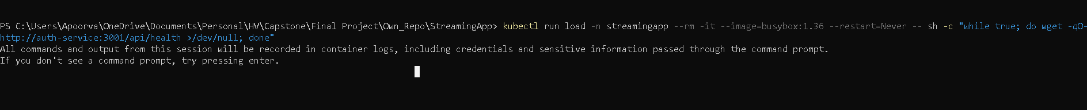
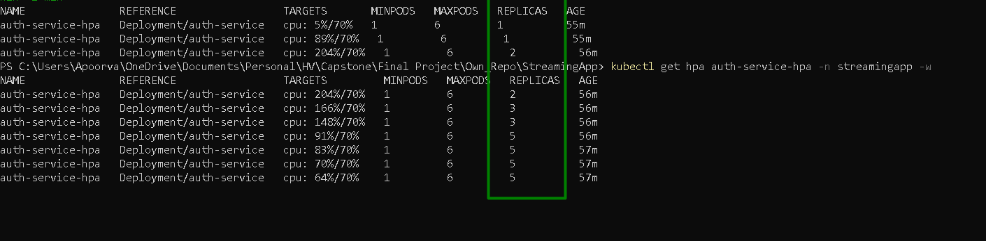

Self-healing:

5 auth-service pods were deleted and 5 new pods appeared:
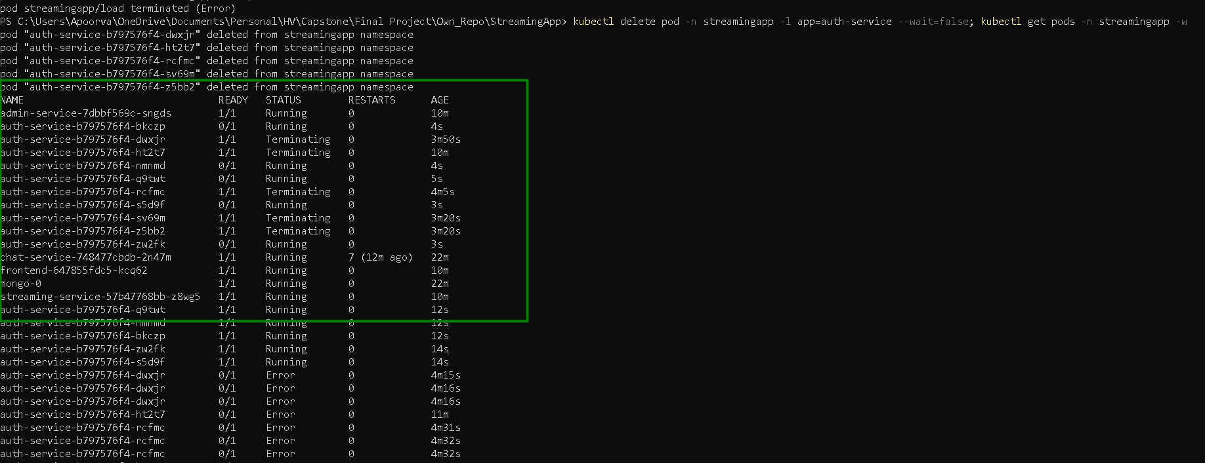

GitHub> Webhooks:

Recent delivery is successful:
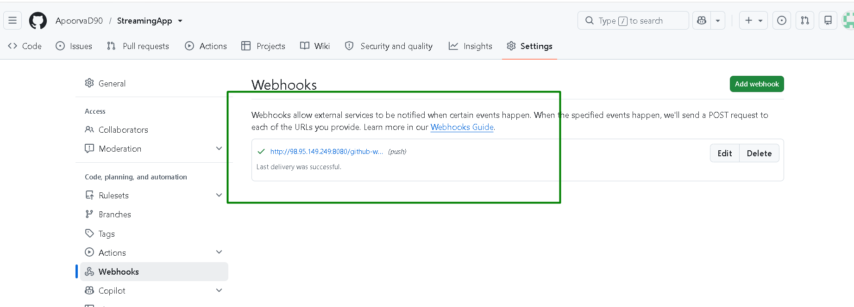

Open the app url> Register> Login:

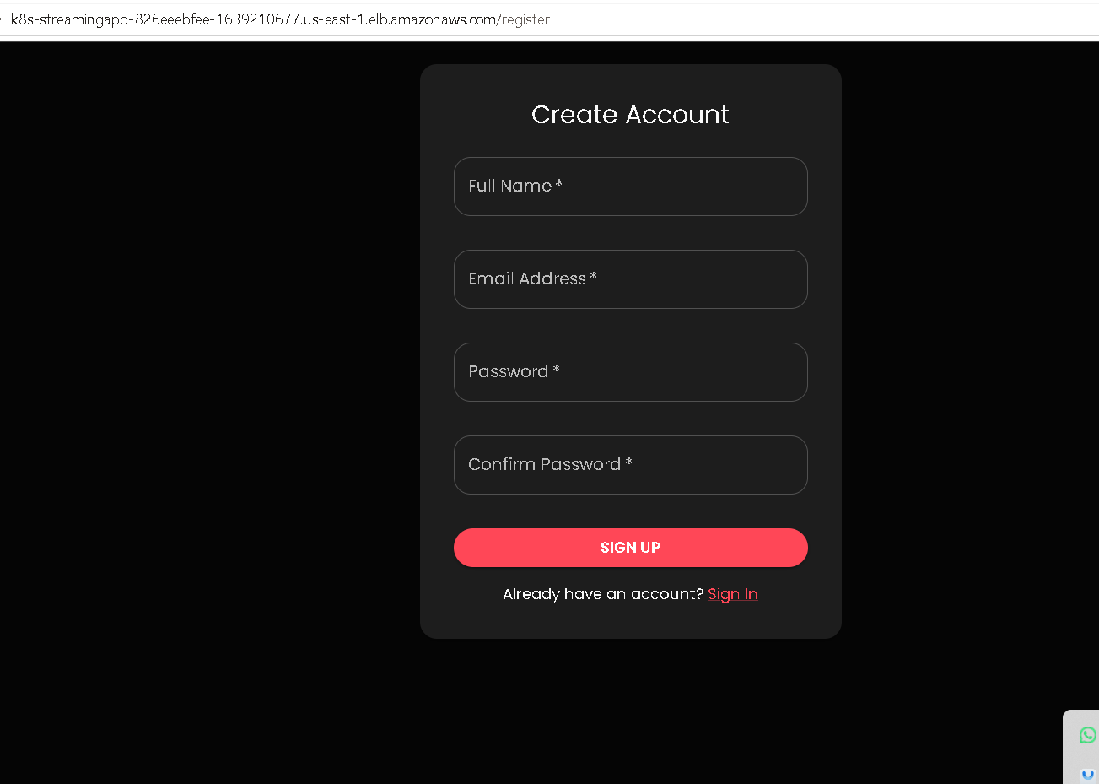
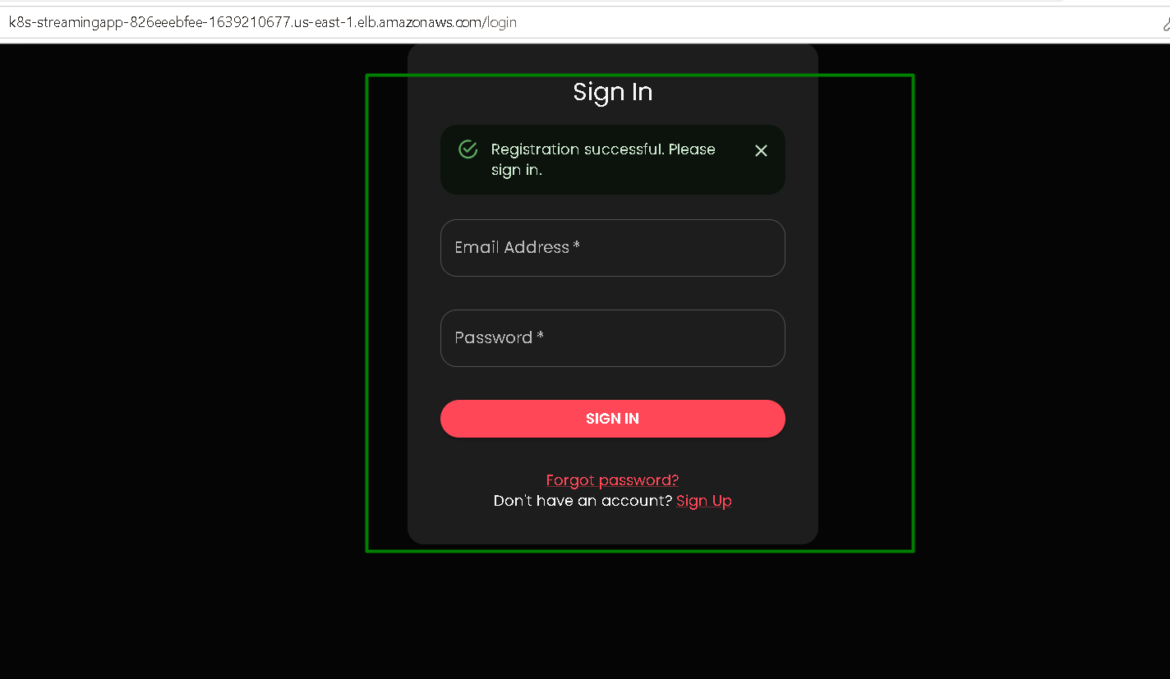


Security:

We are using the dedicated IAM user.

Second command proves EKS control plane, which kubectl talks to, isn’t open to internet.

Jenkins reaches it through the private endpoint inside the VPC.
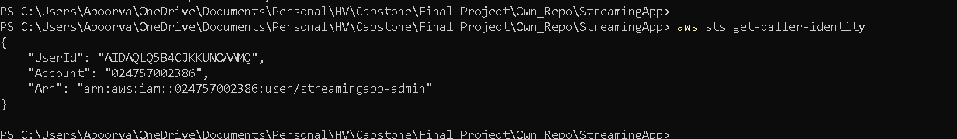

Monitoring and alerting
Components:
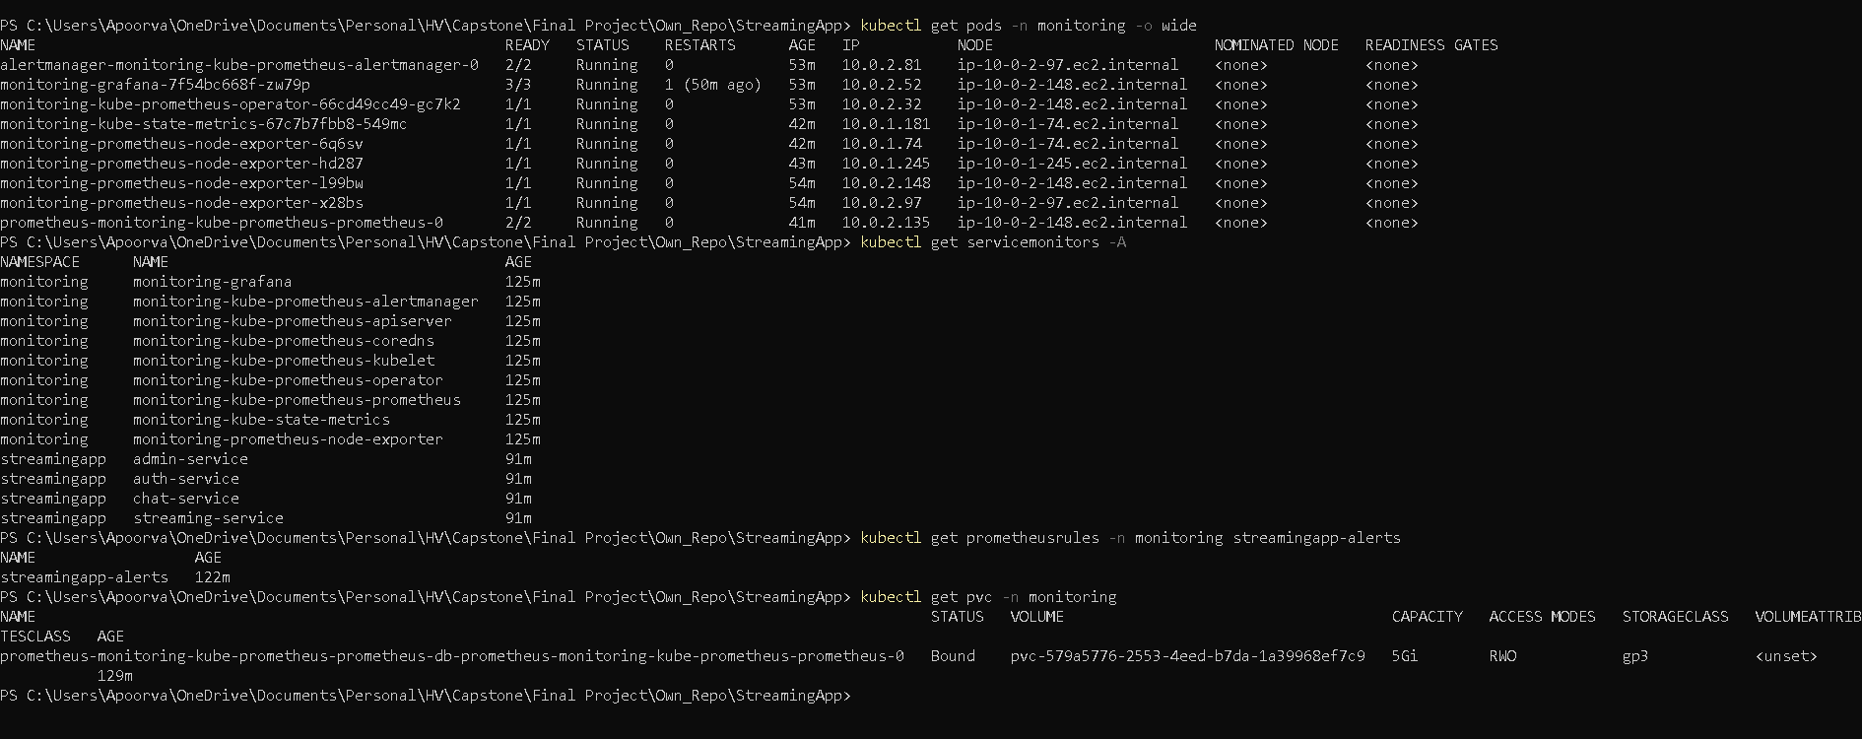

Prometheus:

Run port forwarding command:
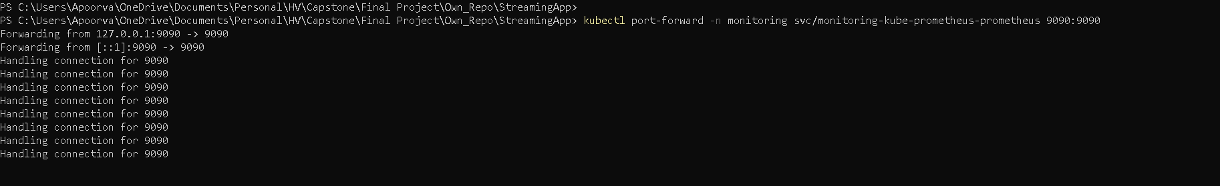

Status> Target health> All services are UP
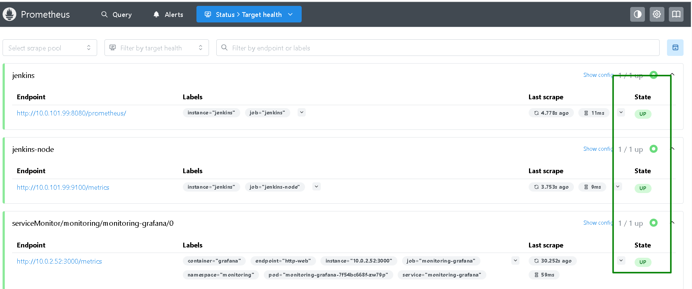
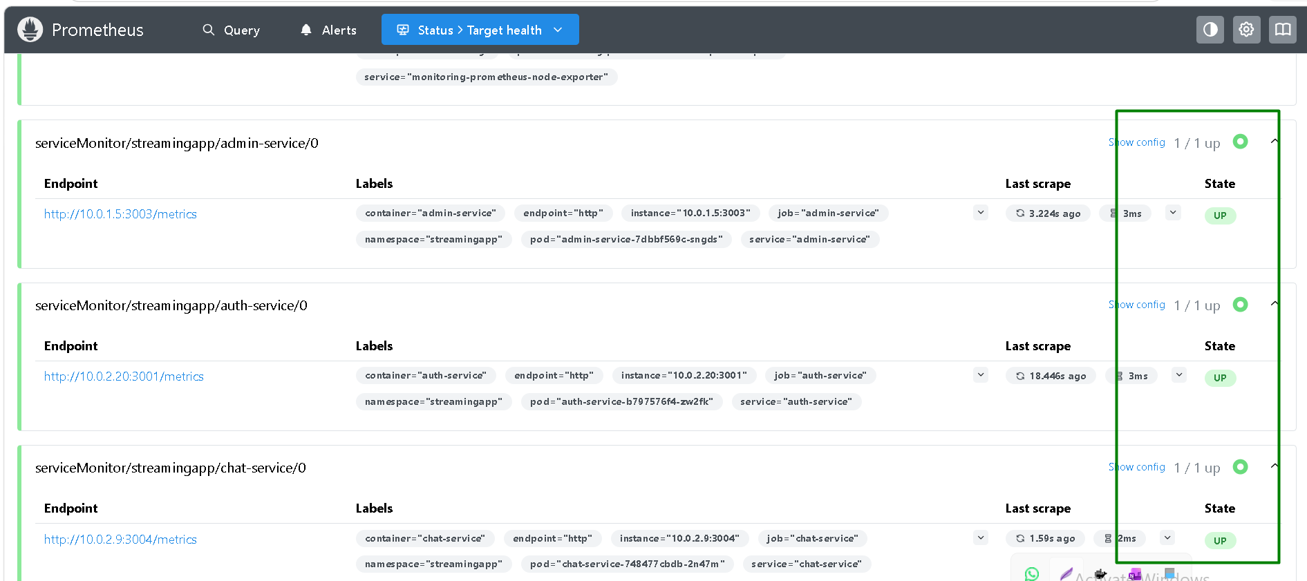
There are 3 groups with 12 rules in total:
- streamingapp.application: 6 rules
- streamingapp.jenkins: 3 rules
- streamingapp.nodes: 3 rules

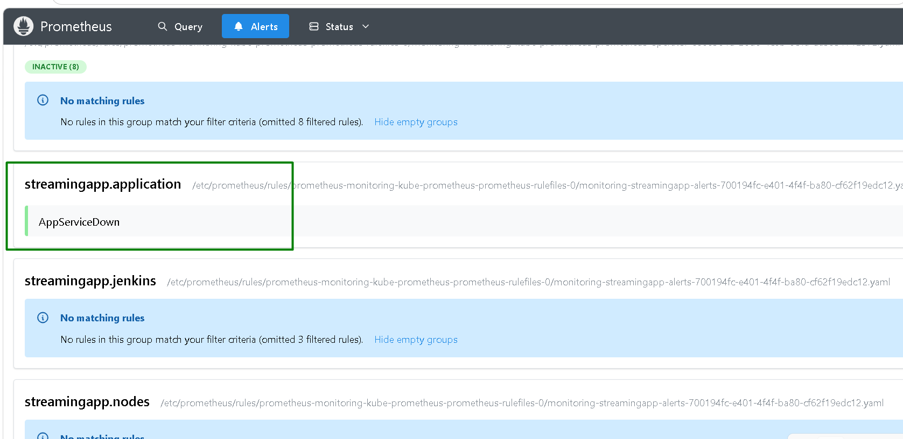
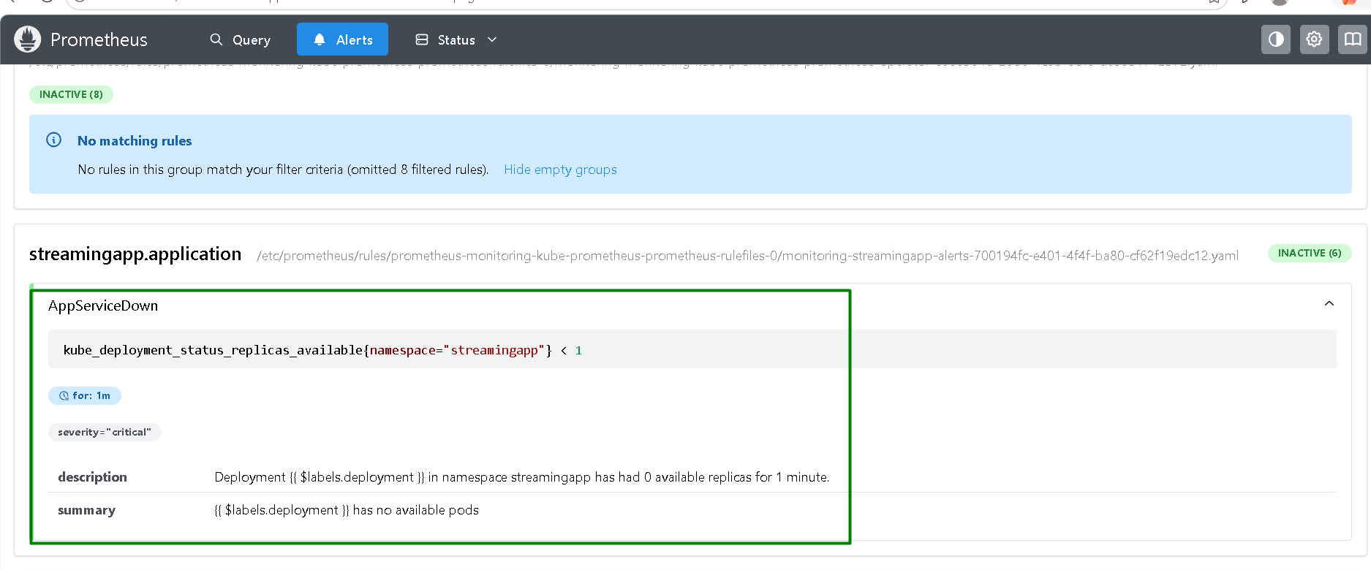
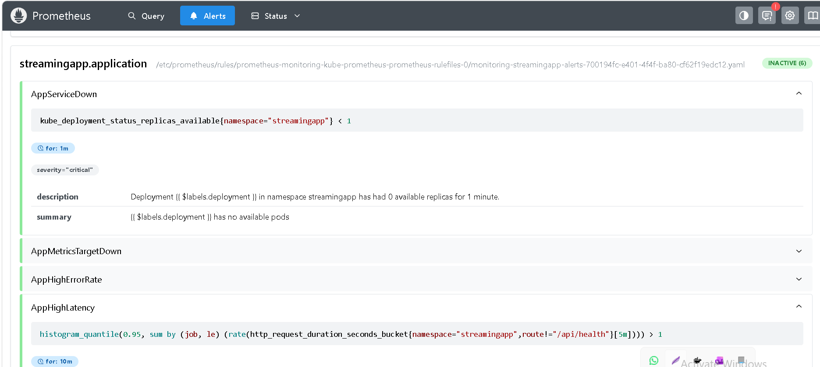
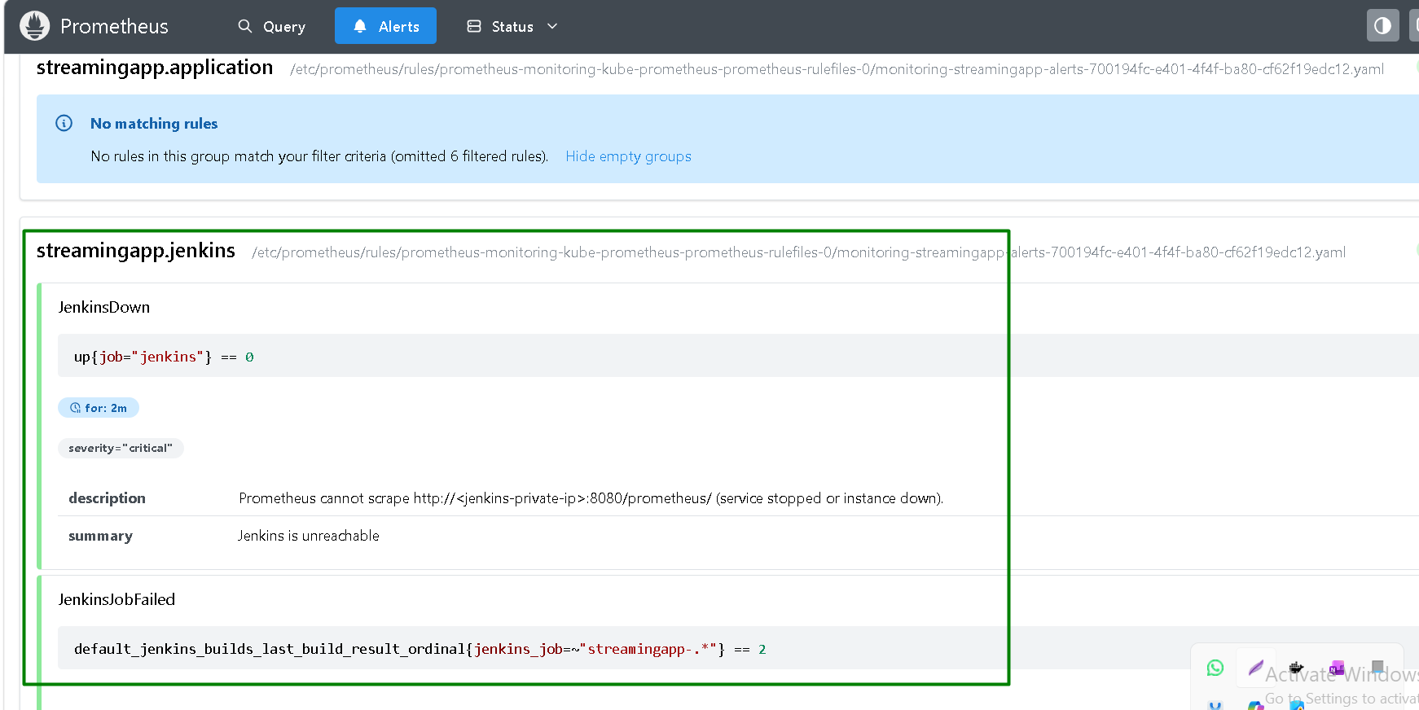

Queries to try >
- sum by (job) (rate(http_request_duration_seconds_count{namespace="streamingapp"}[5m]))
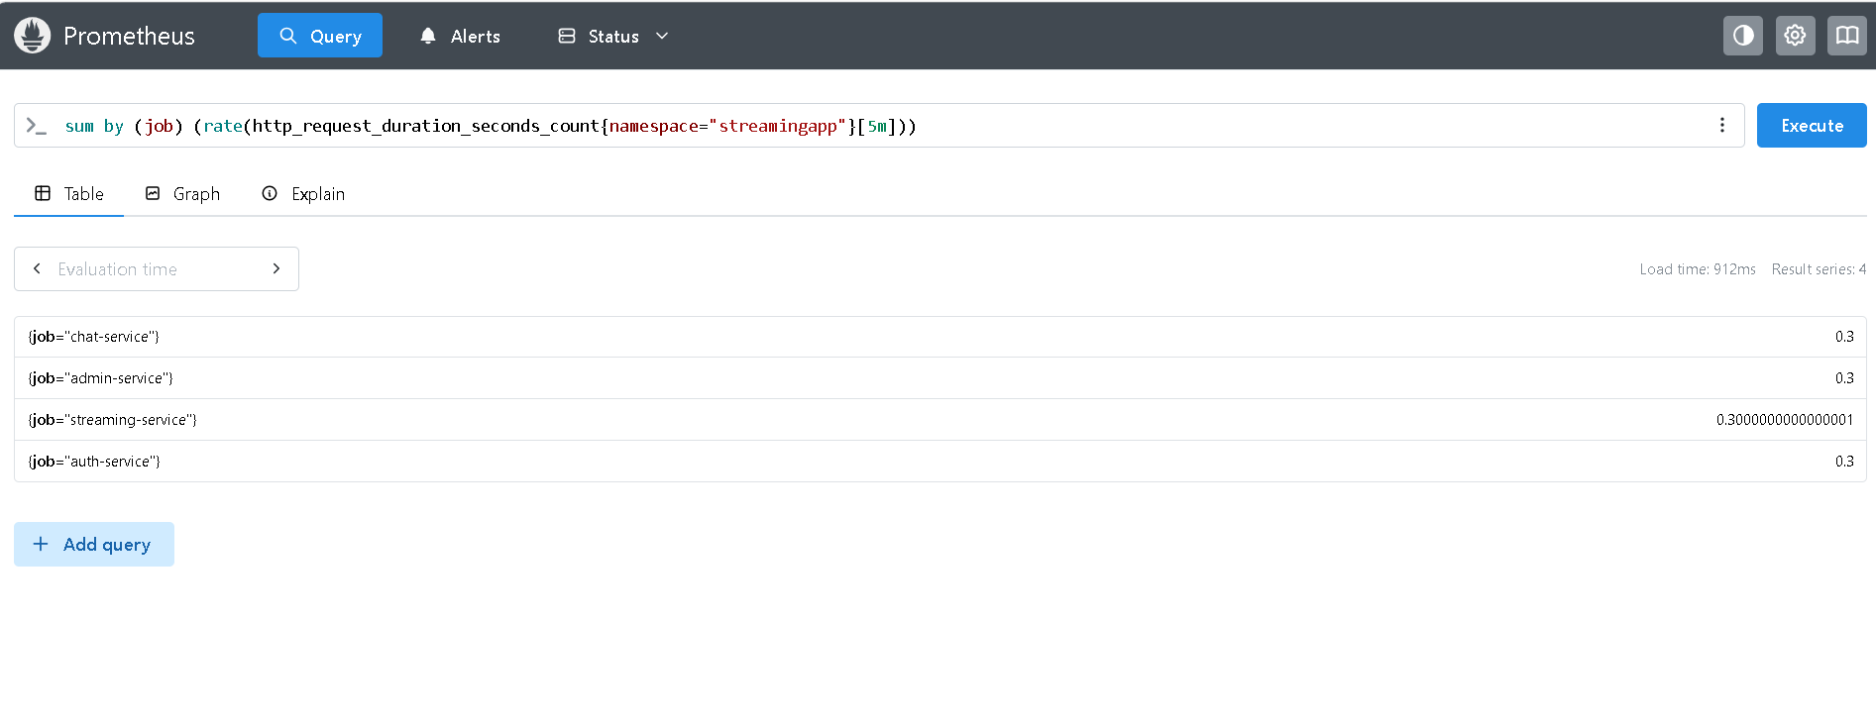

- 100 * (1 - avg by (instance) (rate(node_cpu_seconds_total{mode="idle"}[5m])))
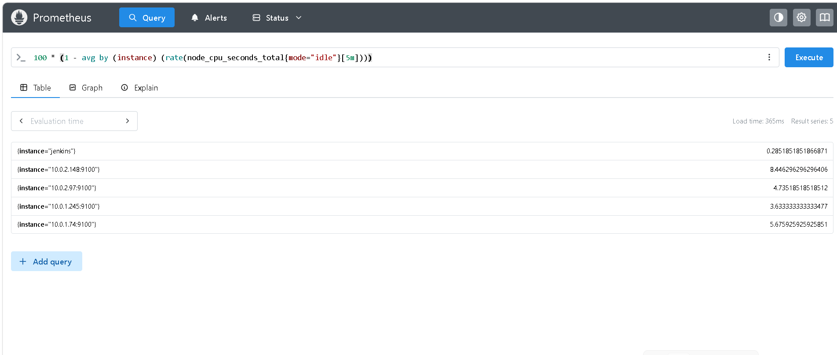
- default_jenkins_builds_last_build_result_ordinal
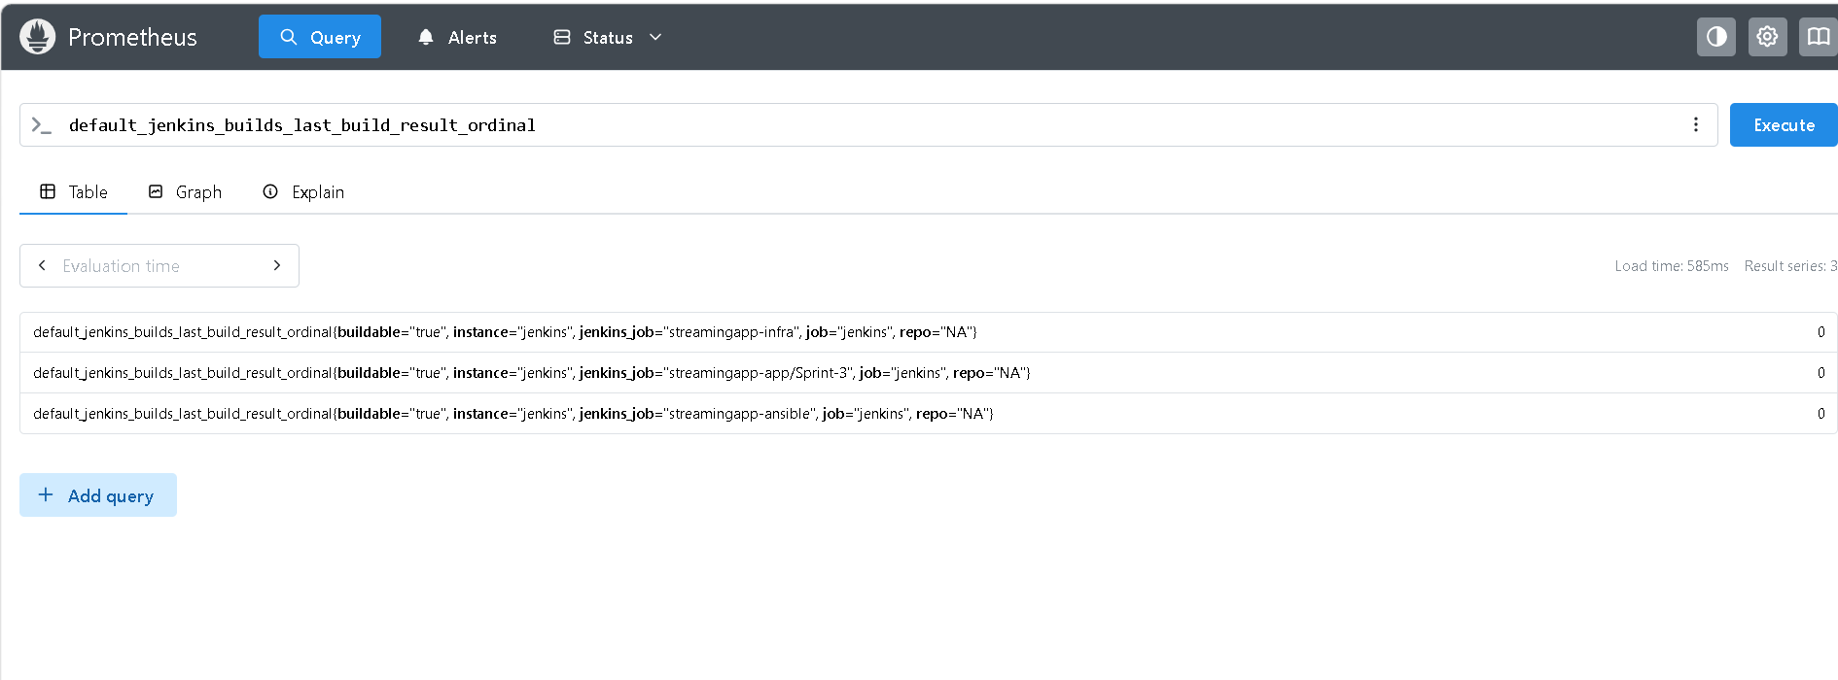

Grafana:

Run port-forwarding command:
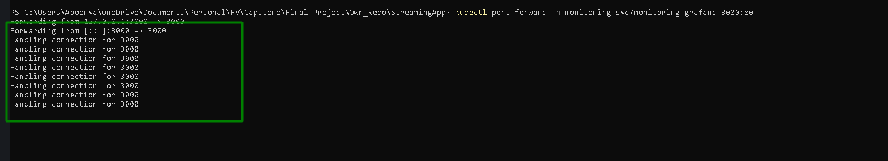
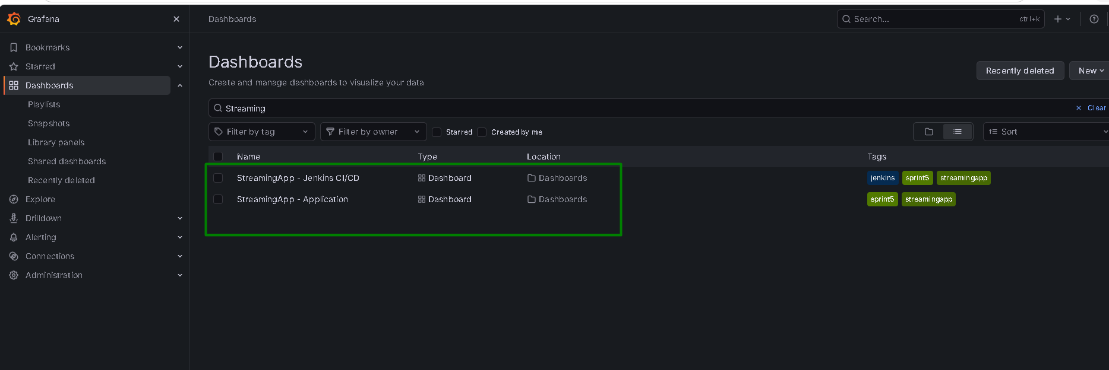

Application:
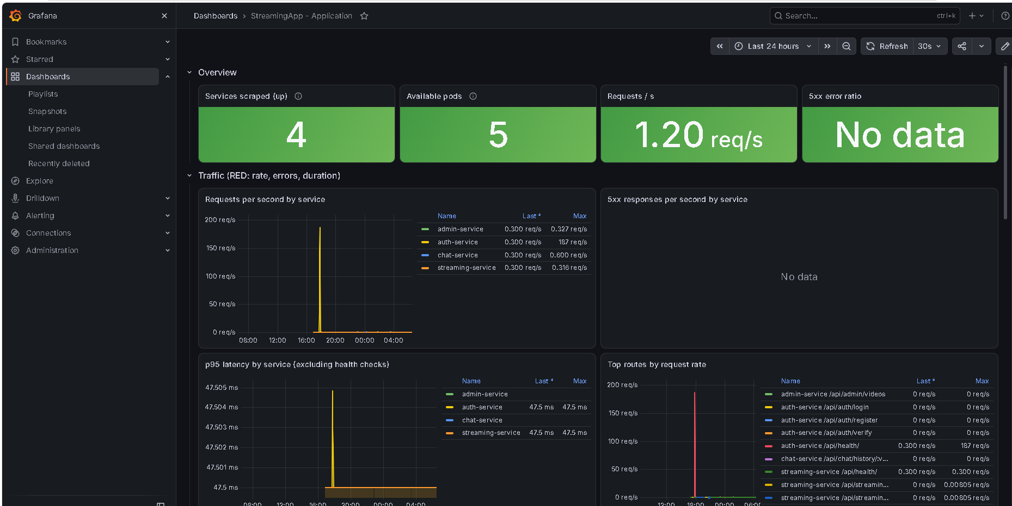
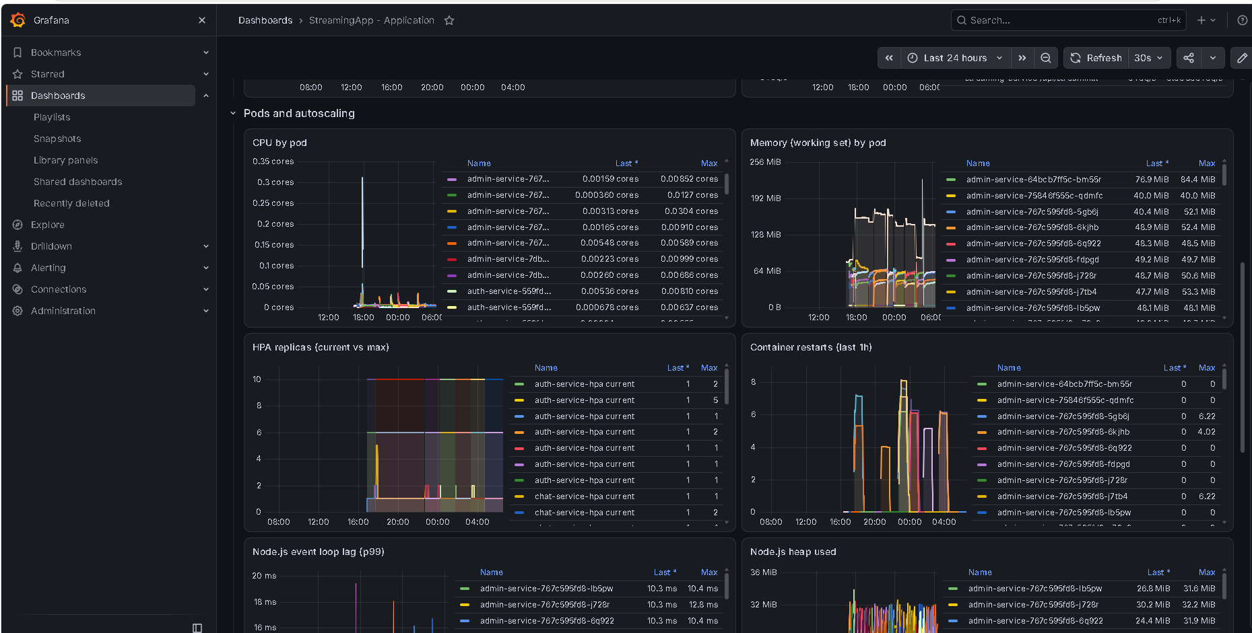
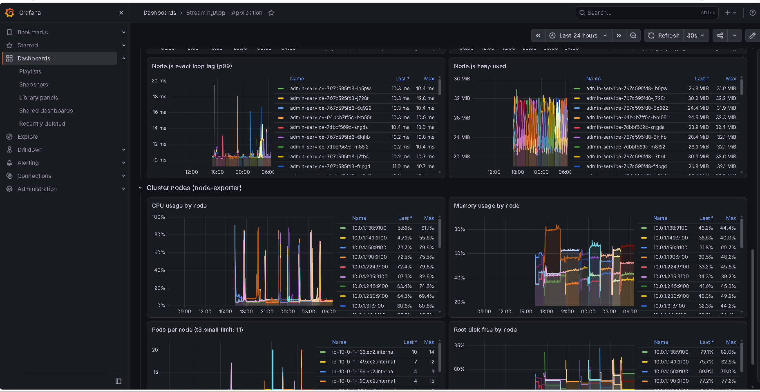

Jenkins CI/CD:
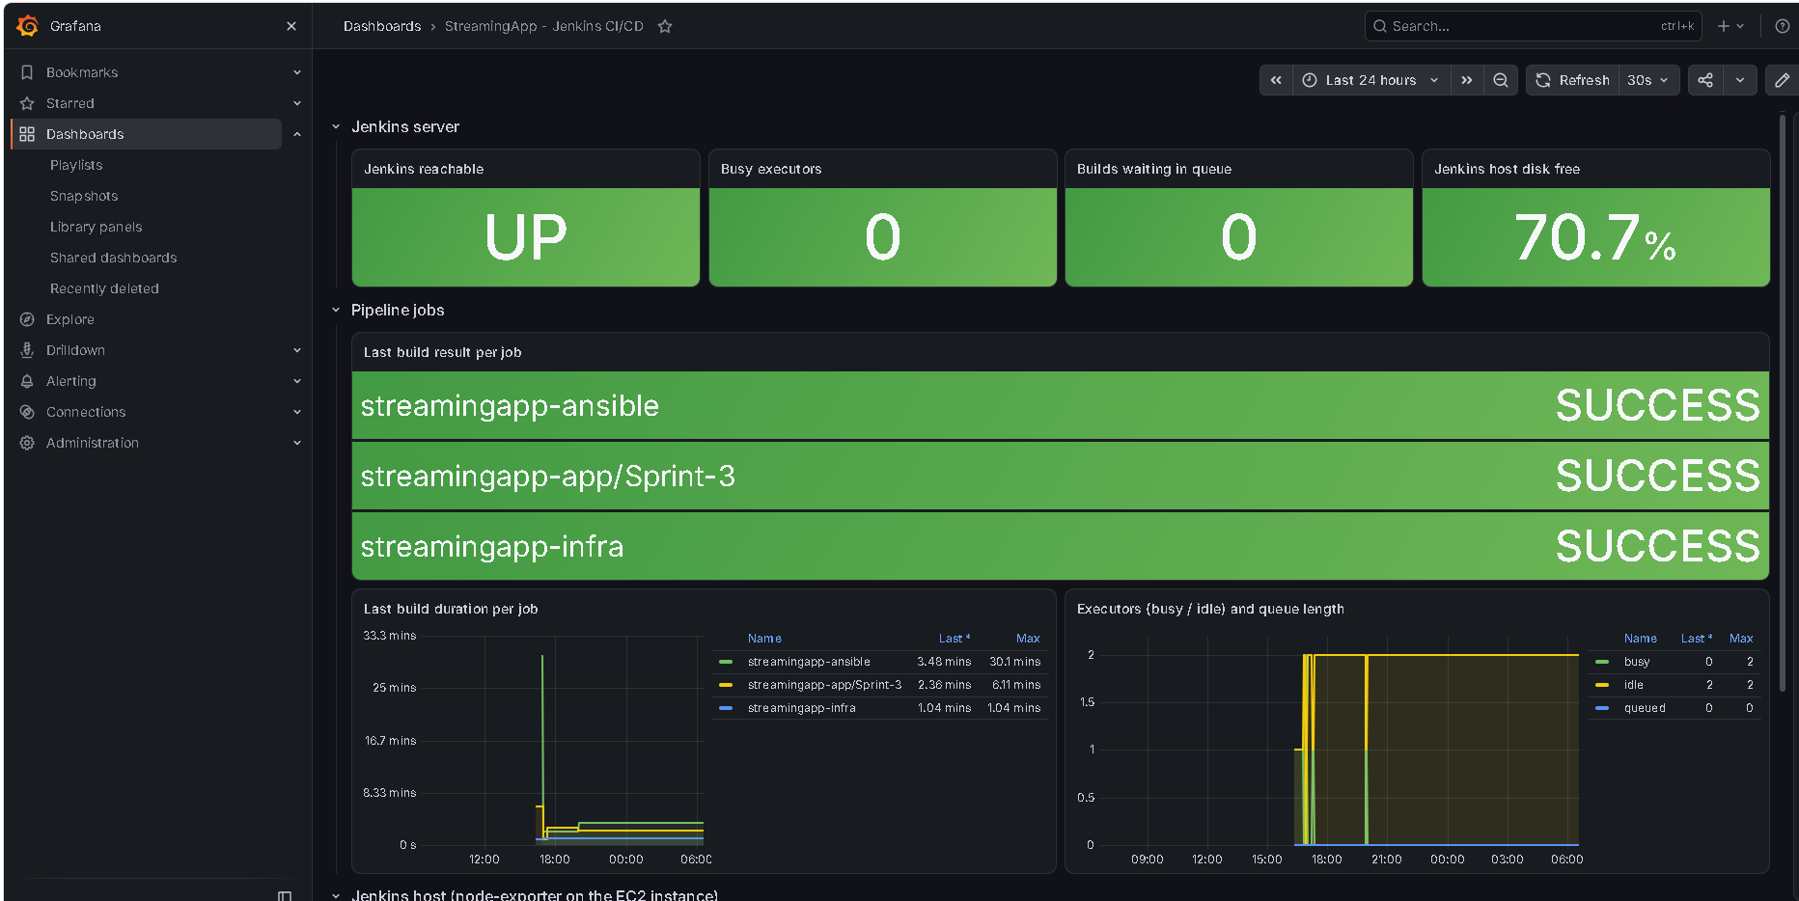
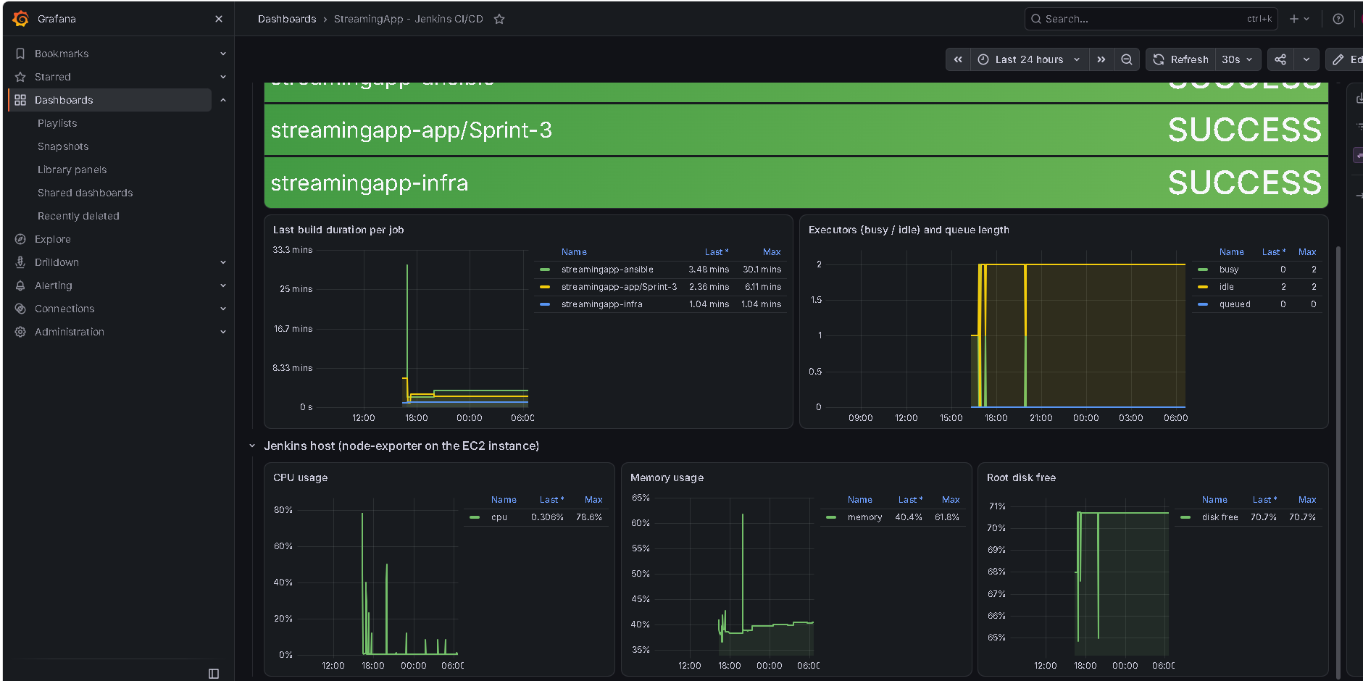

Built In Dashboards:
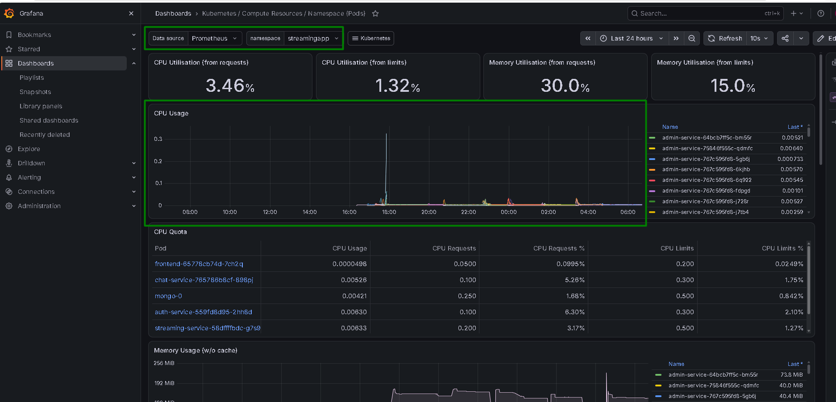
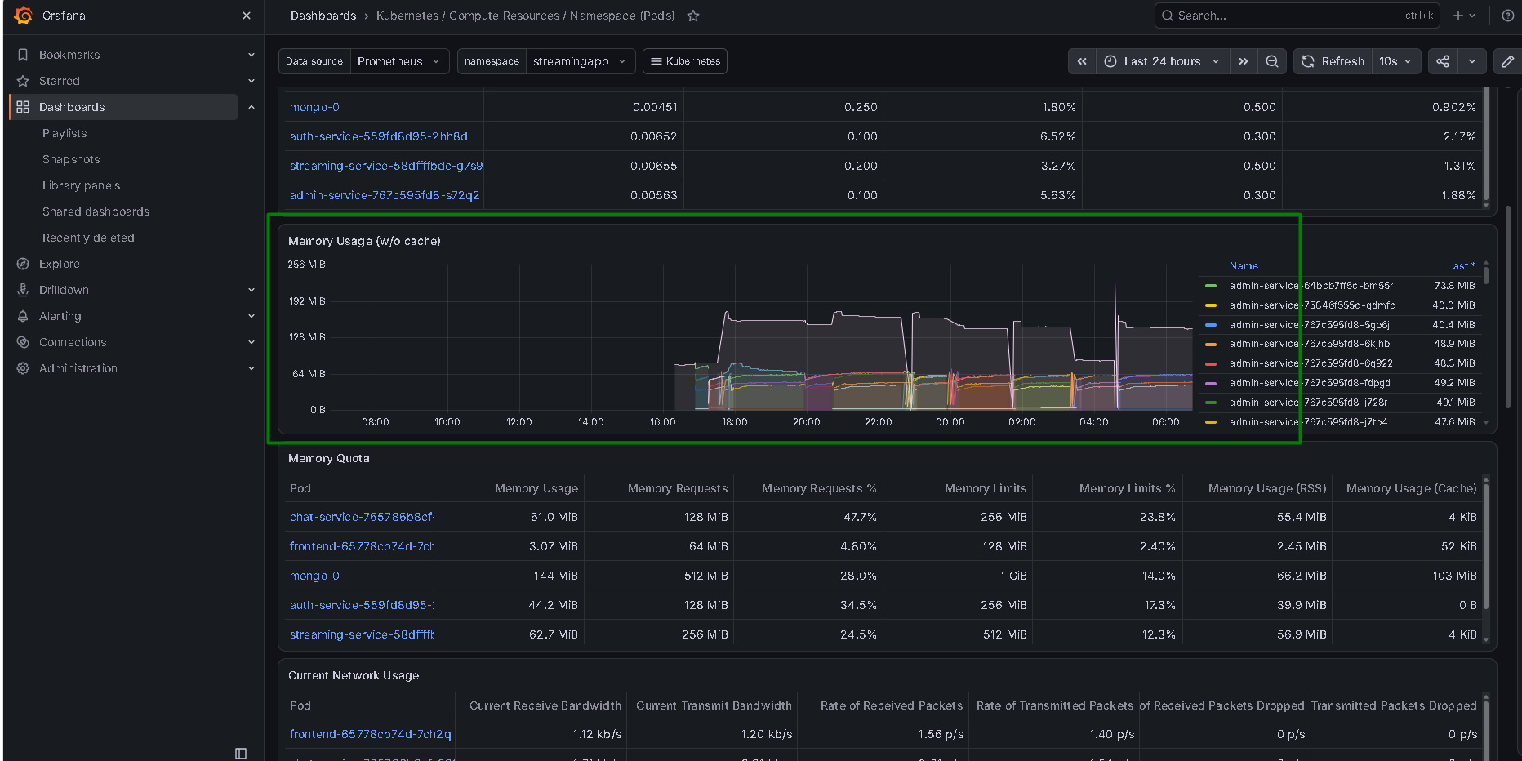
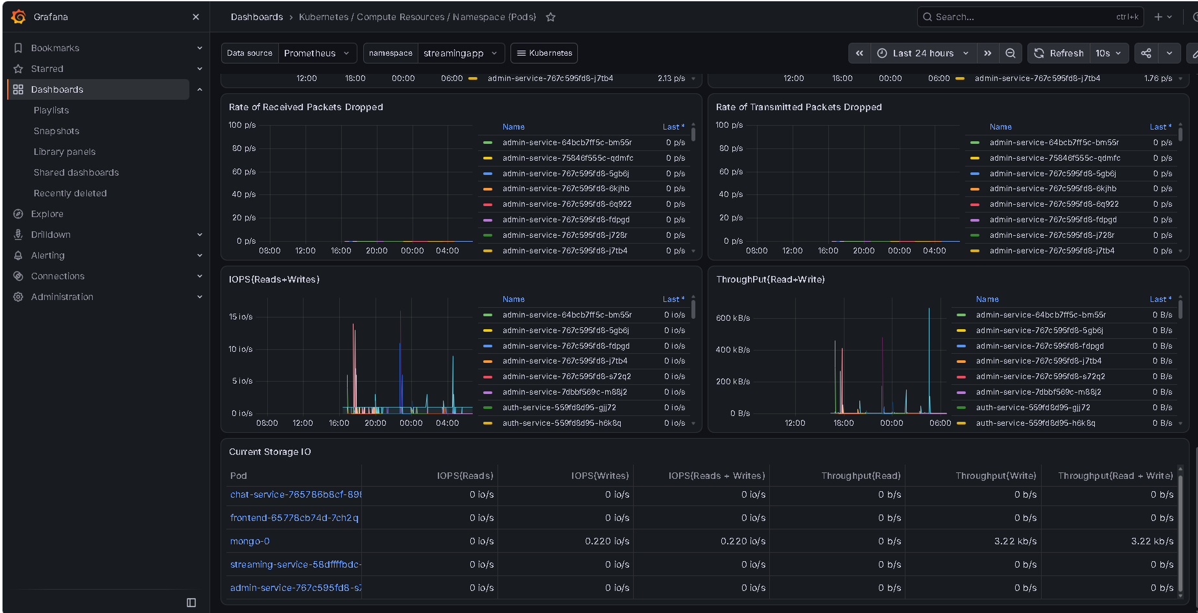

Cost Optimization:
The CPU Quota below shows that the 4 small nodes are well used not oversized:
Kubernetes / Compute Resources / Cluster: memory requests commitment of ~60% on 4 × t3.small Spot nodes. The cluster is sized to the actual workload (app, MongoDB, monitoring stack) with headroom for autoscaling, rolling updates and Spot interruptions, instead of over-provisioning larger instances

Other Cost Optimization points:
- Spot nodes (about 60–70% cheaper than On-Demand), with resilience shown by the real Spot interruption.
- Grafana and Prometheus through kubectl port-forward instead of a second load balancer.
- Prometheus retention of 3 days on a 5 GiB volume.
- Pausing the cluster between sessions (scale nodes to 0, stop Jenkins).
- Budget alert at 50% and 80%.

Jenkins exposes CI/CD metrics for Prometheus:
Jenkins publishes its build results as Prometheus metrics (Jenkins (Prometheus metrics plugin) → Prometheus scrapes it every 30s)
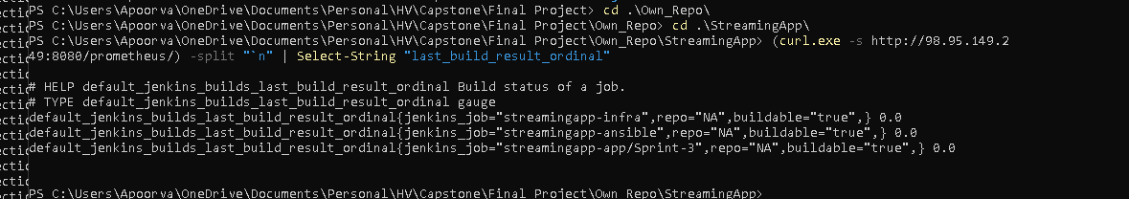
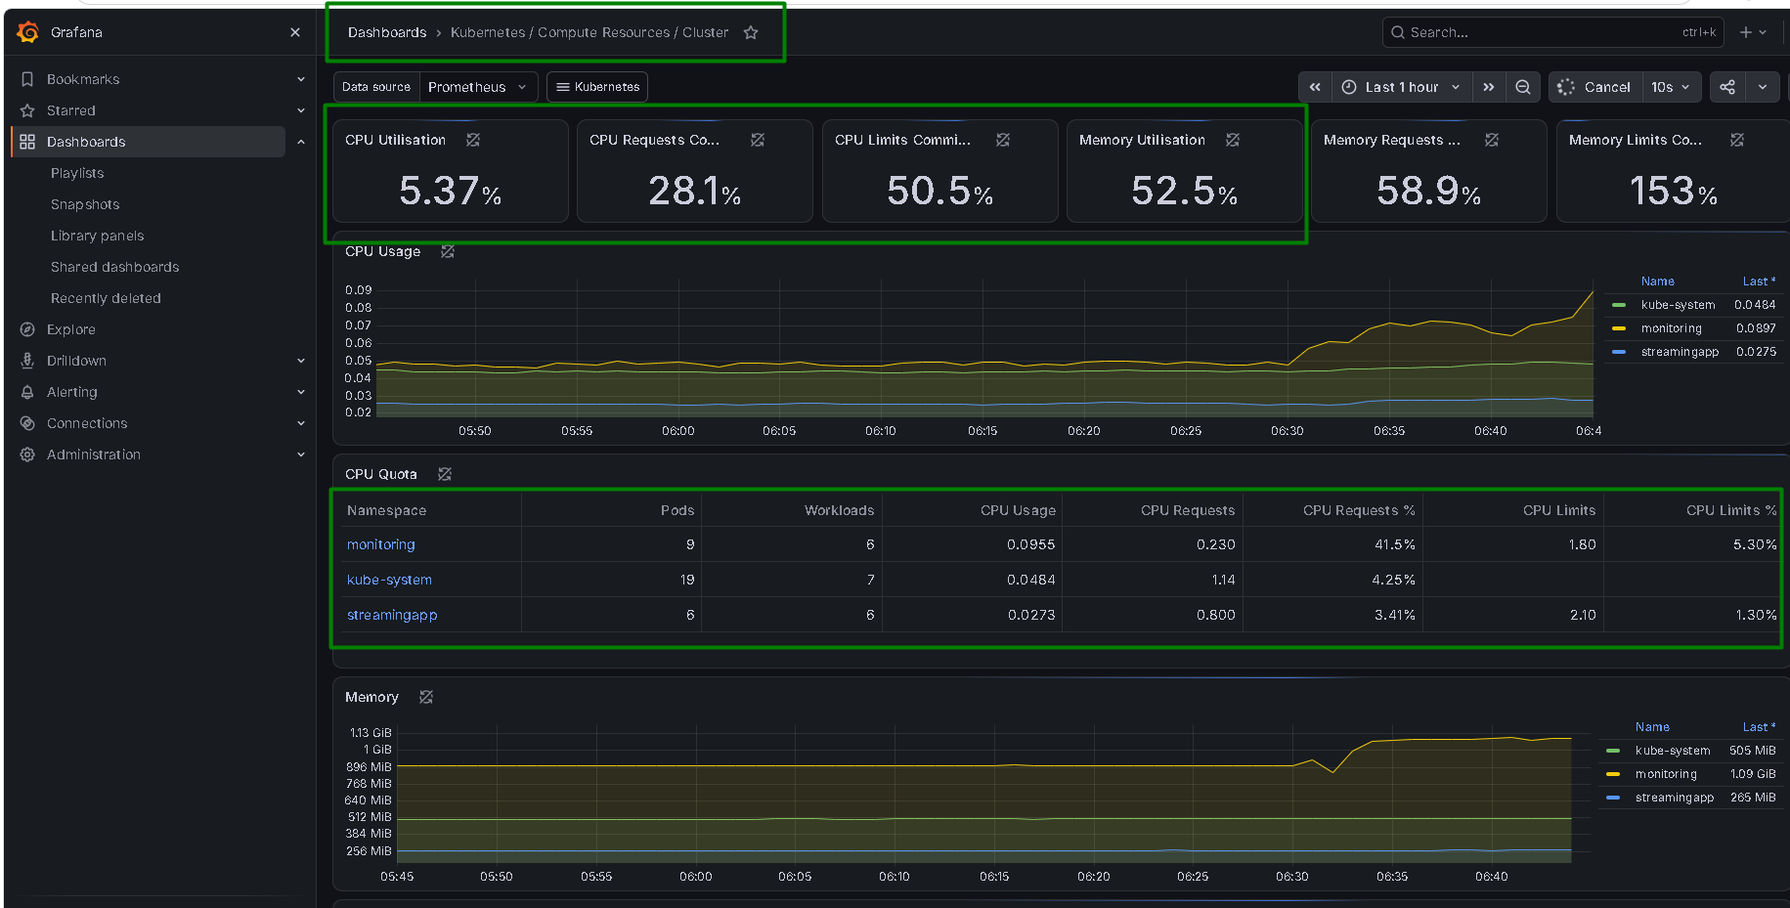

Alert Test:
Port forwarding:
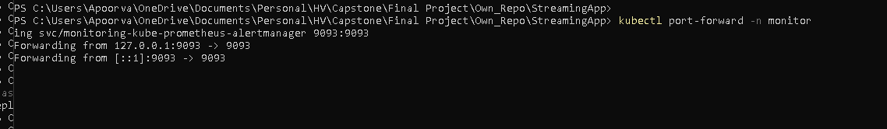
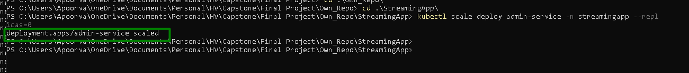

Slack shows “App Service down”
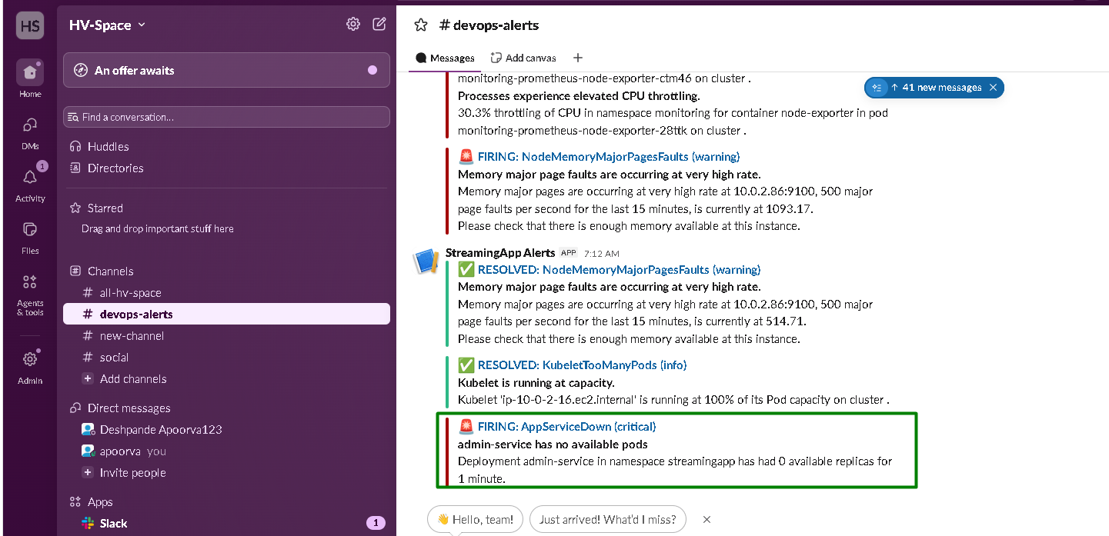
Now we restore the service:
